UNITED STATES
SECURITIES AND EXCHANGE COMMISSION
WASHINGTON, D.C. 20549
FORM 8-K
CURRENT REPORT
Pursuant to Section 13 OR 15(d) of The Securities Exchange Act of 1934
Date of Report (Date of earliest event reported): April 30, 2025
FINWISE BANCORP
(Exact name of registrant as specified in its charter)
Utah |  |  | 001-40721 |  |  | 83-0356689
(State or other jurisdiction of incorporation or organization) |  |  | (Commission file number) |  |  | (I.R.S. employer identification no.)
756 East Winchester St., Suite 100 |  |  |  |  |  |  |  |  |  |  |  |  |  |  | 84107
 |  |  | Murray, |  |  | Utah
(Address of principal executive offices) |  |  |  |  |  |  |  |  |  |  |  |  |  |  | (Zip code)
Registrant’s telephone number, including area code: (801) 501-7200
Not Applicable
(Former Name or Former Address, if Changed Since Last Report)
Check the appropriate box below if the Form 8-K filing is intended to simultaneously satisfy the filing obligation of the registrant under any of the following provisions:
☐ |  |  | Written communications pursuant to Rule 425 under the Securities Act (17 CFR 230.425)
☐ |  |  | Soliciting material pursuant to Rule 14a-12 under the Exchange Act (17 CFR 240.14a-12)
☐ |  |  | Pre-commencement communications pursuant to Rule 14d-2(b) under the Exchange Act (17 CFR 240.14d-2(b))
☐ |  |  | Pre-commencement communications pursuant to Rule 13e-4(c) under the Exchange Act (17 CFR 240.13e-4(c))
Indicate by check mark whether the registrant is an emerging growth company as defined in Rule 405 of the Securities Act of 1933 (§230.405 of this chapter) or Rule 12b-2 of the Securities Exchange Act of 1934 (§240.12b-2 of this chapter).
Emerging growth company |  |  | ☒
If an emerging growth company, indicate by check mark if the registrant has elected not to use the extended transition period for complying with any new or revised financial accounting standards provided pursuant to Section 13(a) of the Exchange Act. ☐
Securities registered pursuant to Section 12(b) of the Act:
Title of each class |  |  | Trading Symbol(s) |  |  | Name of exchange on which registered
Common Stock, par value $0.001 per share |  |  | FINW |  |  | The NASDAQ Stock Market LLC

Item 2.02Results of Operations and Financial Condition.
Attached and incorporated herein by reference as Exhibit 99.1 is a copy of the press release of FinWise Bancorp (the "Company"), dated April 30, 2025, reporting the Company's financial results for the fiscal quarter ended March 31, 2025.
The information set forth under this “Item 2.02 Results of Operations and Financial Condition,” including Exhibit 99.1 attached hereto, shall not be deemed “filed” for purposes of Section 18 of the Securities Exchange Act of 1934, as amended, nor shall such information be deemed incorporated by reference in any filing under the Securities Act of 1933, as amended, except as shall be expressly set forth by specific reference in such filing.

Item 7.01Regulation FD Disclosure.
The Company has prepared materials for presentation to investors. A copy of the materials is furnished as Exhibit 99.2 to this Current Report on Form 8-K and is incorporated herein by reference. The information set forth under “Item 7.01 Regulation FD Disclosure,” including Exhibit 99.2 attached hereto, shall not be deemed “filed” for purposes of Section 18 of the Securities Act of 1934, as amended, nor shall such information be deemed incorporated by reference in any filing under the Securities Act of 1933, as amended, except as shall be expressly set forth by specific reference in such filing.

Item 9.01Financial Statements and Exhibits.
(d)Exhibits
Exhibit No. |  |  |  |  |  | Description
99.1 |  |  |  |  |  | Press Release dated April 30, 2025
99.2 |  |  |  |  |  | Investor Presentation of FinWise Bancorp dated April 2025 (furnished pursuant to Regulation FD).
104 |  |  |  |  |  | Cover Page Interactive Data File (embedded within the Inline XBRL document)

SIGNATURES
Pursuant to the requirements of the Securities Exchange Act of 1934, as amended, FinWise Bancorp has duly caused this report to be signed on its behalf by the undersigned hereunto duly authorized.
DATE: April 30, 2025 |  |  | FINWISE BANCORP
 |  |  | /s/ Robert Wahlman
 |  |  | Robert Wahlman
 |  |  | Chief Financial Officer and Executive Vice President


Exhibit 99.1

FINWISE BANCORP REPORTS FIRST QUARTER 2025 RESULTS
- Loan Originations of $1.3 Billion -
- Net Income of $3.2 Million -
- Diluted Earnings Per Share of $0.23 -

MURRAY, UTAH — April 30, 2025 (GLOBE NEWSWIRE) — FinWise Bancorp (NASDAQ: FINW) (“FinWise” or the “Company”), parent company of FinWise Bank (the “Bank”), today announced results for the quarter ended March 31, 2025.

First Quarter 2025 Highlights
•Loan originations totaled $1.3 billion, compared to $1.3 billion for the quarter ended December 31, 2024, and $1.1 billion for the first quarter of the prior year
•Net interest income was $14.3 million, compared to $15.5 million for the quarter ended December 31, 2024, and $14.0 million for the first quarter of the prior year
•Net income was $3.2 million, compared to $2.8 million for the quarter ended December 31, 2024, and $3.3 million for the first quarter of the prior year
•Diluted earnings per share (“EPS”) were $0.23 for the quarter, compared to $0.20 for the quarter ended December 31, 2024, and $0.25 for the first quarter of the prior year
•Efficiency ratio1 was 64.8%, compared to 64.2% for the quarter ended December 31, 2024, and 61.0% for the first quarter of the prior year
•Nonperforming loan balances were $29.9 million as of March 31, 2025, compared to $36.5 million as of December 31, 2024, and $26.0 million as of March 31, 2024. Nonperforming loan balances guaranteed by the Small Business Administration (“SBA”) were $15.1 million, $19.2 million, and $14.8 million as of March 31, 2025, December 31, 2024, and March 31, 2024, respectively

“Our business model remained resilient in the first quarter, even amidst a more uncertain macro environment,” said Kent Landvatter, Chairman and CEO of FinWise. “We posted solid loan originations and encouraging credit quality metrics, as both non-performing loan balances and net charge-offs declined sequentially. Furthermore, we continued to migrate our loan portfolio to a lower risk profile while still growing profitably and increasing tangible book value. Subsequent to the end of the first quarter, we also announced a new strategic program agreement where FinWise will provide both lending and our Credit Enhanced Balance Sheet product. While we will continue to closely monitor the economic environment, we remain excited about the outlook for our business and will maintain our focus on executing our business strategy to continue to position the Company for long-term growth and shareholder value creation.”

1 See “Reconciliation of Non-GAAP to GAAP Financial Measures” for a reconciliation of this non-GAAP measure.
1

Selected Financial and Other Data

 |  |  | As of and for the Three Months Ended
($ in thousands, except per share amounts) |  |  | 3/31/2025 |  |  |  |  |  | 12/31/2024 |  |  |  |  |  | 3/31/2024
Amount of loans originated |  |  | $ | 1,264,604 |  |  |  |  | $ | 1,305,028 |  |  |  |  | $ | 1,091,479
Net income |  |  | $ | 3,189 |  |  |  |  | $ | 2,793 |  |  |  |  | $ | 3,315
Diluted EPS |  |  | $ | 0.23 |  |  |  |  | $ | 0.20 |  |  |  |  | $ | 0.25
Return on average assets |  |  | 1.7 |  | % |  |  |  | 1.6 |  | % |  |  |  | 2.2 |  | %
Return on average equity |  |  | 7.4 |  | % |  |  |  | 6.5 |  | % |  |  |  | 8.4 |  | %
Yield on loans |  |  | 12.31 |  | % |  |  |  | 14.01 |  | % |  |  |  | 14.80 |  | %
Cost of interest-bearing deposits |  |  | 4.01 |  | % |  |  |  | 4.30 |  | % |  |  |  | 4.71 |  | %
Net interest margin |  |  | 8.27 |  | % |  |  |  | 10.00 |  | % |  |  |  | 10.12 |  | %
Efficiency ratio(1) |  |  | 64.8 |  | % |  |  |  | 64.2 |  | % |  |  |  | 61.0 |  | %
Tangible book value per share(2) |  |  | $ | 13.42 |  |  |  |  | $ | 13.15 |  |  |  |  | $ | 12.70
Tangible shareholders’ equity to tangible assets(2) |  |  | 22.0 |  | % |  |  |  | 23.3 |  | % |  |  |  | 26.6 |  | %
Leverage ratio (Bank under CBLR) |  |  | 18.8 |  | % |  |  |  | 20.6 |  | % |  |  |  | 20.6 |  | %
Full-time equivalent employees |  |  | 196 |  |  |  |  |  | 196 |  |  |  |  |  | 175
(1) This measure is not a measure recognized under United States generally accepted accounting principles, or GAAP, and is therefore considered to be a non-GAAP financial measure. See “Reconciliation of Non-GAAP to GAAP Financial Measures” for a reconciliation of this measure to its most comparable GAAP measure. The efficiency ratio is defined as total non-interest expense divided by the sum of net interest income and non-interest income. The Company believes this measure is important as an indicator of productivity because it shows the amount of revenue generated for each dollar spent.
(2) Tangible shareholders’ equity to tangible assets is considered a non-GAAP financial measure. Tangible shareholders’ equity is defined as total shareholders’ equity less goodwill and other intangible assets. The most directly comparable GAAP financial measure is total shareholder’s equity to total assets. The Company had no goodwill or other intangible assets at the end of any period indicated. The Company has not considered loan servicing rights or loan trailing fee assets as intangible assets for purposes of this calculation. As a result, tangible shareholders’ equity is the same as total shareholders’ equity at the end of each of the periods indicated.

Net Interest Income
Net interest income was $14.3 million for the first quarter of 2025, compared to $15.5 million for the prior quarter and $14.0 million for the prior year period. The decrease from the prior quarter was primarily due to a decrease in yields and a seasonal decline in origination volume on the three highest yielding programs in the held-for-sale portfolio of $0.5 million, a decrease in yield offset in part by an increase in volume on the remaining held-for-sale portfolio of $0.3 million, and a decrease in yields offset in part by the increase in volume of the held-for-investment portfolio as variable rate loans were repriced to reflect the decrease in the prime rate of $0.5 million. The increase from the prior year period was primarily due to an increase in average interest-earning assets of $143.7 million, partially offset by lower yields on interest-earning assets and an increase in the average interest-bearing liabilities of $119.6 million.

Loan originations totaled $1.3 billion for the first quarter of 2025, compared to $1.3 billion for the prior quarter and $1.1 billion for the prior year period.

Net interest margin for the first quarter of 2025 was 8.27%, compared to 10.00% for the prior quarter and 10.12% for the prior year period. The decrease in net interest margin from the prior quarter and prior year period is attributable to the seasonal decline in originations of the three highest yielding held-for-sale programs, the repricing of our variable rate loan portfolio as interest rates have declined, and the Company’s strategy to reduce the average credit risk in the loan portfolio by increasing its investment in higher quality but lower yielding loans offset by a reduction in the costs of funds.
2

Provision for Credit Losses
The Company’s provision for credit losses was $3.3 million for the first quarter of 2025, compared to $3.9 million for the prior quarter and $3.2 million for the prior year period. The decrease in the provision for credit losses from the prior quarter was mainly due to lower net charge-offs of $1.0 million predominately in the non-SP loan portfolio offset in part by increased reserves for the held-for-investment loan portfolio growth, net of changes in modeling assumptions of $0.5 million. The increase in the provision for credit losses from the prior year period was primarily due to growth in the loans held-for-investment portfolio.

Non-interest Income
 |  |  | Three Months Ended
($ in thousands) |  |  | 3/31/2025 |  |  |  |  |  | 12/31/2024 |  |  |  |  |  | 3/31/2024
Non-interest income
Strategic Program fees |  |  | $ | 4,962 |  |  |  |  | $ | 4,899 |  |  |  |  | $ | 3,965
Gain on sale of loans |  |  | 846 |  |  |  |  |  | 872 |  |  |  |  |  | 415
SBA loan servicing fees, net |  |  | 178 |  |  |  |  |  | 181 |  |  |  |  |  | 664
Change in fair value on investment in BFG |  |  | 400 |  |  |  |  |  | (200) |  |  |  |  |  | (124)
Credit enhancement income |  |  | 85 |  |  |  |  |  | 25 |  |  |  |  |  | —
Other miscellaneous income |  |  | 1,339 |  |  |  |  |  | (174) |  |  |  |  |  | 742
Total non-interest income |  |  | $ | 7,810 |  |  |  |  | $ | 5,603 |  |  |  |  | $ | 5,662

The increase in non-interest income from the prior quarter was due to an increase in other miscellaneous income resulting from a charge in the prior quarter of $0.9 million to remove unamortized premiums upon calling $160.0 million of callable certificates of deposits, growth in the Company’s operating lease portfolio, and an increased distribution received from BFG during the quarter. The Company also benefited from a favorable change in the fair value of our investment in BFG.

The increase in non-interest income from the prior year period was primarily due to an increase in Strategic Program fees primarily due to higher originations, a favorable change in the fair value of our investment in BFG, and an increase in other miscellaneous income. The increase in other miscellaneous income from the prior year period was the result of increased revenue from growth in the Company’s operating lease portfolio and increased distributions received from BFG.

Non-interest Expense
 |  |  | Three Months Ended
($ in thousands) |  |  | 3/31/2025 |  |  |  |  |  | 12/31/2024 |  |  |  |  |  | 3/31/2024
Non-interest expense
Salaries and employee benefits |  |  | $ | 9,826 |  |  |  |  | $ | 9,375 |  |  |  |  | $ | 7,562
Professional services |  |  | 907 |  |  |  |  |  | 556 |  |  |  |  |  | 1,567
Occupancy and equipment expenses |  |  | 543 |  |  |  |  |  | 533 |  |  |  |  |  | 544
Credit enhancement expense |  |  | 11 |  |  |  |  |  | 5 |  |  |  |  |  | —
Other operating expenses |  |  | 3,031 |  |  |  |  |  | 3,094 |  |  |  |  |  | 2,332
Total non-interest expense |  |  | $ | 14,318 |  |  |  |  | $ | 13,563 |  |  |  |  | $ | 12,005

The increase in non-interest expense from the prior quarter resulted from increases in salaries and employee benefits and professional services. The salaries and employee benefits increase pertained mainly to an increase in federal employer payroll taxes of $0.4 million while the increase in professional services resulted from the reversal of over-accruals during the fourth quarter of 2024. The increase in non-interest expense from the prior year period was primarily due to an increase in salaries and employee benefits due mainly to increasing headcount and
3

stock based compensation expense and other operating expenses driven by increased spending to support the growth in the Company’s business infrastructure.

Reflecting the decreased net interest income and increase in operating expenses, the Company’s efficiency ratio was 64.8% for the first quarter of 2025, compared to 64.2% for the prior quarter and 61.0% for the prior year period. The Company anticipates the efficiency ratio will level off then begin to decline as revenues are realized in future periods from the credit enhanced loan, BIN sponsorship and payments initiatives developed during 2023 and 2024.

Tax Rate
The Company’s effective tax rate was 28.1% for the first quarter of 2025, compared to 24.3% for the prior quarter and 26.5% for the prior year period. The increases from the prior quarter and prior year period were due primarily to estimated permanent differences related to officer compensation.

Net Income
Net income was $3.2 million for the first quarter of 2025, compared to $2.8 million for the prior quarter and $3.3 million for the prior year period. The changes in net income for the three months ended March 31, 2025 compared to the prior quarter and prior year period are the result of the factors discussed above.

Balance Sheet
The Company’s total assets were $804.1 million as of March 31, 2025, an increase from $746.0 million as of December 31, 2024 and $610.8 million as of March 31, 2024. The increase in total assets from December 31, 2024 was primarily due to continued growth in the Company’s loans held-for-investment, net, and loans held-for-sale portfolios of $24.6 million and $27.2 million, respectively, as well as an increase of $12.6 million in interest-bearing cash deposits. The increase in total assets compared to March 31, 2024 was primarily due to increases in the Company’s loans held-for-investment, net, and loans held-for-sale portfolios of $95.3 million and $63.8 million, respectively, as well as an increase in investment securities available-for-sale of $30.1 million. The increased loan balances are consistent with our strategy to grow the loan portfolio with higher quality lower risk assets.

The following table shows the gross loans held-for-investment (“HFI”) balances as of the dates indicated:

 |  |  | 3/31/2025 |  |  |  |  |  |  |  |  |  |  |  | 12/31/2024 |  |  |  |  |  |  |  |  |  |  |  | 3/31/2024
($ in thousands) |  |  | Amount |  |  |  |  |  | % of total loans |  |  |  |  |  | Amount |  |  |  |  |  | % of total loans |  |  |  |  |  | Amount |  |  |  |  |  | % of total loans
SBA |  |  | $ | 246,004 |  |  |  |  | 50.0 |  | % |  |  |  | $ | 255,056 |  |  |  |  | 54.8 |  | % |  |  |  | $ | 247,810 |  |  |  |  | 63.4 |  | %
Commercial leases |  |  | 76,823 |  |  |  |  |  | 15.6 |  | % |  |  |  | 70,153 |  |  |  |  |  | 15.1 |  | % |  |  |  | 46,690 |  |  |  |  |  | 11.9 |  | %
Commercial, non-real estate |  |  | 3,550 |  |  |  |  |  | 0.7 |  | % |  |  |  | 3,691 |  |  |  |  |  | 0.8 |  | % |  |  |  | 2,077 |  |  |  |  |  | 0.5 |  | %
Residential real estate |  |  | 55,814 |  |  |  |  |  | 11.3 |  | % |  |  |  | 51,574 |  |  |  |  |  | 11.1 |  | % |  |  |  | 39,006 |  |  |  |  |  | 10.0 |  | %
Strategic Program loans |  |  | 19,916 |  |  |  |  |  | 4.1 |  | % |  |  |  | 20,122 |  |  |  |  |  | 4.3 |  | % |  |  |  | 17,216 |  |  |  |  |  | 4.4 |  | %
Commercial real estate:
Owner occupied |  |  | 65,920 |  |  |  |  |  | 13.4 |  | % |  |  |  | 41,046 |  |  |  |  |  | 8.8 |  | % |  |  |  | 21,300 |  |  |  |  |  | 5.4 |  | %
Non-owner occupied |  |  | 1,390 |  |  |  |  |  | 0.3 |  | % |  |  |  | 1,379 |  |  |  |  |  | 0.3 |  | % |  |  |  | 2,155 |  |  |  |  |  | 0.6 |  | %
Consumer |  |  | 22,806 |  |  |  |  |  | 4.6 |  | % |  |  |  | 22,212 |  |  |  |  |  | 4.8 |  | % |  |  |  | 14,689 |  |  |  |  |  | 3.8 |  | %
Total period end loans |  |  | $ | 492,223 |  |  |  |  | 100.0 |  | % |  |  |  | $ | 465,233 |  |  |  |  | 100.0 |  | % |  |  |  | $ | 390,943 |  |  |  |  | 100.0 |  | %

Note: SBA loans as of March 31, 2025, December 31, 2024 and March 31, 2024 include $150.0 million, $158.7 million and $141.7 million, respectively, of SBA 7(a) loan balances that are guaranteed by the SBA. The HFI balance on Strategic Program loans with annual interest rates below 36% as of March 31, 2025, December 31, 2024 and March 31, 2024 was $3.8 million, $3.1 million and $2.7 million, respectively.

4

Total gross loans HFI as of March 31, 2025 increased $27.0 million and $101.3 million compared to December 31, 2024 and March 31, 2024, respectively. The Company experienced growth primarily in its commercial real estate - owner occupied, commercial leases, and residential real estate loan portfolios, consistent with its strategy to increase its loan portfolio with higher quality, lower rate loans.

The following table shows the Company’s deposit composition as of the dates indicated:
 |  |  | As of
 |  |  | 3/31/2025 |  |  |  |  |  |  |  |  |  |  |  | 12/31/2024 |  |  |  |  |  |  |  |  |  |  |  | 3/31/2024
($ in thousands) |  |  | Amount |  |  |  |  |  | Percent |  |  |  |  |  | Amount |  |  |  |  |  | Percent |  |  |  |  |  | Amount |  |  |  |  |  | Percent
Noninterest-bearing demand deposits |  |  | $ | 123,322 |  |  |  |  | 20.4 |  | % |  |  |  | $ | 126,782 |  |  |  |  | 23.3 |  | % |  |  |  | $ | 107,076 |  |  |  |  | 25.3 |  | %
Interest-bearing deposits:
Demand |  |  | 83,410 |  |  |  |  |  | 13.8 |  | % |  |  |  | 71,403 |  |  |  |  |  | 13.1 |  | % |  |  |  | 48,279 |  |  |  |  |  | 11.4 |  | %
Savings |  |  | 8,888 |  |  |  |  |  | 1.5 |  | % |  |  |  | 9,287 |  |  |  |  |  | 1.7 |  | % |  |  |  | 11,206 |  |  |  |  |  | 2.6 |  | %
Money market |  |  | 17,939 |  |  |  |  |  | 2.9 |  | % |  |  |  | 16,709 |  |  |  |  |  | 3.0 |  | % |  |  |  | 9,935 |  |  |  |  |  | 2.3 |  | %
Time certificates of deposit |  |  | 372,200 |  |  |  |  |  | 61.4 |  | % |  |  |  | 320,771 |  |  |  |  |  | 58.9 |  | % |  |  |  | 247,600 |  |  |  |  |  | 58.4 |  | %
Total period end deposits |  |  | $ | 605,759 |  |  |  |  | 100.0 |  | % |  |  |  | $ | 544,952 |  |  |  |  | 100.0 |  | % |  |  |  | $ | 424,096 |  |  |  |  | 100.0 |  | %

The increase in total deposits at March 31, 2025 from December 31, 2024 and March 31, 2024 was driven primarily by increases in brokered time certificates of deposits, which were added to fund loan growth and increase balance sheet liquidity. The increase in total deposits from March 31, 2024 was also driven primarily by an increase in noninterest-bearing demand deposits and interest-bearing demand deposits, primarily due to growth from new and existing customer relationships.

Total shareholders’ equity as of March 31, 2025 increased $3.6 million to $177.4 million from $173.7 million at December 31, 2024. Compared to March 31, 2024, total shareholders’ equity increased by $14.9 million from $162.5 million. The increase from December 31, 2024 was primarily due to the Company’s net income and stock-based compensation. The increase from March 31, 2024 was primarily due to the Company’s net income as well as the additional capital issued in exchange for the Company’s increased ownership in BFG and stock-based compensation partially offset by the repurchase of common stock under the Company’s share repurchase program.

Bank Regulatory Capital Ratios
The following table presents the leverage ratios for the Bank as of the dates indicated as determined under the Community Bank Leverage Ratio Framework of the Federal Deposit Insurance Corporation:
 |  |  | As of
Capital Ratios |  |  | 3/31/2025 |  |  |  |  |  | 12/31/2024 |  |  |  |  |  | 3/31/2024 |  |  |  |  |  | Well-Capitalized Requirement
Leverage ratio |  |  | 18.8% |  |  |  |  |  | 20.6% |  |  |  |  |  | 20.6% |  |  |  |  |  | 9.0%

The decrease in the leverage ratio from the prior quarter and the prior year period primarily results from the growth in the loan portfolio exceeding the relative growth in capital from earnings. The Bank’s capital levels remain significantly above the regulatory well-capitalized guidelines as of March 31, 2025.

Share Repurchase Program
Since the share repurchase program’s inception in March 2024, the Company has repurchased and subsequently retired a total of 44,608 shares for $0.5 million. There were no shares repurchased during the first quarter of 2025.

5

Asset Quality
The recorded balances of nonperforming loans were $29.9 million, or 6.1% of total loans held-for-investment, as of March 31, 2025, compared to $36.5 million, or 7.8% of total loans held-for-investment, as of December 31, 2024 and $26.0 million, or 6.6% of total loans held-for-investment, as of March 31, 2024. The balances of nonperforming loans guaranteed by the SBA were $15.1 million, $19.2 million, and $14.8 million as of March 31, 2025, December 31, 2024 and March 31, 2024, respectively. The decrease in nonperforming loans from the prior quarter was primarily attributable to an increase in principal repayments and payoffs. The increase in nonperforming loans from the prior year period was primarily attributable to loans in the SBA 7(a) loan portfolio being classified as non-accrual mainly due to the negative impact of elevated interest rates on the Company’s small business borrowers. The Company’s allowance for credit losses to total loans held-for-investment was 2.9% as of March 31, 2025 compared to 2.8% as of December 31, 2024 and 3.2% as of March 31, 2024. The slight increase in the ratio from the prior quarter was primarily due to growth in the allowance for credit losses attributable to the retained Strategic Program loans while the actual retained Strategic Program loan balances decreased from the prior quarter. The decrease in the ratio from the prior year period was primarily due to the respective balances of the guaranteed portion of the SBA 7(a) program loans, growth in the balances of lower risk owner-occupied CRE, leasing and other held-for-investment loan portfolios, and the shift in our Strategic Program held-for-investment loan balances to programs with lower historical losses.

The Company’s net charge-offs were $2.2 million, $3.2 million and $3.4 million for the three months ended March 31, 2025, December 31, 2024, and March 31, 2024, respectively. The decrease from the prior quarter is primarily due to prior quarter charge-offs of the unguaranteed portion of SBA loans as well as decreased net charge-offs in the Strategic Program loans portfolio. The decrease from the prior year period is primarily due to a decrease in charge-offs in the Strategic Program loans portfolio as well as increased recoveries during the first quarter of 2025.

6

The following table presents a summary of changes in the allowance for credit losses and credit quality data for the periods indicated:
 |  |  | Three Months Ended
($ in thousands) |  |  | 3/31/2025 |  |  |  |  |  | 12/31/2024 |  |  |  |  |  | 3/31/2024
Allowance for credit losses:
Beginning balance |  |  | $ | 13,176 |  |  |  |  | $ | 12,661 |  |  |  |  | $ | 12,888
Provision for credit losses(1) |  |  | 3,307 |  |  |  |  |  | 3,766 |  |  |  |  |  | 3,145
Charge offs
Construction and land development |  |  | — |  |  |  |  |  | — |  |  |  |  |  | —
Residential real estate |  |  | (7) |  |  |  |  |  | (206) |  |  |  |  |  | (64)
Residential real estate multifamily |  |  | — |  |  |  |  |  | — |  |  |  |  |  | —
Commercial real estate:
Owner occupied |  |  | (68) |  |  |  |  |  | (411) |  |  |  |  |  | (525)
Non-owner occupied |  |  | — |  |  |  |  |  | — |  |  |  |  |  | —
Commercial and industrial |  |  | (83) |  |  |  |  |  | (555) |  |  |  |  |  | (54)
Consumer |  |  | (11) |  |  |  |  |  | (60) |  |  |  |  |  | (41)
Lease financing receivables |  |  | (36) |  |  |  |  |  | — |  |  |  |  |  | (111)
Strategic Program loans |  |  | (2,384) |  |  |  |  |  | (2,528) |  |  |  |  |  | (2,946)
Recoveries
Construction and land development |  |  | — |  |  |  |  |  | — |  |  |  |  |  | —
Residential real estate |  |  | 3 |  |  |  |  |  | 6 |  |  |  |  |  | 53
Residential real estate multifamily |  |  | — |  |  |  |  |  | — |  |  |  |  |  | —
Commercial real estate:
Owner occupied |  |  | 16 |  |  |  |  |  | 112 |  |  |  |  |  | 3
Non-owner occupied |  |  | — |  |  |  |  |  | — |  |  |  |  |  | —
Commercial and industrial |  |  | 14 |  |  |  |  |  | — |  |  |  |  |  | —
Consumer |  |  | 3 |  |  |  |  |  | 1 |  |  |  |  |  | —
Lease financing receivables |  |  | (33) |  |  |  |  |  | 77 |  |  |  |  |  | —
Strategic Program loans |  |  | 338 |  |  |  |  |  | 313 |  |  |  |  |  | 284
Ending Balance |  |  | $ | 14,235 |  |  |  |  | $ | 13,176 |  |  |  |  | $ | 12,632
Credit Quality Data |  |  | As of and For the Three Months Ended
($ in thousands) |  |  | 3/31/2025 |  |  |  |  |  | 12/31/2024 |  |  |  |  |  | 3/31/2024
Nonperforming loans:
Guaranteed |  |  | $ | 15,147 |  |  |  |  | $ | 19,203 |  |  |  |  | $ | 14,765
Unguaranteed |  |  | 14,737 |  |  |  |  |  | 17,281 |  |  |  |  |  | 11,231
Total nonperforming loans |  |  | $ | 29,884 |  |  |  |  | $ | 36,484 |  |  |  |  | $ | 25,996
Allowance for credit losses |  |  | $ | 14,235 |  |  |  |  | $ | 13,176 |  |  |  |  | $ | 12,632
Net charge offs |  |  | $ | 2,248 |  |  |  |  | $ | 3,249 |  |  |  |  | $ | 3,401
Total loans held-for-investment |  |  | $ | 492,223 |  |  |  |  | $ | 465,233 |  |  |  |  | $ | 390,943
Total loans held-for-investment less guaranteed balances |  |  | $ | 342,259 |  |  |  |  | $ | 306,483 |  |  |  |  | $ | 249,229
Average loans held-for-investment |  |  | $ | 485,780 |  |  |  |  | $ | 454,474 |  |  |  |  | $ | 387,300
Nonperforming loans to total loans held-for-investment |  |  | 6.1 |  | % |  |  |  | 7.8 |  | % |  |  |  | 6.6 |  | %
Net charge offs to average loans held-for-investment (annualized) |  |  | 1.9 |  | % |  |  |  | 2.8 |  | % |  |  |  | 3.5 |  | %
Allowance for credit losses to loans held-for-investment |  |  | 2.9 |  | % |  |  |  | 2.8 |  | % |  |  |  | 3.2 |  | %
Allowance for credit losses to loans held-for-investment less guaranteed balances |  |  | 4.2 |  | % |  |  |  | 4.3 |  | % |  |  |  | 5.1 |  | %
(1) Excludes the provision for unfunded commitments.

7

Webcast and Conference Call Information
FinWise will host a conference call today at 5:30 PM ET to discuss its financial results for the first quarter. A simultaneous audio webcast of the conference call will be available at https://investors.finwisebancorp.com/.

The dial-in number for the conference call is (877) 423-9813 (toll-free) or (201) 689-8573 (international). The conference ID is 13752183. Please dial the number 10 minutes prior to the scheduled start time.

A webcast replay of the call will be available at investors.finwisebancorp.com for six months following the call.

Website Information
The Company intends to use its website, www.finwisebancorp.com, as a means of disclosing material non-public information and for complying with its disclosure obligations under Regulation FD. Such disclosures will be included in the Company’s website’s Investor Relations section. Accordingly, investors should monitor the Investor Relations portion of the Company’s website, in addition to following its press releases, filings with the Securities and Exchange Commission (“SEC”), public conference calls, and webcasts. To subscribe to the Company’s e-mail alert service, please click the “Email Alerts” link in the Investor Relations section of its website and submit your email address. The information contained in, or that may be accessed through, the Company’s website is not incorporated by reference into or a part of this document or any other report or document it files with or furnishes to the SEC, and any references to the Company’s website are intended to be inactive textual references only.

About FinWise Bancorp
FinWise Bancorp is a Utah bank holding company headquartered in Murray, Utah which wholly owns FinWise Bank, a Utah chartered state bank, and FinWise Investment LLC (together “FinWise”). FinWise provides Banking and Payment Solutions to fintech brands. The Company is expanding and diversifying its business model by incorporating Payments (MoneyRailsTM) and BIN Sponsorship offerings. Its existing Strategic Program Lending business, conducted through scalable API-driven infrastructure, powers deposit, lending and payments programs for leading fintech brands. In addition, FinWise manages other Lending programs such as SBA 7(a), Owner Occupied Commercial Real Estate, and Leasing, which provide flexibility for disciplined balance sheet growth. Through its compliance oversight and risk management-first culture, the Company is well positioned to guide fintechs through a rigorous process to facilitate regulatory compliance. For more information about FinWise visit https://investors.finwisebancorp.com.

Contacts
investors@finwisebank.com
media@finwisebank.com

8

"Safe Harbor" Statement Under the Private Securities Litigation Reform Act of 1995
This release contains forward-looking statements made pursuant to the safe harbor provisions of the Private Securities Litigation Reform Act of 1995. These forward-looking statements reflect the Company’s current views with respect to, among other things, future events and its financial performance. These statements are often, but not always, made through the use of words or phrases such as “may,” “might,” “should,” “could,” “predict,” “potential,” “believe,” “will likely result,” “expect,” “continue,” “will,” “anticipate,” “seek,” “estimate,” “intend,” “plan,” “project,” “projection,” “forecast,” “budget,” “goal,” “target,” “would,” “aim” and “outlook,” or the negative version of those words or other comparable words or phrases of a future or forward-looking nature. These forward-looking statements are not historical facts, and are based on current expectations, estimates and projections about the Company’s industry and management’s beliefs and certain assumptions made by management, many of which, by their nature, are inherently uncertain and beyond the Company’s control. The inclusion of these forward-looking statements should not be regarded as a representation by the Company or any other person that such expectations, estimates and projections will be achieved. Accordingly, the Company cautions you that any such forward-looking statements are not guarantees of future performance and are subject to risks, assumptions and uncertainties that are difficult to predict. Although the Company believes that the expectations reflected in these forward-looking statements are reasonable as of the date made, actual results may prove to be materially different from the results expressed or implied by the forward-looking statements.

There are or will be important factors that could cause the Company’s actual results to differ materially from those indicated in these forward-looking statements, including, but not limited to, the following: (a) the success of the financial technology and banking-as-a-service (“BaaS”) industries, as well as the continued evolution of the regulation of these industries; (b) the ability of the Company’s Fintech Banking and Payment Solutions service providers to comply with regulatory regimes, and the Company’s ability to adequately oversee and monitor its Fintech Banking and Payment Solutions service providers; (c) the Company’s ability to maintain and grow its relationships with its service providers; (d) changes in the laws, rules, regulations, interpretations or policies relating to financial institutions, accounting, tax, trade, tariffs, monetary and fiscal matters, including the application of interest rate caps or maximums; (e) the Company’s ability to keep pace with rapid technological changes in the industry or implement new technology effectively; (f) system failure or cybersecurity breaches of the Company’s network security; (g) potential exposure to fraud, negligence, computer theft and cyber-crime and other disruptions in the Company’s computer systems relating to its development and use of new technology platforms; (h) the Company’s reliance on third-party service providers for core systems support, informational website hosting, internet services, online account opening and other processing services; (i) general economic, political and business conditions, either nationally or in the Company’s market areas; (j) increased national or regional competition in the financial services industry; (k) the Company’s ability to measure and manage its credit risk effectively and the potential deterioration of the business and economic conditions in the Company’s primary market areas; (l) the adequacy of the Company’s risk management framework; (m) the adequacy of the Company’s allowance for credit losses (“ACL”); (n) the financial soundness of other financial institutions; (o) changes in Small Business Administration (“SBA”) rules, regulations and loan products, including specifically the Section 7(a) program or changes to the status of the Bank as an SBA Preferred Lender; (p) changes in the existing regulatory framework for brokered deposits and potential reclassification of certain BaaS deposits as brokered deposits in light of proposed rulemaking or application of the current deposit framework by the Federal Deposit Insurance Corporation (“FDIC”) to the Bank's BaaS deposits; (q) the value of collateral securing the Company’s loans; (r) the Company’s levels of nonperforming assets; (s) losses from loan defaults; (t) the Company’s ability to protect its intellectual property and the risks it faces with respect to claims and litigation initiated against the Company; (u) the Company’s ability to implement its growth strategy; (v) the Company’s ability to continue to launch new products or services successfully; (w) the concentration of the Company’s lending and depositor relationships through Strategic Programs in the financial technology industry generally; (x) interest rate, volatility and liquidity risks; (y) the effectiveness of the Company’s internal control over financial reporting and its ability to
9

remediate any future material weakness in its internal control over financial reporting; (z) dependence on the Company’s management team and changes in management composition; (aa) the sufficiency of the Company’s capital; (bb) compliance with laws and regulations, supervisory actions, the Dodd-Frank Act, capital requirements, the Bank Secrecy Act and other anti-money laundering laws, predatory lending laws, and other statutes and regulations; (cc) the Company’s ability to maintain a strong core deposit base or other low-cost funding sources; (dd) results of examinations of the Company by its regulators; (ee) the Company’s involvement from time to time in legal proceedings; (ff) natural disasters and adverse weather, acts of terrorism, pandemics, an outbreak of hostilities or other international or domestic calamities, and other matters beyond the Company’s control; (gg) future equity and debt issuances; (hh) that the anticipated benefits of new lines of business that the Company may enter or investments or acquisitions the Company may make are not realized within the expected time frame or at all as a result of such things as the strength or weakness of the economy and competitive factors in the areas where the Company and such other businesses operate; (ii) further negative ratings outlooks or downgrades of the U.S.’s long-term credit rating, (jj) changes in legislative, regulatory or tax priorities, (kk) reductions in staffing at U.S. governmental agencies, (ll) potential government shutdowns or political impasses, including with respect to the U.S. debt ceiling and federal budget; and (mm) other factors listed from time to time in the Company’s filings with the Securities and Exchange Commission, including, without limitation, its Annual Report on Form 10-K for the year ended December 31, 2024 and subsequent reports on Form 10-Q and Form 8-K.

The timing and amount of purchases under the Company’s share repurchase program will be determined by the Share Repurchase Committee based upon market conditions and other factors. Purchases may be made pursuant to a program adopted under Rule 10b5-1 under the Securities Exchange Act of 1934, as amended. The program does not require the Company to purchase any specific number or amount of shares and may be suspended or reinstated at any time in the Company’s discretion and without notice.

Any forward-looking statement speaks only as of the date of this release, and the Company does not undertake any obligation to publicly update or review any forward-looking statement, whether because of new information, future developments or otherwise, except as required by law. New risks and uncertainties may emerge from time to time, and it is not possible for the Company to predict their occurrence. In addition, the Company cannot assess the impact of each risk and uncertainty on its business or the extent to which any risk or uncertainty, or combination of risks and uncertainties, may cause actual results to differ materially from those contained in any forward-looking statements.

10

FINWISE BANCORP
CONSOLIDATED BALANCE SHEETS
($ in thousands; Unaudited)

 |  |  | 3/31/2025 |  |  |  |  |  | 12/31/2024 |  |  |  |  |  | 3/31/2024
ASSETS
Cash and cash equivalents
Cash and due from banks |  |  | $ | 8,155 |  |  |  |  | $ | 9,600 |  |  |  |  | $ | 3,944
Interest-bearing deposits |  |  | 112,117 |  |  |  |  |  | 99,562 |  |  |  |  |  | 111,846
Total cash and cash equivalents |  |  | 120,272 |  |  |  |  |  | 109,162 |  |  |  |  |  | 115,790
Investment securities available-for-sale, at fair value |  |  | 30,138 |  |  |  |  |  | 29,930 |  |  |  |  |  | —
Investment securities held-to-maturity, at cost |  |  | 12,008 |  |  |  |  |  | 12,565 |  |  |  |  |  | 14,820
Investment in Federal Home Loan Bank (“FHLB”) stock, at cost |  |  | 440 |  |  |  |  |  | 349 |  |  |  |  |  | 349
Strategic Program loans held-for-sale, at lower of cost or fair value |  |  | 118,769 |  |  |  |  |  | 91,588 |  |  |  |  |  | 54,947
Loans held-for-investment, net |  |  | 472,402 |  |  |  |  |  | 447,812 |  |  |  |  |  | 377,101
Credit enhancement asset |  |  | 195 |  |  |  |  |  | 111 |  |  |  |  |  | —
Premises and equipment, net |  |  | 3,123 |  |  |  |  |  | 3,548 |  |  |  |  |  | 6,665
Accrued interest receivable |  |  | 2,708 |  |  |  |  |  | 3,566 |  |  |  |  |  | 3,429
Deferred taxes, net |  |  | 290 |  |  |  |  |  | — |  |  |  |  |  | —
SBA servicing asset, net |  |  | 3,331 |  |  |  |  |  | 3,273 |  |  |  |  |  | 4,072
Investment in Business Funding Group (“BFG”), at fair value |  |  | 8,100 |  |  |  |  |  | 7,700 |  |  |  |  |  | 8,200
Operating lease right-of-use (“ROU”) assets |  |  | 3,555 |  |  |  |  |  | 3,564 |  |  |  |  |  | 4,104
Income tax receivable, net |  |  | 3,353 |  |  |  |  |  | 8,868 |  |  |  |  |  | 2,400
Other assets |  |  | 25,445 |  |  |  |  |  | 23,939 |  |  |  |  |  | 18,956
Total assets |  |  | $ | 804,129 |  |  |  |  | $ | 745,976 |  |  |  |  | $ | 610,833
LIABILITIES AND SHAREHOLDERS’ EQUITY
Liabilities
Deposits
Noninterest-bearing |  |  | $ | 123,322 |  |  |  |  | $ | 126,782 |  |  |  |  | $ | 107,076
Interest-bearing |  |  | 482,437 |  |  |  |  |  | 418,170 |  |  |  |  |  | 317,020
Total deposits |  |  | 605,759 |  |  |  |  |  | 544,952 |  |  |  |  |  | 424,096
Accrued interest payable |  |  | 2,750 |  |  |  |  |  | 1,494 |  |  |  |  |  | 588
Income taxes payable, net |  |  | 962 |  |  |  |  |  | 4,423 |  |  |  |  |  | 3,207
Deferred taxes, net |  |  | — |  |  |  |  |  | 899 |  |  |  |  |  | 508
Operating lease liabilities |  |  | 5,226 |  |  |  |  |  | 5,302 |  |  |  |  |  | 6,046
Other liabilities |  |  | 12,071 |  |  |  |  |  | 15,186 |  |  |  |  |  | 13,906
Total liabilities |  |  | 626,768 |  |  |  |  |  | 572,256 |  |  |  |  |  | 448,351
Shareholders’ equity
Common stock |  |  | 13 |  |  |  |  |  | 13 |  |  |  |  |  | 13
Additional paid-in-capital |  |  | 57,548 |  |  |  |  |  | 56,926 |  |  |  |  |  | 55,304
Retained earnings |  |  | 119,781 |  |  |  |  |  | 116,594 |  |  |  |  |  | 107,165
Accumulated other comprehensive income, net of tax |  |  | 19 |  |  |  |  |  | 187 |  |  |  |  |  | —
Total shareholders’ equity |  |  | 177,361 |  |  |  |  |  | 173,720 |  |  |  |  |  | 162,482
Total liabilities and shareholders’ equity |  |  | $ | 804,129 |  |  |  |  | $ | 745,976 |  |  |  |  | $ | 610,833

11

FINWISE BANCORP
CONSOLIDATED STATEMENTS OF INCOME
($ in thousands, except per share amounts; Unaudited)

 |  |  | Three Months Ended
 |  |  | 3/31/2025 |  |  |  |  |  | 12/31/2024 |  |  |  |  |  | 3/31/2024
Interest income
Interest and fees on loans |  |  | $ | 17,155 |  |  |  |  | $ | 18,388 |  |  |  |  | $ | 16,035
Interest on securities |  |  | 390 |  |  |  |  |  | 401 |  |  |  |  |  | 101
Other interest income |  |  | 991 |  |  |  |  |  | 573 |  |  |  |  |  | 1,509
Total interest income |  |  | 18,536 |  |  |  |  |  | 19,362 |  |  |  |  |  | 17,645
Interest expense
Interest on deposits |  |  | 4,256 |  |  |  |  |  | 3,833 |  |  |  |  |  | 3,639
Total interest expense |  |  | 4,256 |  |  |  |  |  | 3,833 |  |  |  |  |  | 3,639
Net interest income |  |  | 14,280 |  |  |  |  |  | 15,529 |  |  |  |  |  | 14,006
Provision for credit losses |  |  | 3,336 |  |  |  |  |  | 3,878 |  |  |  |  |  | 3,154
Net interest income after provision for credit losses |  |  | 10,944 |  |  |  |  |  | 11,651 |  |  |  |  |  | 10,852
Non-interest income
Strategic Program fees |  |  | 4,962 |  |  |  |  |  | 4,899 |  |  |  |  |  | 3,965
Gain on sale of loans, net |  |  | 846 |  |  |  |  |  | 872 |  |  |  |  |  | 415
SBA loan servicing fees, net |  |  | 178 |  |  |  |  |  | 181 |  |  |  |  |  | 664
Change in fair value on investment in BFG |  |  | 400 |  |  |  |  |  | (200) |  |  |  |  |  | (124)
Credit enhancement income |  |  | 85 |  |  |  |  |  | 25 |  |  |  |  |  | —
Other miscellaneous (loss) income |  |  | 1,339 |  |  |  |  |  | (174) |  |  |  |  |  | 742
Total non-interest income |  |  | 7,810 |  |  |  |  |  | 5,603 |  |  |  |  |  | 5,662
Non-interest expense
Salaries and employee benefits |  |  | 9,826 |  |  |  |  |  | 9,375 |  |  |  |  |  | 7,562
Professional services |  |  | 907 |  |  |  |  |  | 556 |  |  |  |  |  | 1,567
Occupancy and equipment expenses |  |  | 543 |  |  |  |  |  | 533 |  |  |  |  |  | 544
Credit enhancement expense |  |  | 11 |  |  |  |  |  | 5 |  |  |  |  |  | —
Other operating expenses |  |  | 3,031 |  |  |  |  |  | 3,094 |  |  |  |  |  | 2,332
Total non-interest expense |  |  | 14,318 |  |  |  |  |  | 13,563 |  |  |  |  |  | 12,005
Income before income taxes |  |  | 4,436 |  |  |  |  |  | 3,691 |  |  |  |  |  | 4,509
Provision for income taxes |  |  | 1,247 |  |  |  |  |  | 897 |  |  |  |  |  | 1,194
Net income |  |  | $ | 3,189 |  |  |  |  | $ | 2,794 |  |  |  |  | $ | 3,315
Earnings per share, basic |  |  | $ | 0.24 |  |  |  |  | $ | 0.21 |  |  |  |  | $ | 0.26
Earnings per share, diluted |  |  | $ | 0.23 |  |  |  |  | $ | 0.20 |  |  |  |  | $ | 0.25
Weighted average shares outstanding, basic |  |  | 12,716,155 |  |  |  |  |  | 12,659,986 |  |  |  |  |  | 12,502,448
Weighted average shares outstanding, diluted |  |  | 13,483,647 |  |  |  |  |  | 13,392,411 |  |  |  |  |  | 13,041,605
Shares outstanding at end of period |  |  | 13,216,903 |  |  |  |  |  | 13,211,640 |  |  |  |  |  | 12,793,555
12

FINWISE BANCORP
AVERAGE BALANCES, YIELDS, AND RATES
($ in thousands; Unaudited)
 |  |  | Three Months Ended
 |  |  | 3/31/2025 |  |  |  |  |  |  |  |  |  |  |  |  |  |  |  |  |  | 12/31/2024 |  |  |  |  |  |  |  |  |  |  |  |  |  |  |  |  |  | 3/31/2024
 |  |  | Average Balance |  |  |  |  |  | Interest |  |  |  |  |  | Average Yield/Rate |  |  |  |  |  | Average Balance |  |  |  |  |  | Interest |  |  |  |  |  | Average Yield/Rate |  |  |  |  |  | Average Balance |  |  |  |  |  | Interest |  |  |  |  |  | Average Yield/Rate
Interest-earning assets:
Interest-bearing deposits |  |  | $ | 92,794 |  |  |  |  | $ | 991 |  |  |  |  | 4.33 |  | % |  |  |  | $ | 52,375 |  |  |  |  | $ | 573 |  |  |  |  | 4.35 |  | % |  |  |  | $ | 111,911 |  |  |  |  | $ | 1,509 |  |  |  |  | 5.42 |  | %
Investment securities |  |  | 42,314 |  |  |  |  |  | 390 |  |  |  |  |  | 3.74 |  | % |  |  |  | 43,212 |  |  |  |  |  | 401 |  |  |  |  |  | 3.69 |  | % |  |  |  | 15,174 |  |  |  |  |  | 101 |  |  |  |  |  | 2.67 |  | %
Strategic Program loans held-for-sale |  |  | 79,612 |  |  |  |  |  | 4,264 |  |  |  |  |  | 21.72 |  | % |  |  |  | 67,676 |  |  |  |  |  | 5,040 |  |  |  |  |  | 29.63 |  | % |  |  |  | 42,452 |  |  |  |  |  | 3,475 |  |  |  |  |  | 32.93 |  | %
Loans held-for-investment |  |  | 485,780 |  |  |  |  |  | 12,891 |  |  |  |  |  | 10.76 |  | % |  |  |  | 454,474 |  |  |  |  |  | 13,348 |  |  |  |  |  | 11.68 |  | % |  |  |  | 387,300 |  |  |  |  |  | 12,560 |  |  |  |  |  | 13.04 |  | %
Total interest-earning assets |  |  | 700,500 |  |  |  |  |  | 18,536 |  |  |  |  |  | 10.73 |  | % |  |  |  | 617,737 |  |  |  |  |  | 19,362 |  |  |  |  |  | 12.47 |  | % |  |  |  | 556,837 |  |  |  |  |  | 17,645 |  |  |  |  |  | 12.74 |  | %
Noninterest-earning assets |  |  | 54,184 |  |  |  |  |  |  |  |  |  |  |  |  |  |  |  |  |  | 55,767 |  |  |  |  |  |  |  |  |  |  |  |  |  |  |  |  |  | 39,123
Total assets |  |  | $ | 754,684 |  |  |  |  |  |  |  |  |  |  |  |  |  |  |  |  | $ | 673,504 |  |  |  |  |  |  |  |  |  |  |  |  |  |  |  |  | $ | 595,960
Interest-bearing liabilities:
Demand |  |  | $ | 76,403 |  |  |  |  | $ | 670 |  |  |  |  | 3.56 |  | % |  |  |  | $ | 57,305 |  |  |  |  | $ | 617 |  |  |  |  | 4.28 |  | % |  |  |  | $ | 51,603 |  |  |  |  | $ | 503 |  |  |  |  | 3.92 |  | %
Savings |  |  | 9,247 |  |  |  |  |  | 7 |  |  |  |  |  | 0.30 |  | % |  |  |  | 9,192 |  |  |  |  |  | 9 |  |  |  |  |  | 0.40 |  | % |  |  |  | 9,301 |  |  |  |  |  | 19 |  |  |  |  |  | 0.83 |  | %
Money market accounts |  |  | 17,884 |  |  |  |  |  | 163 |  |  |  |  |  | 3.70 |  | % |  |  |  | 15,726 |  |  |  |  |  | 147 |  |  |  |  |  | 3.73 |  | % |  |  |  | 10,200 |  |  |  |  |  | 66 |  |  |  |  |  | 2.60 |  | %
Certificates of deposit |  |  | 326,920 |  |  |  |  |  | 3,416 |  |  |  |  |  | 4.24 |  | % |  |  |  | 272,799 |  |  |  |  |  | 3,060 |  |  |  |  |  | 4.46 |  | % |  |  |  | 239,577 |  |  |  |  |  | 3,051 |  |  |  |  |  | 5.12 |  | %
Total deposits |  |  | 430,454 |  |  |  |  |  | 4,256 |  |  |  |  |  | 4.01 |  | % |  |  |  | 355,022 |  |  |  |  |  | 3,833 |  |  |  |  |  | 4.30 |  | % |  |  |  | 310,681 |  |  |  |  |  | 3,639 |  |  |  |  |  | 4.71 |  | %
Other borrowings |  |  | 48 |  |  |  |  |  | — |  |  |  |  |  | 0.35 |  | % |  |  |  | 79 |  |  |  |  |  | — |  |  |  |  |  | 0.35 |  | % |  |  |  | 172 |  |  |  |  |  | — |  |  |  |  |  | 0.35 |  | %
Total interest-bearing liabilities |  |  | 430,502 |  |  |  |  |  | 4,256 |  |  |  |  |  | 4.01 |  | % |  |  |  | 355,101 |  |  |  |  |  | 3,833 |  |  |  |  |  | 4.29 |  | % |  |  |  | 310,853 |  |  |  |  |  | 3,639 |  |  |  |  |  | 4.71 |  | %
Noninterest-bearing deposits |  |  | 119,501 |  |  |  |  |  |  |  |  |  |  |  |  |  |  |  |  |  | 119,945 |  |  |  |  |  |  |  |  |  |  |  |  |  |  |  |  |  | 100,507
Noninterest-bearing liabilities |  |  | 29,644 |  |  |  |  |  |  |  |  |  |  |  |  |  |  |  |  |  | 27,636 |  |  |  |  |  |  |  |  |  |  |  |  |  |  |  |  |  | 25,446
Shareholders’ equity |  |  | 175,037 |  |  |  |  |  |  |  |  |  |  |  |  |  |  |  |  |  | 170,823 |  |  |  |  |  |  |  |  |  |  |  |  |  |  |  |  |  | 159,154
Total liabilities and shareholders’ equity |  |  | $ | 754,684 |  |  |  |  |  |  |  |  |  |  |  |  |  |  |  |  | $ | 673,505 |  |  |  |  |  |  |  |  |  |  |  |  |  |  |  |  | $ | 595,960
Net interest income and interest rate spread |  |  |  |  |  |  |  |  | $ | 14,280 |  |  |  |  | 6.72 |  | % |  |  |  |  |  |  |  |  |  | $ | 15,529 |  |  |  |  | 8.18 |  | % |  |  |  |  |  |  |  |  |  | $ | 14,006 |  |  |  |  | 8.03 |  | %
Net interest margin |  |  |  |  |  |  |  |  |  |  |  |  |  |  | 8.27 |  | % |  |  |  |  |  |  |  |  |  |  |  |  |  |  |  | 10.00 |  | % |  |  |  |  |  |  |  |  |  |  |  |  |  |  |  | 10.12 |  | %
Ratio of average interest-earning assets to average interest- bearing liabilities |  |  |  |  |  |  |  |  |  |  |  |  |  |  | 162.72 |  | % |  |  |  |  |  |  |  |  |  |  |  |  |  |  |  | 173.96 |  | % |  |  |  |  |  |  |  |  |  |  |  |  |  |  |  | 179.13 |  | %

13

Reconciliation of Non-GAAP to GAAP Financial Measures
(Unaudited)
Efficiency ratio |  |  | Three Months Ended
($ in thousands) |  |  | 3/31/2025 |  |  |  |  |  | 12/31/2024 |  |  |  |  |  | 3/31/2024
Non-interest expense |  |  | $ | 14,318 |  |  |  |  | $ | 13,563 |  |  |  |  | $ | 12,005
Net interest income |  |  | 14,280 |  |  |  |  |  | 15,529 |  |  |  |  |  | 14,006
Total non-interest income |  |  | 7,810 |  |  |  |  |  | 5,603 |  |  |  |  |  | 5,662
Adjusted operating revenue |  |  | $ | 22,090 |  |  |  |  | $ | 21,132 |  |  |  |  | $ | 19,668
Efficiency ratio |  |  | 64.8 |  | % |  |  |  | 64.2 |  | % |  |  |  | 61.0 |  | %

FinWise has entered into agreements with certain of its Strategic Program service providers pursuant to which they provide credit enhancement on loans which protects the Bank by indemnifying or reimbursing the Bank for incurred credit and fraud losses. We estimate and record a provision for expected losses for these Strategic Program loans in accordance with GAAP, which requires estimation of the provision without consideration of the credit enhancement. When the provision for expected losses over the life of the loans that are subject to such credit enhancement is recorded, a credit enhancement asset reflecting the potential future recovery of those losses is also recorded on the balance sheet in the form of non-interest income (credit enhancement income). Reimbursement or indemnification for incurred losses is provided for in the form of a deposit reserve account that is replenished periodically by the respective Strategic Program service provider. Any remaining income on such loans in excess of the amounts retained by FinWise and placed in the deposit reserve account are paid to the Strategic Program service provider. Income on such loans in excess of amounts retained by FinWise are expensed for services provided by the Strategic Program service provider including its legal commitment to indemnify or reimburse all credit or fraud losses pursuant to credit enhancement agreements. The credit enhancement asset is reduced as credit enhancement payments and recoveries are received from the Strategic Program service provider or taken from its cash reserve account. If the Strategic Program service provider is unable to fulfill its contracted obligations under its credit enhancement agreement, then the Bank could be exposed to the loss of the reimbursement and credit enhancement income as a result of this counterparty risk. See the following reconciliations of non-GAAP measures for the impact of the credit enhancement on our financial condition and results. Note that these amounts are supplemental and are not a substitute for an analysis based on GAAP measures. Similar amounts for periods prior to the quarter ended December 31, 2024 were immaterial and therefore not separately disclosed.
The following non-GAAP measures are presented to illustrate the impact of certain credit enhancement expenses on total interest income on loans held-for-investment and average yield on loans held-for-investment:

 |  |  | As of and for the Three Months Ended |  |  |  |  |  |  |  |  |  |  |  |  |  |  |  |  |  | As of and for the Three Months Ended
($ in thousands; unaudited) |  |  | 3/31/2025 |  |  |  |  |  |  |  |  |  |  |  |  |  |  |  |  |  | 12/31/2024
 |  |  | Total Average Loans HFI |  |  |  |  |  | Total Interest Income on Loans HFI |  |  |  |  |  | Average Yield on Loans HFI |  |  |  |  |  | Total Average Loans HFI |  |  |  |  |  | Total Interest Income on Loans HFI |  |  |  |  |  | Average Yield on Loans HFI
Before adjustment for credit enhancement |  |  | $ | 485,780 |  |  |  |  | $ | 12,891 |  |  |  |  | 10.76 |  | % |  |  |  | $ | 454,474 |  |  |  |  | $ | 13,348 |  |  |  |  | 11.68 |  | %
Less: credit enhancement expense |  |  |  |  |  |  |  |  | (11) |  |  |  |  |  |  |  |  |  |  |  |  |  |  |  |  |  | (5)
Net of adjustment for credit enhancement expenses |  |  | $ | 485,780 |  |  |  |  | $ | 12,880 |  |  |  |  | 10.76 |  | % |  |  |  | $ | 454,474 |  |  |  |  | $ | 13,343 |  |  |  |  | 11.68 |  | %

14

Total interest income on loans held-for-investment net of credit enhancement expense and the average yield on loans held-for-investment net of credit enhancement expense are non-GAAP measures that include the impact of credit enhancement expense on total interest income on loans held-for-investment and the respective average yield on loans held-for-investment, the most directly comparable GAAP measures.

The following non-GAAP measures are presented to illustrate the impact of certain credit enhancement expenses on net interest income and net interest margin:

 |  |  | As of and for the Three Months Ended |  |  |  |  |  |  |  |  |  |  |  |  |  |  |  |  |  | As of and for the Three Months Ended
 |  |  | 3/31/2025 |  |  |  |  |  |  |  |  |  |  |  |  |  |  |  |  |  | 12/31/2024
($ in thousands; unaudited) |  |  | Total Average Interest-Earning Assets |  |  |  |  |  | Net Interest Income |  |  |  |  |  | Net Interest Margin |  |  |  |  |  | Total Average Interest-Earning Assets |  |  |  |  |  | Net Interest Income |  |  |  |  |  | Net Interest Margin
Before adjustment for credit enhancement |  |  | $ | 700,500 |  |  |  |  | $ | 14,280 |  |  |  |  | 8.27 |  | % |  |  |  | $ | 617,737 |  |  |  |  | $ | 15,529 |  |  |  |  | 10.00 |  | %
Less: credit enhancement expense |  |  |  |  |  |  |  |  | (11) |  |  |  |  |  |  |  |  |  |  |  |  |  |  |  |  |  | (5)
Net of adjustment for credit enhancement expenses |  |  | $ | 700,500 |  |  |  |  | $ | 14,269 |  |  |  |  | 8.27 |  | % |  |  |  | $ | 617,737 |  |  |  |  | $ | 15,524 |  |  |  |  | 10.00 |  | %

Net interest income and net interest margin net of credit enhancement expense are non-GAAP measures that include the impact of credit enhancement expenses on net interest income and net interest margin, the most directly comparable GAAP measures.

Non-interest expenses less credit enhancement expenses is a non-GAAP measure presented to illustrate the impact of credit enhancement expense on non-interest expense:
($ in thousands; unaudited) |  |  | Three Months Ended March 31, 2025 |  |  |  |  |  | Three Months Ended December 31, 2024
Total non-interest expense |  |  | $ | 14,318 |  |  |  |  | $ | 13,564
Less: credit enhancement expense |  |  | (11) |  |  |  |  |  | (5)
Total non-interest expense less credit enhancement expenses |  |  | $ | 14,307 |  |  |  |  | $ | 13,559

Total non-interest expense less credit enhancement expense is a non-GAAP measure that illustrates the impact of credit enhancement expenses on non-interest expense, the most directly comparable GAAP measure.

Total non-interest income less credit enhancement income is a non-GAAP measure to illustrate the impact of credit enhancement income resulting from credit enhanced loans on non-interest income:
($ in thousands; unaudited) |  |  | Three Months Ended March 31, 2025 |  |  |  |  |  | Three Months Ended December 31, 2024
Total non-interest income |  |  | $ | 7,810 |  |  |  |  | $ | 5,603
Less: credit enhancement income |  |  | (85) |  |  |  |  |  | (25)
Total non-interest income less credit enhancement income |  |  | $ | 7,725 |  |  |  |  | $ | 5,578

Total non-interest income less indemnification income is a non-GAAP measure that illustrates the impact of credit enhancement income on non-interest income. The most directly comparable GAAP measure is non-interest income.

15

The following non-GAAP measure is presented to illustrate the effect of the credit enhancement program that creates the credit enhancement on the allowance for credit losses:
($ in thousands; unaudited) |  |  | As of March 31, 2025 |  |  |  |  |  | As of December 31, 2024
Allowance for credit losses |  |  | $ | (14,235) |  |  |  |  | $ | (13,176)
Less: allowance for credit losses related to credit enhanced loans |  |  | (195) |  |  |  |  |  | (111)
Allowance for credit losses excluding the effect of the allowance for credit losses related to credit enhanced loans |  |  | $ | (14,040) |  |  |  |  | $ | (13,065)

The allowance for credit losses excluding the effect of the allowance for credit losses related to credit enhanced loans is a non-GAAP measure that reflects the effect of the credit enhancement program on the allowance for credit losses. The total outstanding balance of loans held-for-investment with credit enhancement as of March 31, 2025 and December 31, 2024 was approximately $1.3 million and $0.9 million, respectively.

16

April 2025

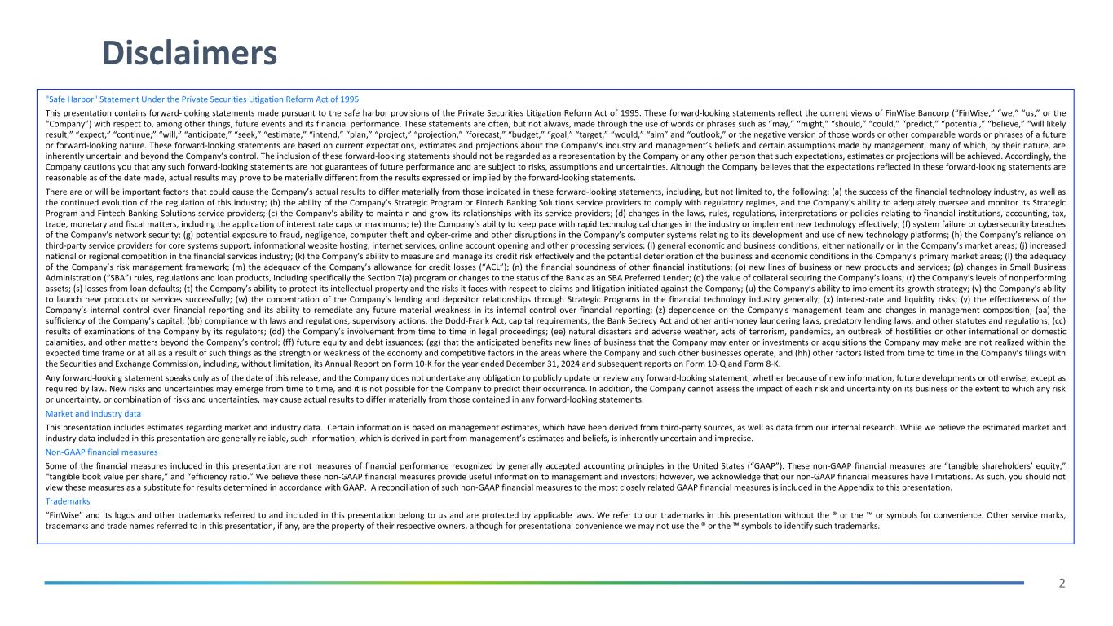
2 Disclaimers "Safe Harbor" Statement Under the Private Securities Litigation Reform Act of 1995 This presentation contains forward-looking statements made pursuant to the safe harbor provisions of the Private Securities Litigation Reform Act of 1995. These forward-looking statements reflect the current views of FinWise Bancorp (“FinWise,” “we,” “us,” or the “Company”) with respect to, among other things, future events and its financial performance. These statements are often, but not always, made through the use of words or phrases such as “may,” “might,” “should,” “could,” “predict,” “potential,” “believe,” “will likely result,” “expect,” “continue,” “will,” “anticipate,” “seek,” “estimate,” “intend,” “plan,” “project,” “projection,” “forecast,” “budget,” “goal,” “target,” “would,” “aim” and “outlook,” or the negative version of those words or other comparable words or phrases of a future or forward-looking nature. These forward-looking statements are based on current expectations, estimates and projections about the Company’s industry and management’s beliefs and certain assumptions made by management, many of which, by their nature, are inherently uncertain and beyond the Company’s control. The inclusion of these forward-looking statements should not be regarded as a representation by the Company or any other person that such expectations, estimates or projections will be achieved. Accordingly, the Company cautions you that any such forward-looking statements are not guarantees of future performance and are subject to risks, assumptions and uncertainties. Although the Company believes that the expectations reflected in these forward-looking statements are reasonable as of the date made, actual results may prove to be materially different from the results expressed or implied by the forward-looking statements. There are or will be important factors that could cause the Company’s actual results to differ materially from those indicated in these forward-looking statements, including, but not limited to, the following: (a) the success of the financial technology industry, as well as the continued evolution of the regulation of this industry; (b) the ability of the Company’s Strategic Program or Fintech Banking Solutions service providers to comply with regulatory regimes, and the Company’s ability to adequately oversee and monitor its Strategic Program and Fintech Banking Solutions service providers; (c) the Company’s ability to maintain and grow its relationships with its service providers; (d) changes in the laws, rules, regulations, interpretations or policies relating to financial institutions, accounting, tax, trade, monetary and fiscal matters, including the application of interest rate caps or maximums; (e) the Company’s ability to keep pace with rapid technological changes in the industry or implement new technology effectively; (f) system failure or cybersecurity breaches of the Company’s network security; (g) potential exposure to fraud, negligence, computer theft and cyber-crime and other disruptions in the Company’s computer systems relating to its development and use of new technology platforms; (h) the Company’s reliance on third-party service providers for core systems support, informational website hosting, internet services, online account opening and other processing services; (i) general economic and business conditions, either nationally or in the Company’s market areas; (j) increased national or regional competition in the financial services industry; (k) the Company’s ability to measure and manage its credit risk effectively and the potential deterioration of the business and economic conditions in the Company’s primary market areas; (l) the adequacy of the Company’s risk management framework; (m) the adequacy of the Company’s allowance for credit losses (“ACL”); (n) the financial soundness of other financial institutions; (o) new lines of business or new products and services; (p) changes in Small Business Administration (“SBA”) rules, regulations and loan products, including specifically the Section 7(a) program or changes to the status of the Bank as an SBA Preferred Lender; (q) the value of collateral securing the Company’s loans; (r) the Company’s levels of nonperforming assets; (s) losses from loan defaults; (t) the Company’s ability to protect its intellectual property and the risks it faces with respect to claims and litigation initiated against the Company; (u) the Company’s ability to implement its growth strategy; (v) the Company’s ability to launch new products or services successfully; (w) the concentration of the Company’s lending and depositor relationships through Strategic Programs in the financial technology industry generally; (x) interest-rate and liquidity risks; (y) the effectiveness of the Company’s internal control over financial reporting and its ability to remediate any future material weakness in its internal control over financial reporting; (z) dependence on the Company's management team and changes in management composition; (aa) the sufficiency of the Company’s capital; (bb) compliance with laws and regulations, supervisory actions, the Dodd-Frank Act, capital requirements, the Bank Secrecy Act and other anti-money laundering laws, predatory lending laws, and other statutes and regulations; (cc) results of examinations of the Company by its regulators; (dd) the Company’s involvement from time to time in legal proceedings; (ee) natural disasters and adverse weather, acts of terrorism, pandemics, an outbreak of hostilities or other international or domestic calamities, and other matters beyond the Company’s control; (ff) future equity and debt issuances; (gg) that the anticipated benefits new lines of business that the Company may enter or investments or acquisitions the Company may make are not realized within the expected time frame or at all as a result of such things as the strength or weakness of the economy and competitive factors in the areas where the Company and such other businesses operate; and (hh) other factors listed from time to time in the Company’s filings with the Securities and Exchange Commission, including, without limitation, its Annual Report on Form 10-K for the year ended December 31, 2024 and subsequent reports on Form 10-Q and Form 8-K. Any forward-looking statement speaks only as of the date of this release, and the Company does not undertake any obligation to publicly update or review any forward-looking statement, whether because of new information, future developments or otherwise, except as required by law. New risks and uncertainties may emerge from time to time, and it is not possible for the Company to predict their occurrence. In addition, the Company cannot assess the impact of each risk and uncertainty on its business or the extent to which any risk or uncertainty, or combination of risks and uncertainties, may cause actual results to differ materially from those contained in any forward-looking statements. Market and industry data This presentation includes estimates regarding market and industry data. Certain information is based on management estimates, which have been derived from third-party sources, as well as data from our internal research. While we believe the estimated market and industry data included in this presentation are generally reliable, such information, which is derived in part from management’s estimates and beliefs, is inherently uncertain and imprecise. Non-GAAP financial measures Some of the financial measures included in this presentation are not measures of financial performance recognized by generally accepted accounting principles in the United States (“GAAP”). These non-GAAP financial measures are “tangible shareholders’ equity,” “tangible book value per share,” and “efficiency ratio.” We believe these non-GAAP financial measures provide useful information to management and investors; however, we acknowledge that our non-GAAP financial measures have limitations. As such, you should not view these measures as a substitute for results determined in accordance with GAAP. A reconciliation of such non-GAAP financial measures to the most closely related GAAP financial measures is included in the Appendix to this presentation. Trademarks “FinWise” and its logos and other trademarks referred to and included in this presentation belong to us and are protected by applicable laws. We refer to our trademarks in this presentation without the ® or the ™ or symbols for convenience. Other service marks, trademarks and trade names referred to in this presentation, if any, are the property of their respective owners, although for presentational convenience we may not use the ® or the ™ symbols to identify such trademarks.

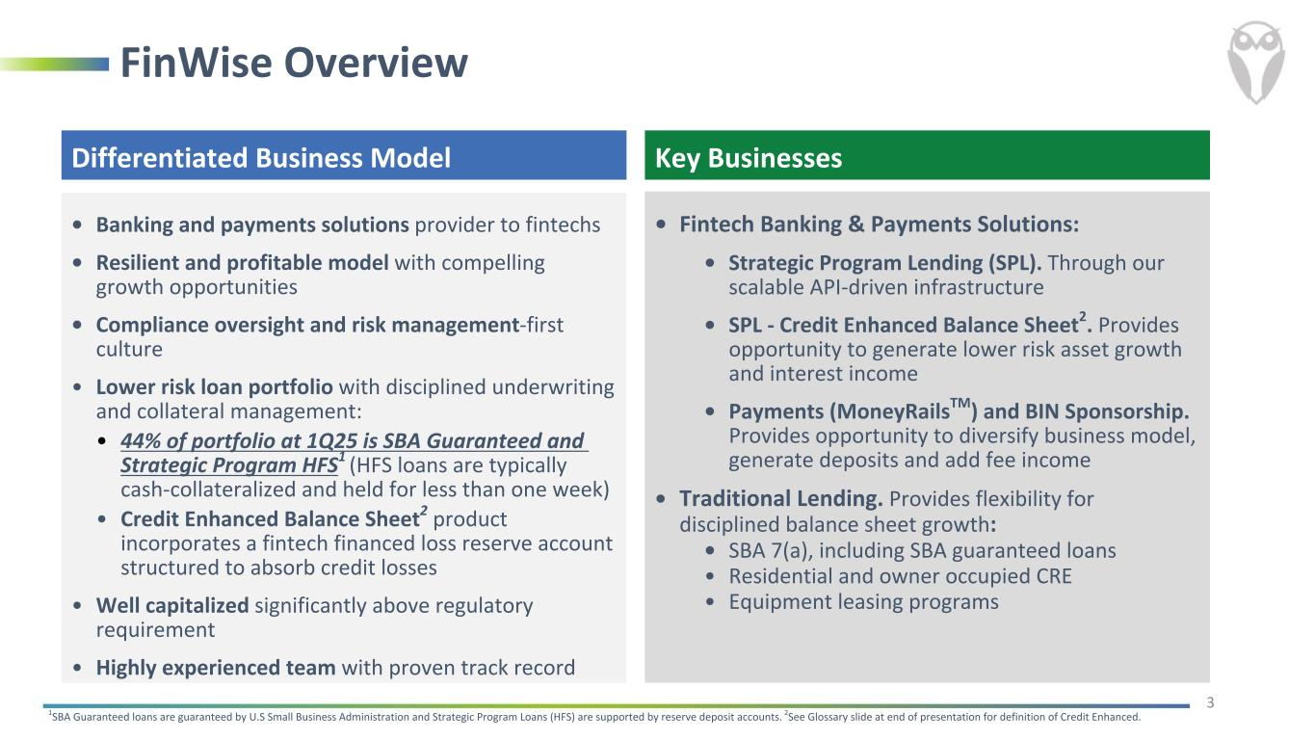
FinWise Overview Differentiated Business Model • Banking and payments solutions provider to fintechs • Resilient and profitable model with compelling growth opportunities • Compliance oversight and risk management-first culture • Lower risk loan portfolio with disciplined underwriting and collateral management: • 44% of portfolio at 1Q25 is SBA Guaranteed and Strategic Program HFS1 (HFS loans are typically cash-collateralized and held for less than one week) • Credit Enhanced Balance Sheet2 product incorporates a fintech financed loss reserve account structured to absorb credit losses • Well capitalized significantly above regulatory requirement • Highly experienced team with proven track record 1SBA Guaranteed loans are guaranteed by U.S Small Business Administration and Strategic Program Loans (HFS) are supported by reserve deposit accounts. 2See Glossary slide at end of presentation for definition of Credit Enhanced. 3 • Fintech Banking & Payments Solutions: • Strategic Program Lending (SPL). Through our scalable API-driven infrastructure • SPL - Credit Enhanced Balance Sheet2. Provides opportunity to generate lower risk asset growth and interest income • Payments (MoneyRailsTM) and BIN Sponsorship. Provides opportunity to diversify business model, generate deposits and add fee income • Traditional Lending. Provides flexibility for disciplined balance sheet growth: • SBA 7(a), including SBA guaranteed loans • Residential and owner occupied CRE • Equipment leasing programs Key Businesses

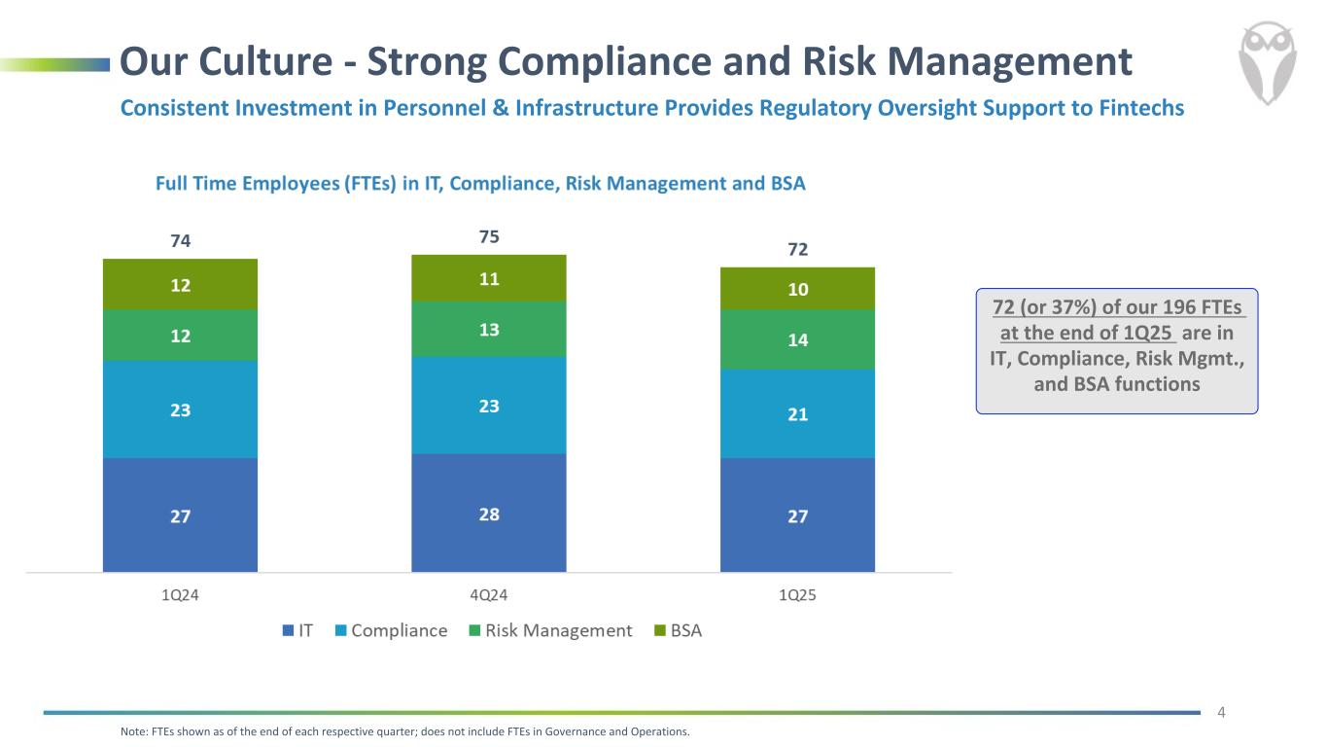
Our Culture - Strong Compliance and Risk Management 4 Consistent Investment in Personnel & Infrastructure Provides Regulatory Oversight Support to Fintechs Note: FTEs shown as of the end of each respective quarter; does not include FTEs in Governance and Operations. 72 (or 37%) of our 196 FTEs at the end of 1Q25 are in IT, Compliance, Risk Mgmt., and BSA functions

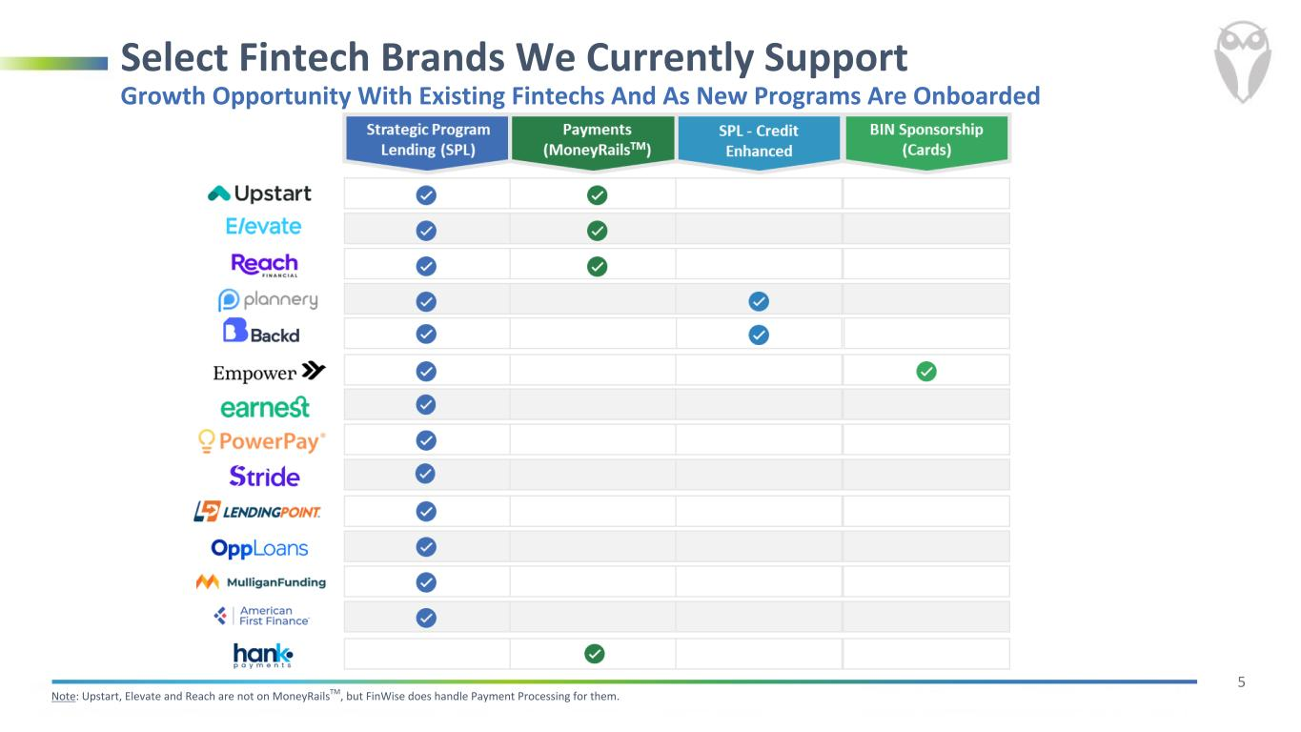
5 Select Fintech Brands We Currently Support Note: Upstart, Elevate and Reach are not on MoneyRailsTM, but FinWise does handle Payment Processing for them. Growth Opportunity With Existing Fintechs And As New Programs Are Onboarded

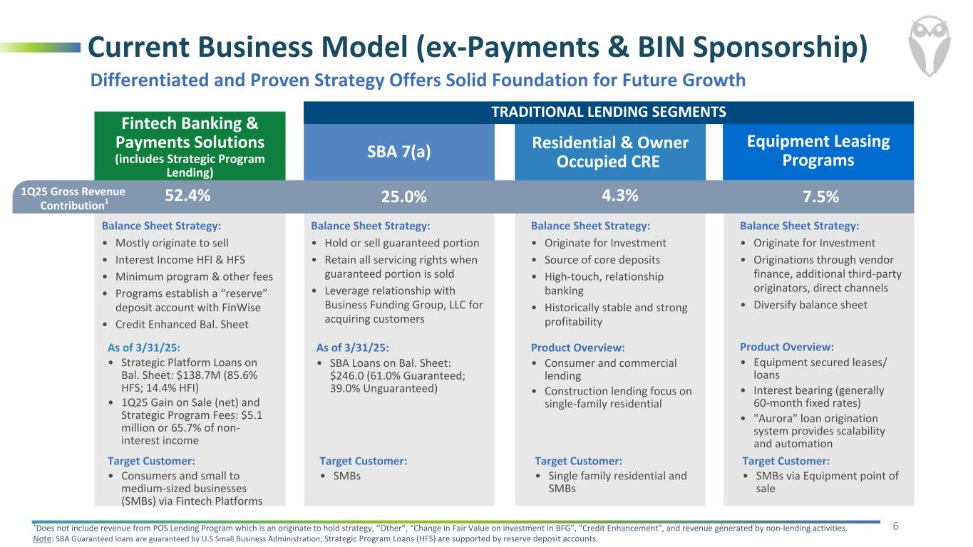
Equipment Leasing Programs Balance Sheet Strategy: • Originate for Investment • Originations through vendor finance, additional third-party originators, direct channels • Diversify balance sheet Fintech Banking & Payments Solutions (includes Strategic Program Lending) Balance Sheet Strategy: • Mostly originate to sell • Interest Income HFI & HFS • Minimum program & other fees • Programs establish a “reserve” deposit account with FinWise • Credit Enhanced Bal. Sheet SBA 7(a) Balance Sheet Strategy: • Hold or sell guaranteed portion • Retain all servicing rights when guaranteed portion is sold • Leverage relationship with Business Funding Group, LLC for acquiring customers Residential & Owner Occupied CRE Balance Sheet Strategy: • Originate for Investment • Source of core deposits • High-touch, relationship banking • Historically stable and strong profitability Current Business Model (ex-Payments & BIN Sponsorship) 1Q25 Gross Revenue Contribution1 1Does not include revenue from POS Lending Program which is an originate to hold strategy, “Other”, “Change in Fair Value on investment in BFG”, "Credit Enhancement", and revenue generated by non-lending activities. Note: SBA Guaranteed loans are guaranteed by U.S Small Business Administration; Strategic Program Loans (HFS) are supported by reserve deposit accounts. 52.4% 25.0% 4.3% 6 7.5% Differentiated and Proven Strategy Offers Solid Foundation for Future Growth As of 3/31/25: • Strategic Platform Loans on Bal. Sheet: $138.7M (85.6% HFS; 14.4% HFI) • 1Q25 Gain on Sale (net) and Strategic Program Fees: $5.1 million or 65.7% of non- interest income As of 3/31/25: • SBA Loans on Bal. Sheet: $246.0 (61.0% Guaranteed; 39.0% Unguaranteed) Product Overview: • Consumer and commercial lending • Construction lending focus on single-family residential Product Overview: • Equipment secured leases/ loans • Interest bearing (generally 60-month fixed rates) • "Aurora" loan origination system provides scalability and automation Target Customer: • Consumers and small to medium-sized businesses (SMBs) via Fintech Platforms Target Customer: • SMBs Target Customer: • Single family residential and SMBs Target Customer: • SMBs via Equipment point of sale TRADITIONAL LENDING SEGMENTS

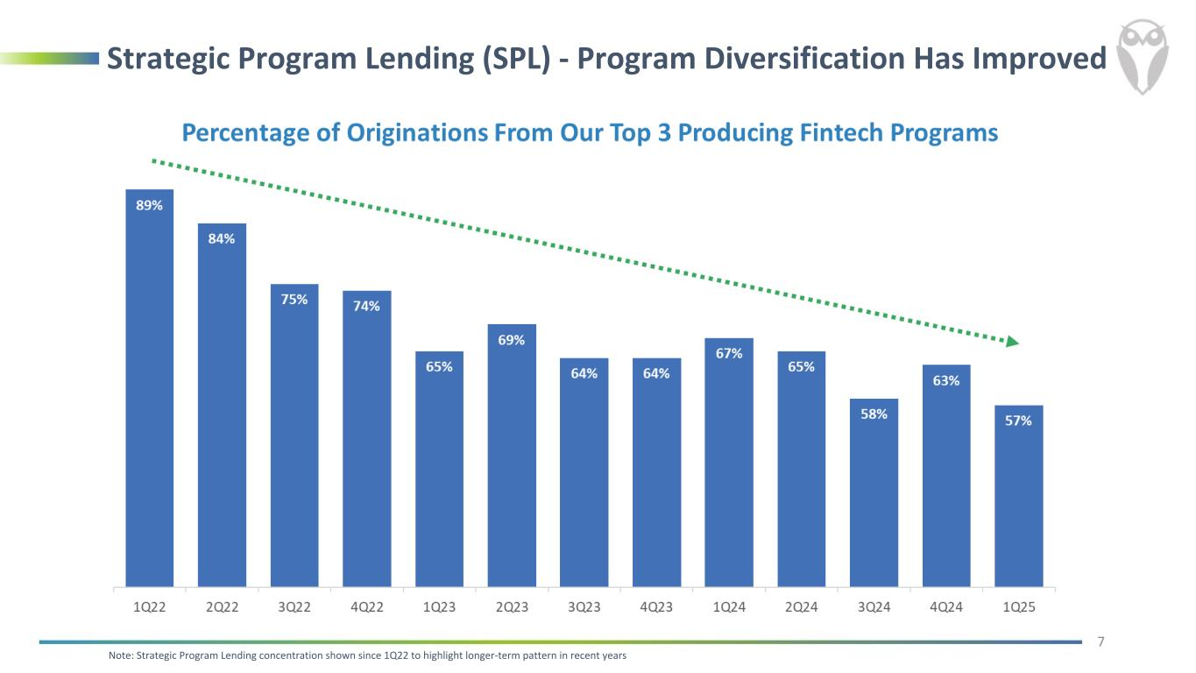
Strategic Program Lending (SPL) - Program Diversification Has Improved Note: Strategic Program Lending concentration shown since 1Q22 to highlight longer-term pattern in recent years 7

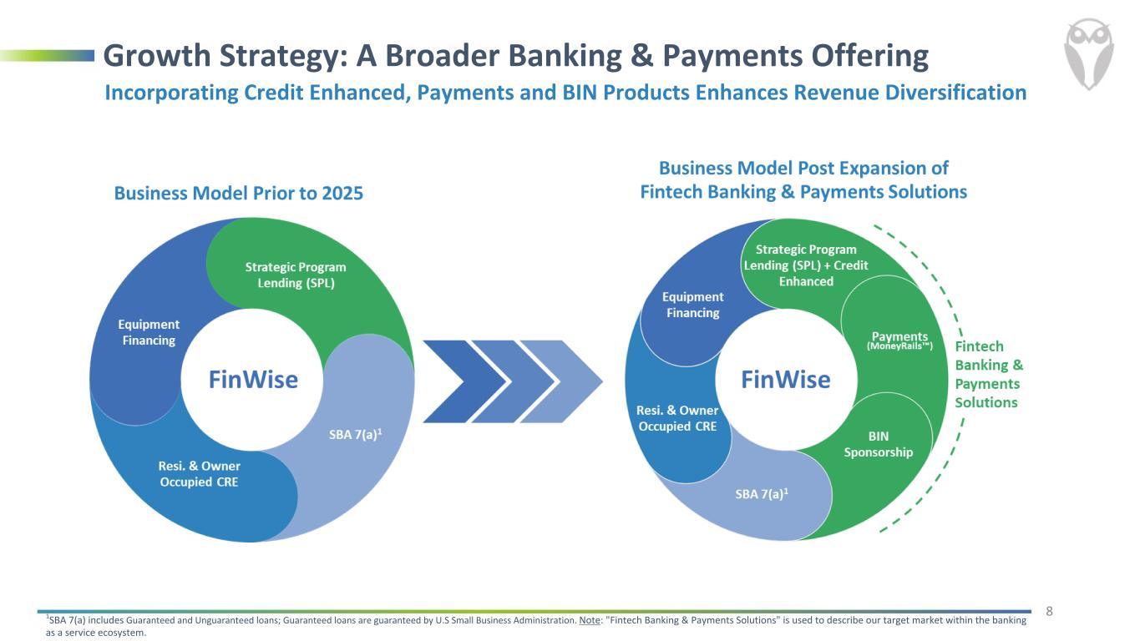
Growth Strategy: A Broader Banking & Payments Offering 1SBA 7(a) includes Guaranteed and Unguaranteed loans; Guaranteed loans are guaranteed by U.S Small Business Administration. Note: "Fintech Banking & Payments Solutions" is used to describe our target market within the banking as a service ecosystem. 8 Strategic Program Lending (SPL) SBA 7(a)1 Resi. & Owner Occupied CRE Equipment Financing BIN Sponsorship Strategic Program Lending (SPL) + Credit Enhancement SBA 7(a)1 Equipment Financing Resi. & Owner Occupied CRE Incorporating Credit Enhanced, Payments and BIN Products Enhances Revenue Diversification Payments (MoneyRails™)

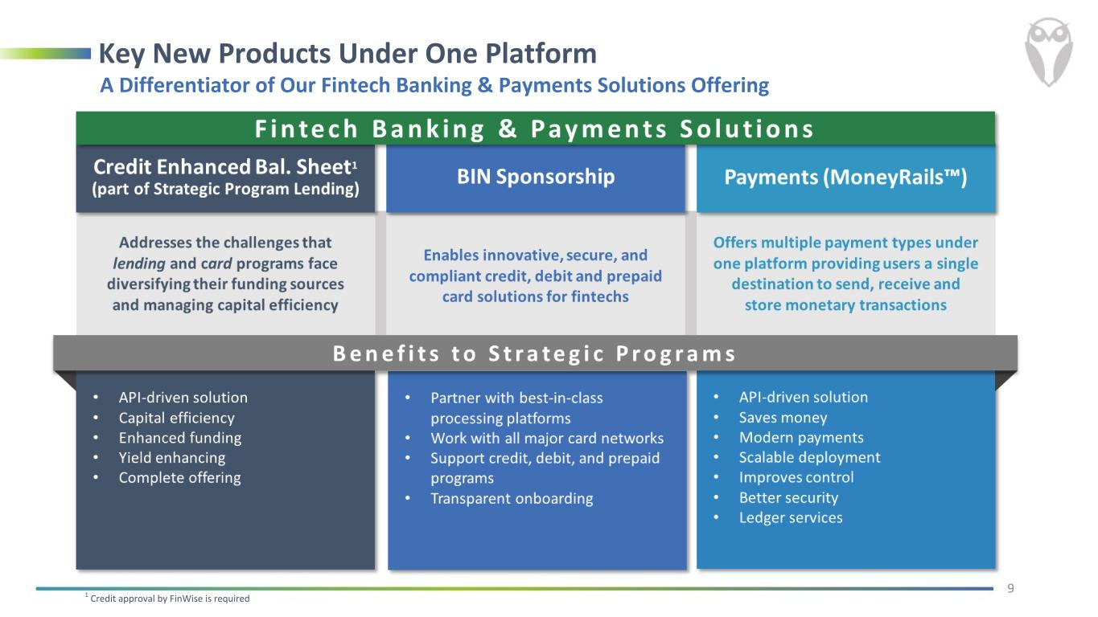
Key New Products Under One Platform 1 Credit approval by FinWise is required 9 A Differentiator of Our Fintech Banking & Payments Solutions Offering

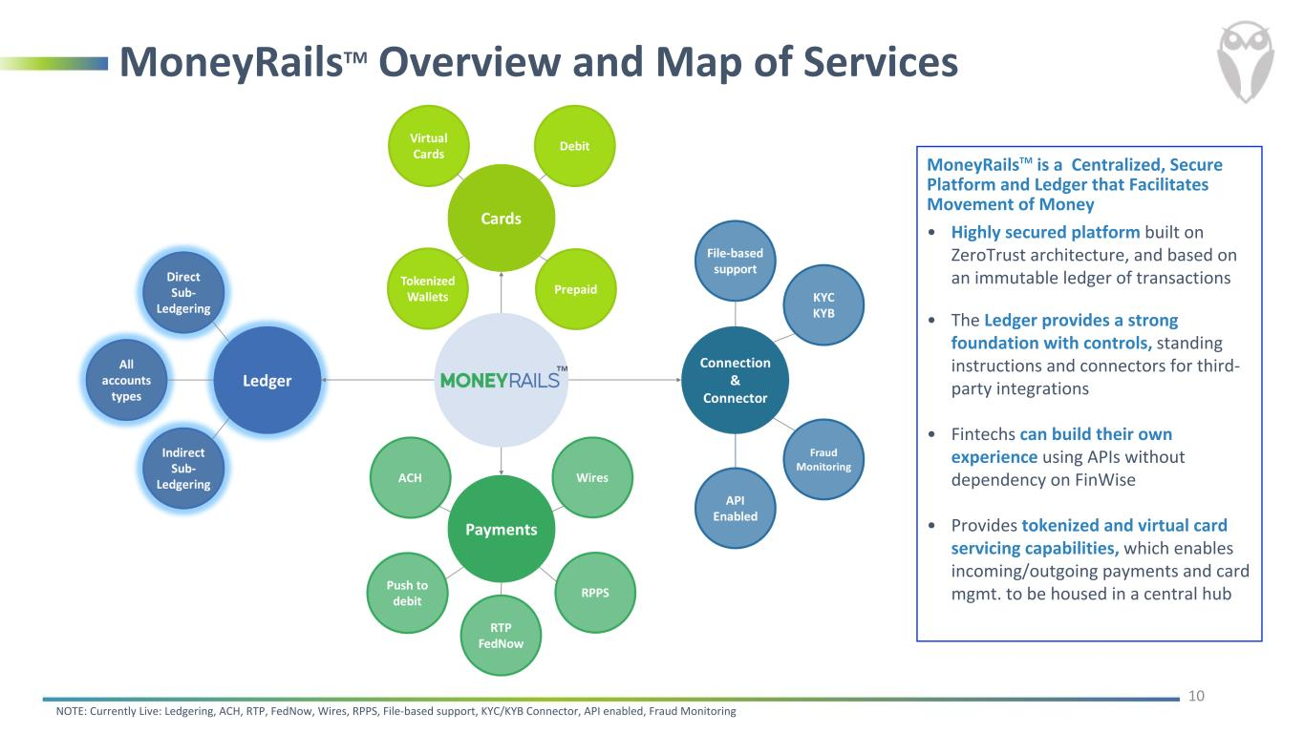
MoneyRailsTM Overview and Map of Services 10 MoneyRailsTM is a Centralized, Secure Platform and Ledger that Facilitates Movement of Money • Highly secured platform built on ZeroTrust architecture, and based on an immutable ledger of transactions • The Ledger provides a strong foundation with controls, standing instructions and connectors for third- party integrations • Fintechs can build their own experience using APIs without dependency on FinWise • Provides tokenized and virtual card servicing capabilities, which enables incoming/outgoing payments and card mgmt. to be housed in a central hub NOTE: Currently Live: Ledgering, ACH, RTP, FedNow, Wires, RPPS, File-based support, KYC/KYB Connector, API enabled, Fraud Monitoring

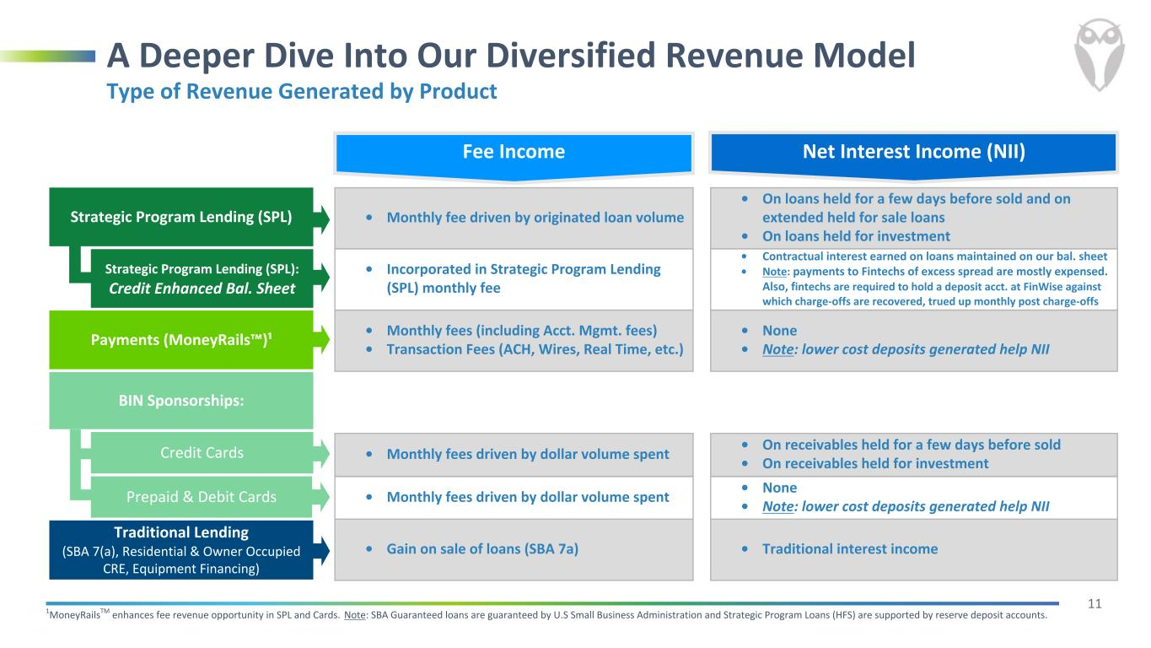
11 Interest Income • Monthly fee driven by originated loan volume • On loans held for a few days before sold and on extended held for sale loans • On loans held for investment • Incorporated in Strategic Program Lending (SPL) monthly fee • Contractual interest earned on loans maintained on our bal. sheet • Note: payments to Fintechs of excess spread are mostly expensed. Also, fintechs are required to hold a deposit acct. at FinWise against which charge-offs are recovered, trued up monthly post charge-offs • Monthly fees (including Acct. Mgmt. fees) • Transaction Fees (ACH, Wires, Real Time, etc.) • None • Note: lower cost deposits generated help NII • Monthly fees driven by dollar volume spent • On receivables held for a few days before sold • On receivables held for investment • Monthly fees driven by dollar volume spent • None • Note: lower cost deposits generated help NII • Gain on sale of loans (SBA 7a) • Traditional interest income 1MoneyRailsTM enhances fee revenue opportunity in SPL and Cards. Note: SBA Guaranteed loans are guaranteed by U.S Small Business Administration and Strategic Program Loans (HFS) are supported by reserve deposit accounts. A Deeper Dive Into Our Diversified Revenue Model Strategic Program Lending (SPL) Payments (MoneyRails™)¹ Credit Cards Traditional Lending (SBA 7(a), Residential & Owner Occupied CRE, Equipment Financing) Strategic Program Lending (SPL): Credit Enhanced Bal. Sheet Prepaid & Debit Cards Type of Revenue Generated by Product BIN Sponsorships: Net Interest Income (NII)Fee Income

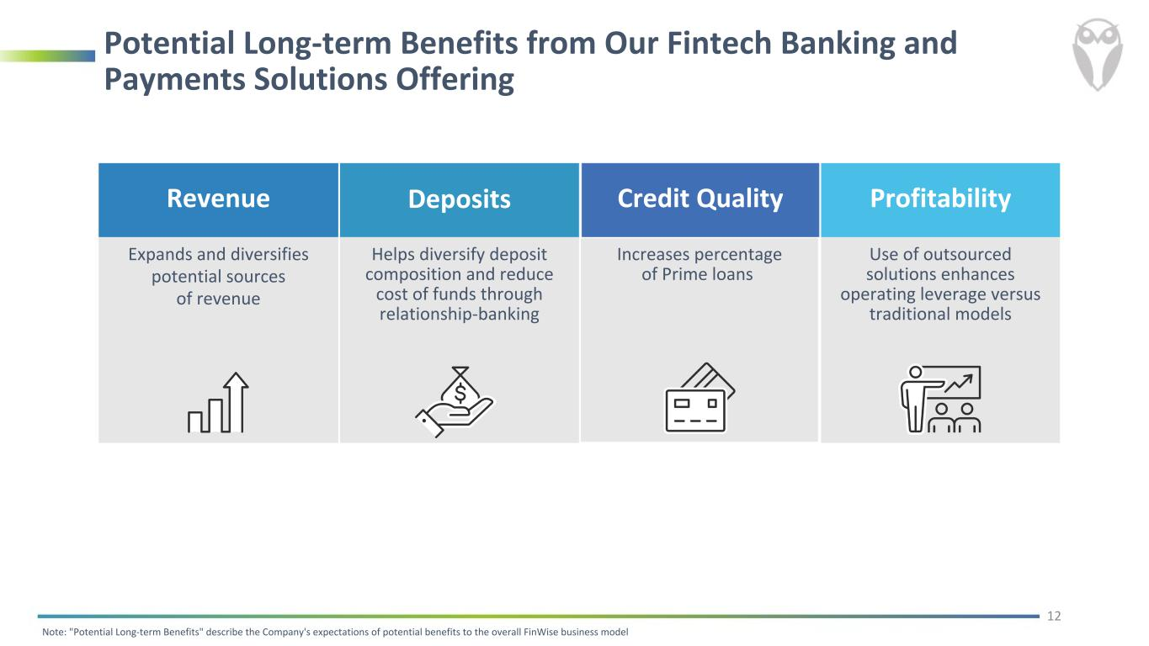
Potential Long-term Benefits from Our Fintech Banking and Payments Solutions Offering Revenue Expands and diversifies potential sources of revenue Deposits Helps diversify deposit composition and reduce cost of funds through relationship-banking Credit Quality Increases percentage of Prime loans Profitability Use of outsourced solutions enhances operating leverage versus traditional models Note: "Potential Long-term Benefits" describe the Company's expectations of potential benefits to the overall FinWise business model 12

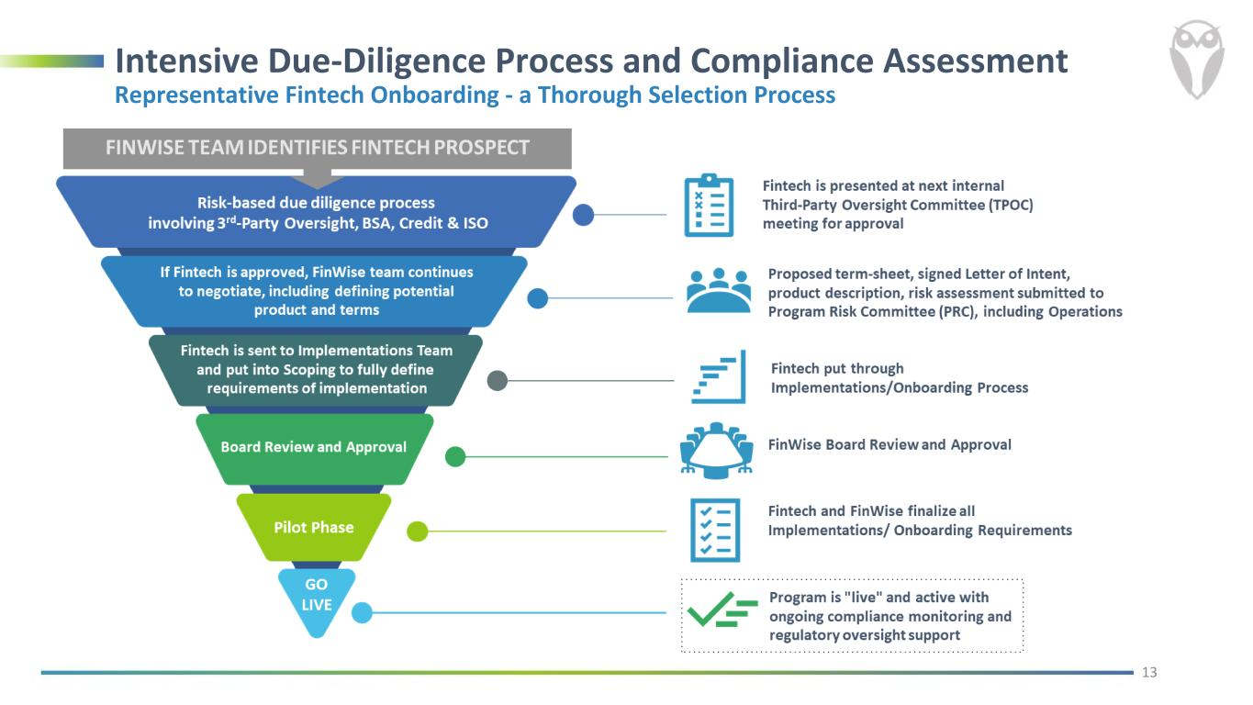
Intensive Due-Diligence Process and Compliance Assessment Representative Fintech Onboarding - a Thorough Selection Process 13

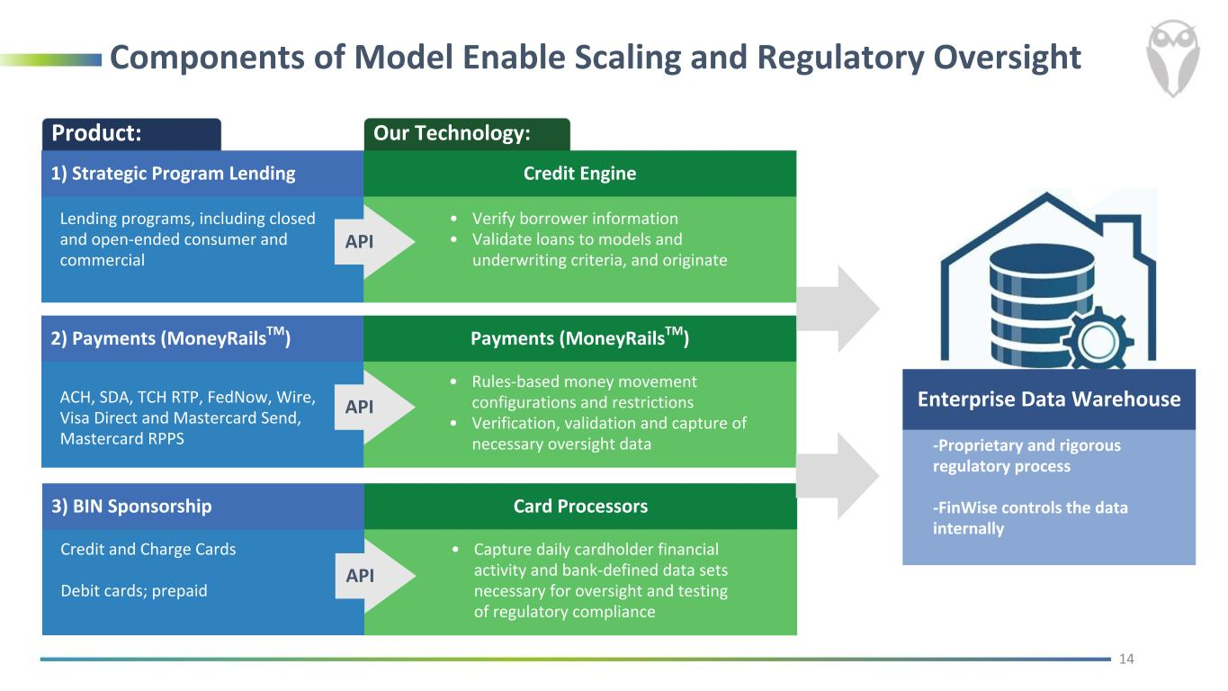
Components of Model Enable Scaling and Regulatory Oversight Our Technology:Product: Enterprise Data Warehouse -Proprietary and rigorous regulatory process -FinWise controls the data internally Lending programs, including closed and open-ended consumer and commercial • Verify borrower information • Validate loans to models and underwriting criteria, and originate API 2) Payments (MoneyRailsTM) Payments (MoneyRailsTM) ACH, SDA, TCH RTP, FedNow, Wire, Visa Direct and Mastercard Send, Mastercard RPPS • Rules-based money movement configurations and restrictions • Verification, validation and capture of necessary oversight data API 3) BIN Sponsorship Card Processors Credit and Charge Cards Debit cards; prepaid • Capture daily cardholder financial activity and bank-defined data sets necessary for oversight and testing of regulatory compliance API 14 1) Strategic Program Lending Credit Engine

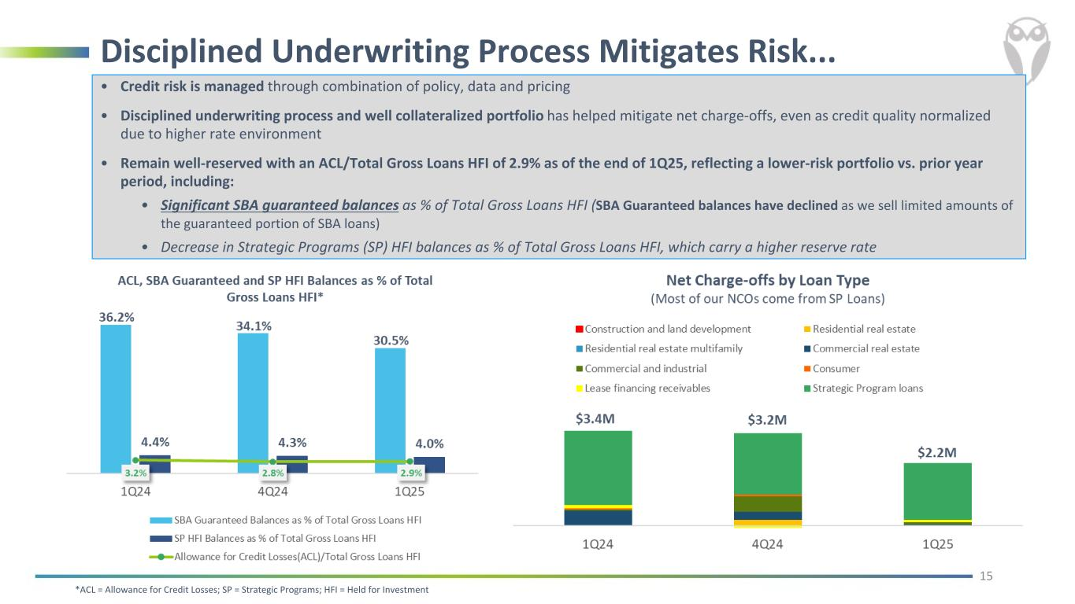
Disciplined Underwriting Process Mitigates Risk... • Credit risk is managed through combination of policy, data and pricing • Disciplined underwriting process and well collateralized portfolio has helped mitigate net charge-offs, even as credit quality normalized due to higher rate environment • Remain well-reserved with an ACL/Total Gross Loans HFI of 2.9% as of the end of 1Q25, reflecting a lower-risk portfolio vs. prior year period, including: • Significant SBA guaranteed balances as % of Total Gross Loans HFI (SBA Guaranteed balances have declined as we sell limited amounts of the guaranteed portion of SBA loans) • Decrease in Strategic Programs (SP) HFI balances as % of Total Gross Loans HFI, which carry a higher reserve rate 15 *ACL = Allowance for Credit Losses; SP = Strategic Programs; HFI = Held for Investment

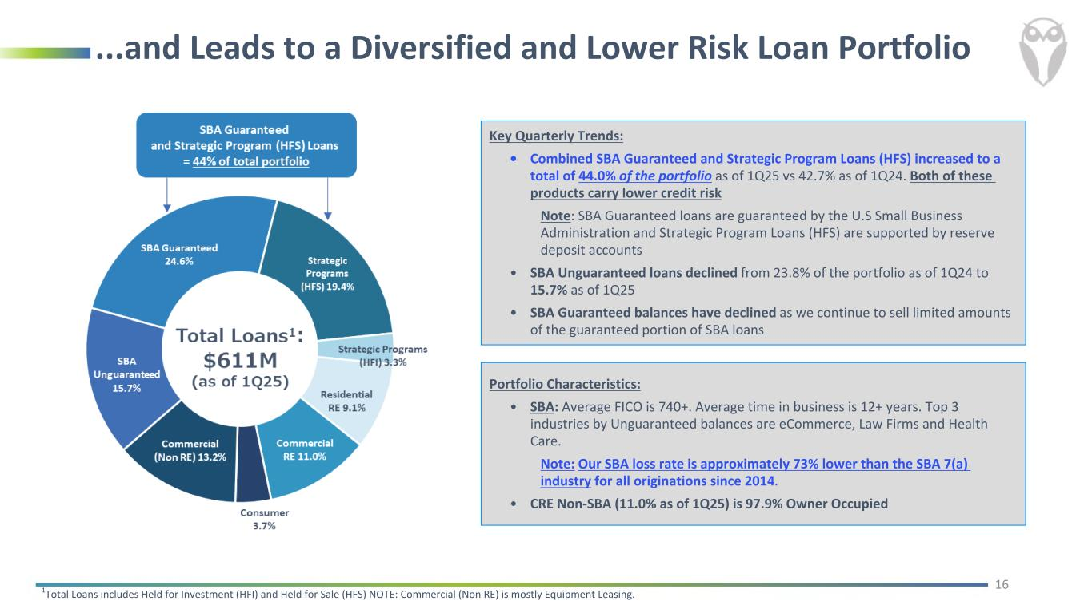
...and Leads to a Diversified and Lower Risk Loan Portfolio Key Quarterly Trends: • Combined SBA Guaranteed and Strategic Program Loans (HFS) increased to a total of 44.0% of the portfolio as of 1Q25 vs 42.7% as of 1Q24. Both of these products carry lower credit risk Note: SBA Guaranteed loans are guaranteed by the U.S Small Business Administration and Strategic Program Loans (HFS) are supported by reserve deposit accounts • SBA Unguaranteed loans declined from 23.8% of the portfolio as of 1Q24 to 15.7% as of 1Q25 • SBA Guaranteed balances have declined as we continue to sell limited amounts of the guaranteed portion of SBA loans 161Total Loans includes Held for Investment (HFI) and Held for Sale (HFS) NOTE: Commercial (Non RE) is mostly Equipment Leasing. Portfolio Characteristics: • SBA: Average FICO is 740+. Average time in business is 12+ years. Top 3 industries by Unguaranteed balances are eCommerce, Law Firms and Health Care. Note: Our SBA loss rate is approximately 73% lower than the SBA 7(a) industry for all originations since 2014. • CRE Non-SBA (11.0% as of 1Q25) is 97.9% Owner Occupied

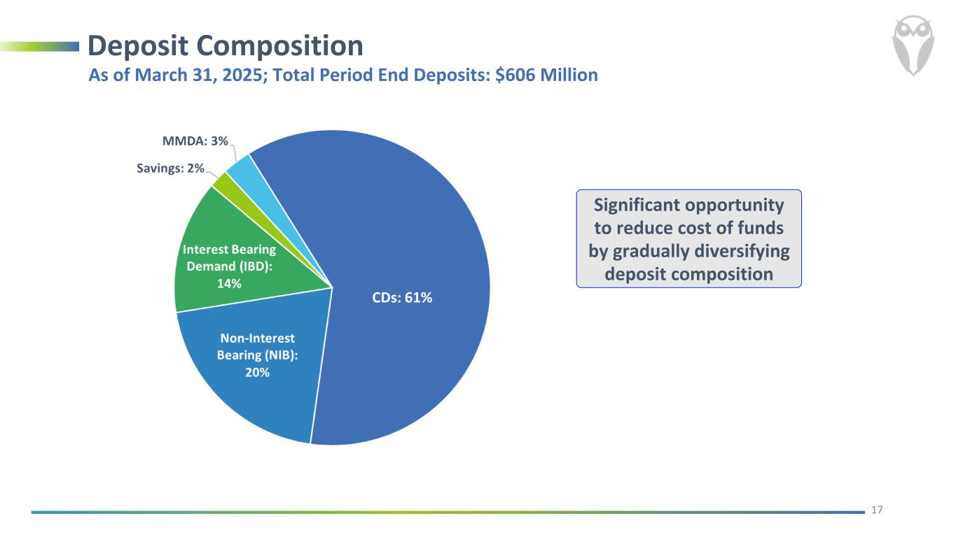
Deposit Composition 17 As of March 31, 2025; Total Period End Deposits: $606 Million Significant opportunity to reduce cost of funds by gradually diversifying deposit composition

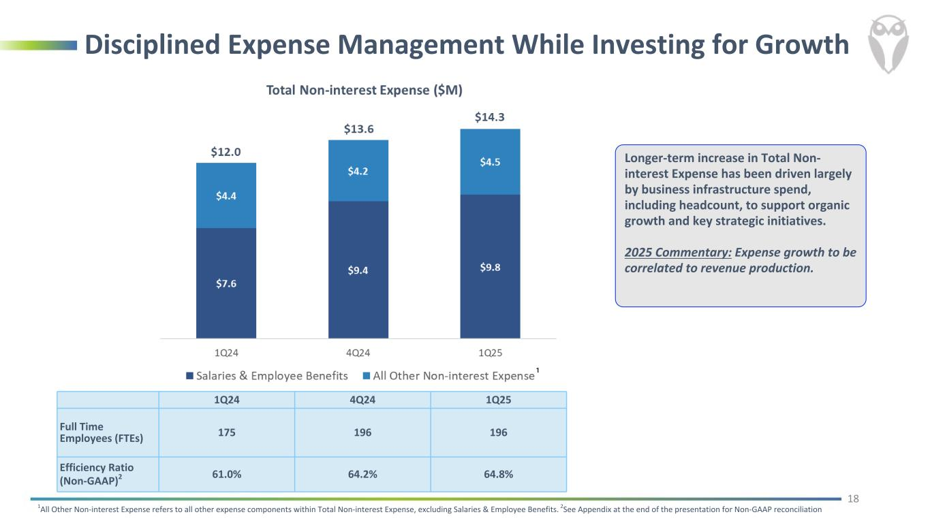
Disciplined Expense Management While Investing for Growth Longer-term increase in Total Non- interest Expense has been driven largely by business infrastructure spend, including headcount, to support organic growth and key strategic initiatives. 2025 Commentary: Expense growth to be correlated to revenue production. 18 1Q24 4Q24 1Q25 Full Time Employees (FTEs) 175 196 196 Efficiency Ratio (Non-GAAP)2 61.0% 64.2% 64.8% 1All Other Non-interest Expense refers to all other expense components within Total Non-interest Expense, excluding Salaries & Employee Benefits. 2See Appendix at the end of the presentation for Non-GAAP reconciliation

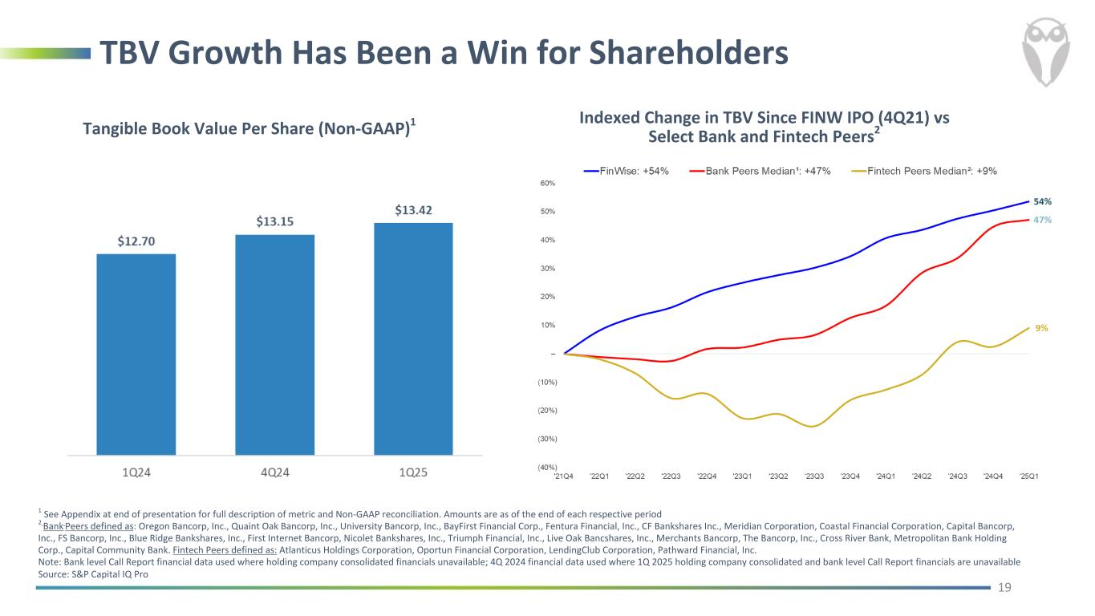
TBV Growth Has Been a Win for Shareholders Tangible Book Value Per Share (Non-GAAP)1 19 1 See Appendix at end of presentation for full description of metric and Non-GAAP reconciliation. Amounts are as of the end of each respective period 2 Bank Peers defined as: Oregon Bancorp, Inc., Quaint Oak Bancorp, Inc., University Bancorp, Inc., BayFirst Financial Corp., Fentura Financial, Inc., CF Bankshares Inc., Meridian Corporation, Coastal Financial Corporation, Capital Bancorp, Inc., FS Bancorp, Inc., Blue Ridge Bankshares, Inc., First Internet Bancorp, Nicolet Bankshares, Inc., Triumph Financial, Inc., Live Oak Bancshares, Inc., Merchants Bancorp, The Bancorp, Inc., Cross River Bank, Metropolitan Bank Holding Corp., Capital Community Bank. Fintech Peers defined as: Atlanticus Holdings Corporation, Oportun Financial Corporation, LendingClub Corporation, Pathward Financial, Inc. Note: Bank level Call Report financial data used where holding company consolidated financials unavailable; 4Q 2024 financial data used where 1Q 2025 holding company consolidated and bank level Call Report financials are unavailable Source: S&P Capital IQ Pro Indexed Change in TBV Since FINW IPO (4Q21) vs Select Bank and Fintech Peers2

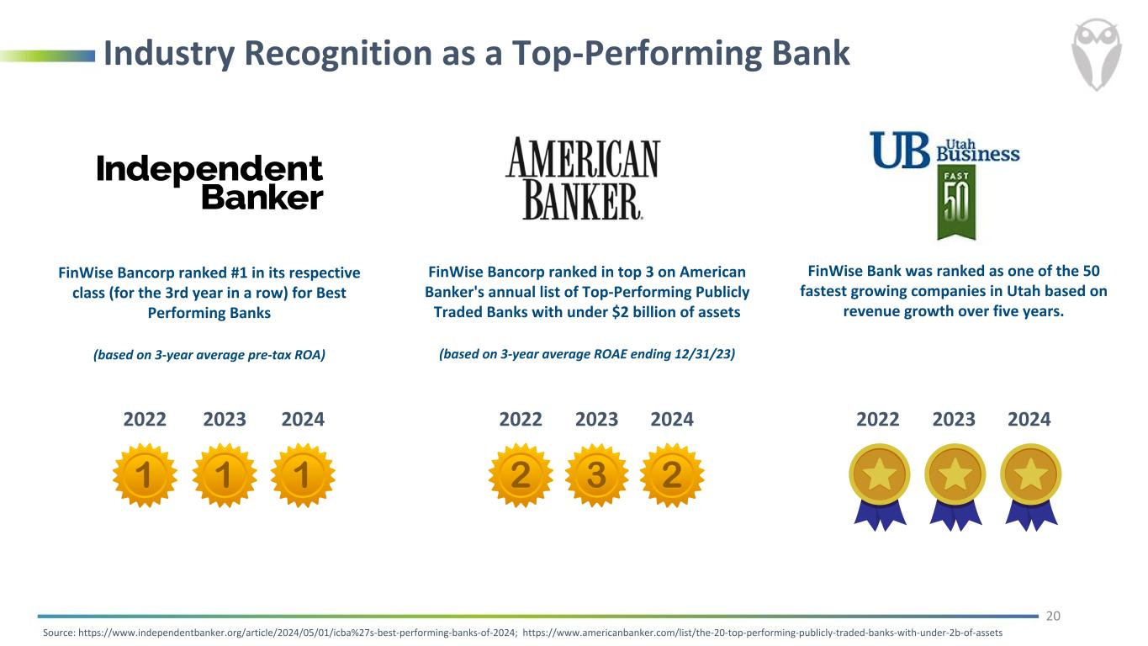
Industry Recognition as a Top-Performing Bank 20 FinWise Bancorp ranked in top 3 on American Banker's annual list of Top-Performing Publicly Traded Banks with under $2 billion of assets (based on 3-year average ROAE ending 12/31/23) 2022 2023 2022 2023 20242024 Source: https://www.independentbanker.org/article/2024/05/01/icba%27s-best-performing-banks-of-2024; https://www.americanbanker.com/list/the-20-top-performing-publicly-traded-banks-with-under-2b-of-assets FinWise Bancorp ranked #1 in its respective class (for the 3rd year in a row) for Best Performing Banks (based on 3-year average pre-tax ROA) FinWise Bank was ranked as one of the 50 fastest growing companies in Utah based on revenue growth over five years. 2022 2023 2024

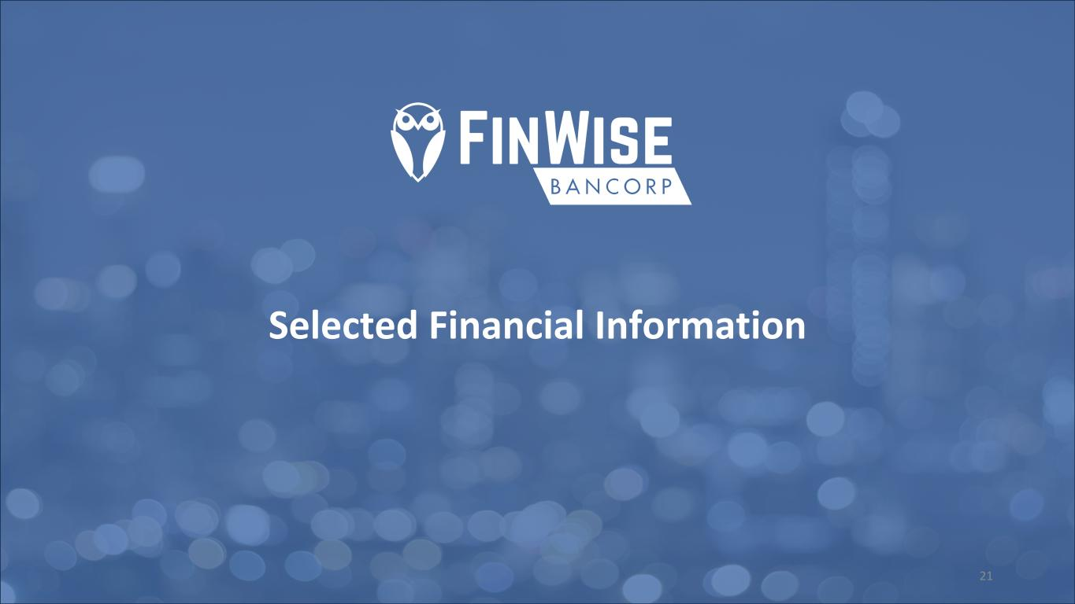
Selected Financial Information 21

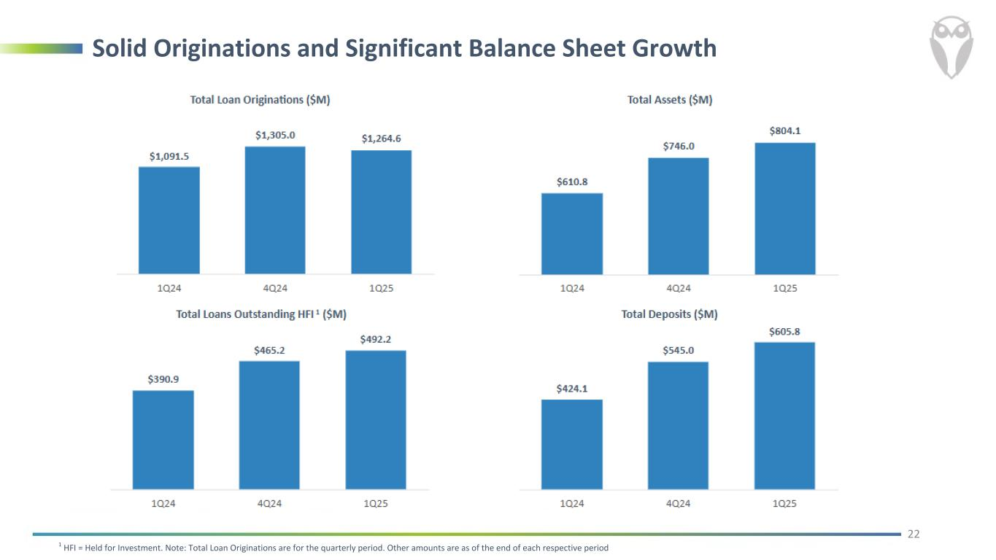
Solid Originations and Significant Balance Sheet Growth 22 1 HFI = Held for Investment. Note: Total Loan Originations are for the quarterly period. Other amounts are as of the end of each respective period

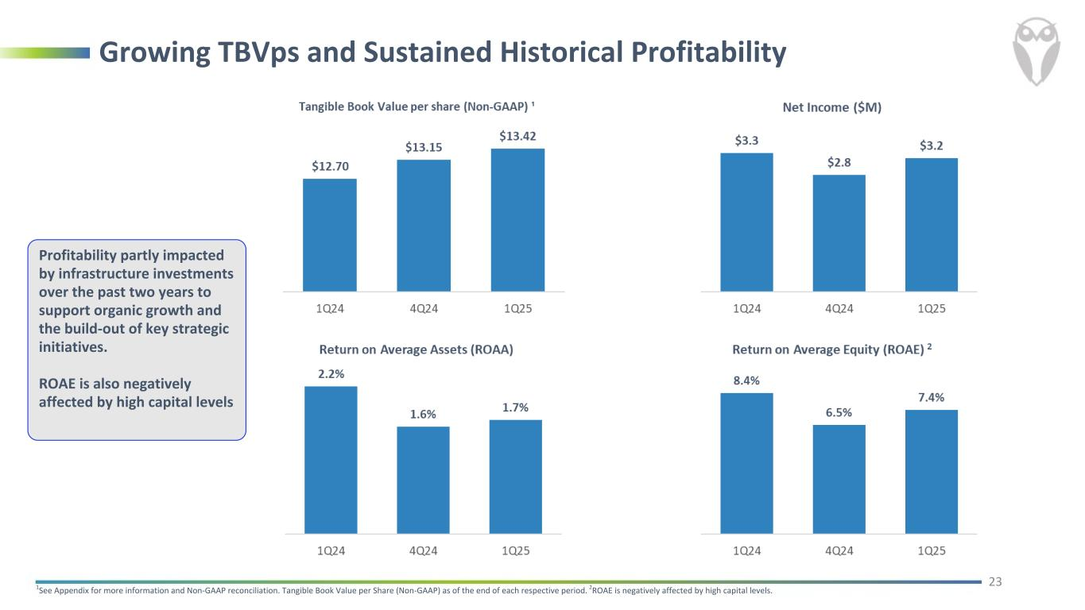
Growing TBVps and Sustained Historical Profitability 231See Appendix for more information and Non-GAAP reconciliation. Tangible Book Value per Share (Non-GAAP) as of the end of each respective period. 2ROAE is negatively affected by high capital levels. Profitability partly impacted by infrastructure investments over the past two years to support organic growth and the build-out of key strategic initiatives. ROAE is also negatively affected by high capital levels

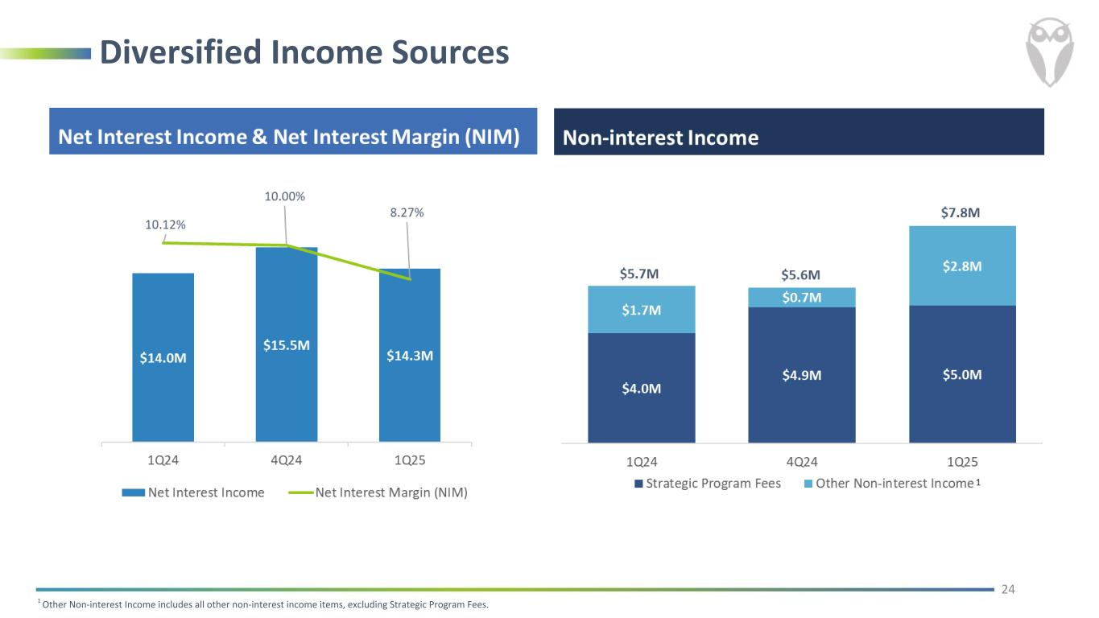
Diversified Income Sources 24 1 Other Non-interest Income includes all other non-interest income items, excluding Strategic Program Fees.

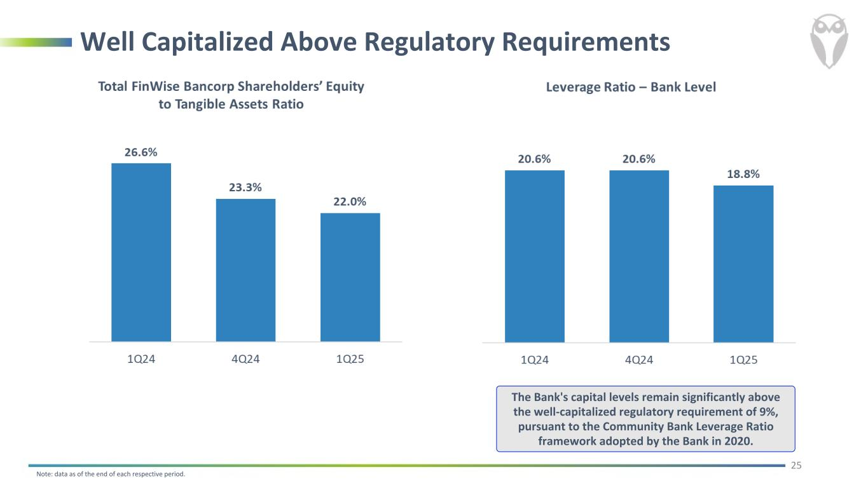
Well Capitalized Above Regulatory Requirements 25 Note: data as of the end of each respective period. The Bank's capital levels remain significantly above the well-capitalized regulatory requirement of 9%, pursuant to the Community Bank Leverage Ratio framework adopted by the Bank in 2020.

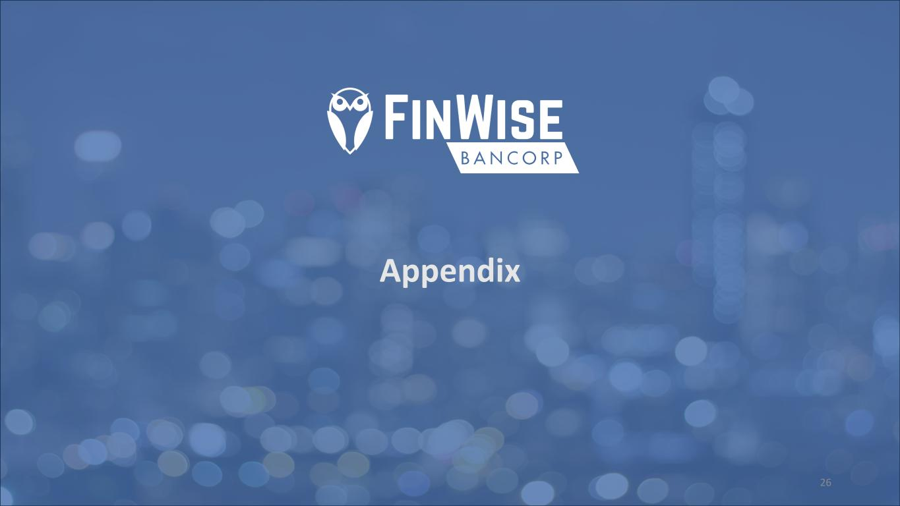
Appendix 26

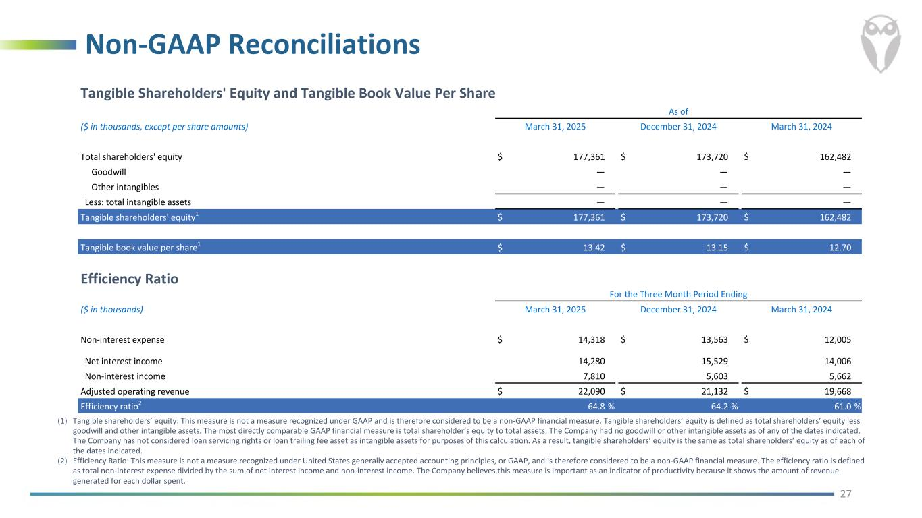
Non-GAAP Reconciliations 27 (1) Tangible shareholders’ equity: This measure is not a measure recognized under GAAP and is therefore considered to be a non-GAAP financial measure. Tangible shareholders’ equity is defined as total shareholders’ equity less goodwill and other intangible assets. The most directly comparable GAAP financial measure is total shareholder’s equity to total assets. The Company had no goodwill or other intangible assets as of any of the dates indicated. The Company has not considered loan servicing rights or loan trailing fee asset as intangible assets for purposes of this calculation. As a result, tangible shareholders’ equity is the same as total shareholders’ equity as of each of the dates indicated. (2) Efficiency Ratio: This measure is not a measure recognized under United States generally accepted accounting principles, or GAAP, and is therefore considered to be a non-GAAP financial measure. The efficiency ratio is defined as total non-interest expense divided by the sum of net interest income and non-interest income. The Company believes this measure is important as an indicator of productivity because it shows the amount of revenue generated for each dollar spent. Tangible Shareholders' Equity and Tangible Book Value Per Share As of ($ in thousands, except per share amounts) March 31, 2025 December 31, 2024 March 31, 2024 Total shareholders' equity $ 177,361 $ 173,720 $ 162,482 Goodwill — — — Other intangibles — — — Less: total intangible assets — — — Tangible shareholders' equity1 $ 177,361 $ 173,720 $ 162,482 Tangible book value per share1 $ 13.42 $ 13.15 $ 12.70 Efficiency Ratio For the Three Month Period Ending ($ in thousands) March 31, 2025 December 31, 2024 March 31, 2024 Non-interest expense $ 14,318 $ 13,563 $ 12,005 Net interest income 14,280 15,529 14,006 Non-interest income 7,810 5,603 5,662 Adjusted operating revenue $ 22,090 $ 21,132 $ 19,668 Efficiency ratio2 64.8 % 64.2 % 61.0 %

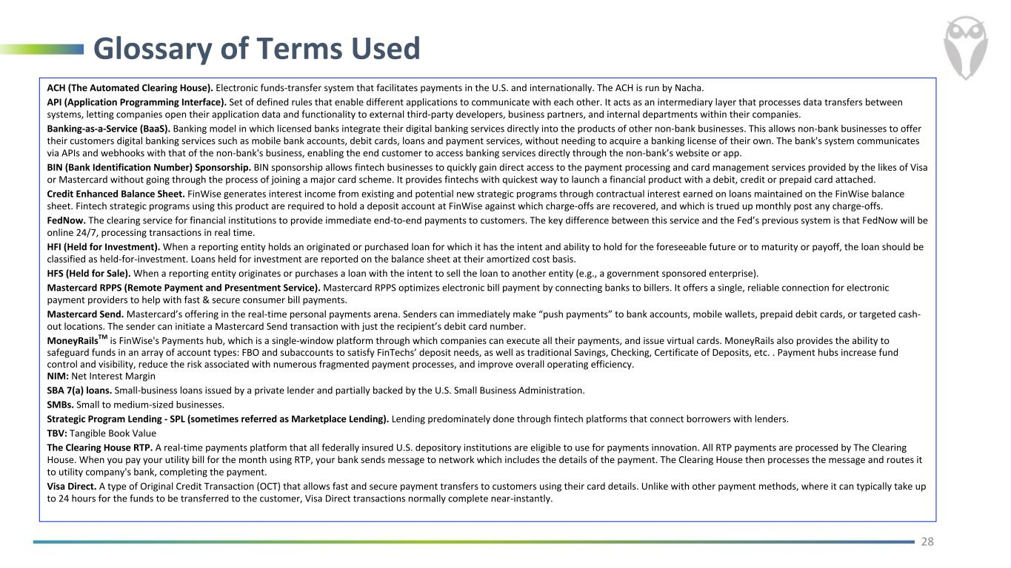
Glossary of Terms Used 28 ACH (The Automated Clearing House). Electronic funds-transfer system that facilitates payments in the U.S. and internationally. The ACH is run by Nacha. API (Application Programming Interface). Set of defined rules that enable different applications to communicate with each other. It acts as an intermediary layer that processes data transfers between systems, letting companies open their application data and functionality to external third-party developers, business partners, and internal departments within their companies. Banking-as-a-Service (BaaS). Banking model in which licensed banks integrate their digital banking services directly into the products of other non-bank businesses. This allows non-bank businesses to offer their customers digital banking services such as mobile bank accounts, debit cards, loans and payment services, without needing to acquire a banking license of their own. The bank's system communicates via APIs and webhooks with that of the non-bank's business, enabling the end customer to access banking services directly through the non-bank’s website or app. BIN (Bank Identification Number) Sponsorship. BIN sponsorship allows fintech businesses to quickly gain direct access to the payment processing and card management services provided by the likes of Visa or Mastercard without going through the process of joining a major card scheme. It provides fintechs with quickest way to launch a financial product with a debit, credit or prepaid card attached. Credit Enhanced Balance Sheet. FinWise generates interest income from existing and potential new strategic programs through contractual interest earned on loans maintained on the FinWise balance sheet. Fintech strategic programs using this product are required to hold a deposit account at FinWise against which charge-offs are recovered, and which is trued up monthly post any charge-offs. FedNow. The clearing service for financial institutions to provide immediate end-to-end payments to customers. The key difference between this service and the Fed’s previous system is that FedNow will be online 24/7, processing transactions in real time. HFI (Held for Investment). When a reporting entity holds an originated or purchased loan for which it has the intent and ability to hold for the foreseeable future or to maturity or payoff, the loan should be classified as held-for-investment. Loans held for investment are reported on the balance sheet at their amortized cost basis. HFS (Held for Sale). When a reporting entity originates or purchases a loan with the intent to sell the loan to another entity (e.g., a government sponsored enterprise). Mastercard RPPS (Remote Payment and Presentment Service). Mastercard RPPS optimizes electronic bill payment by connecting banks to billers. It offers a single, reliable connection for electronic payment providers to help with fast & secure consumer bill payments. Mastercard Send. Mastercard’s offering in the real-time personal payments arena. Senders can immediately make “push payments” to bank accounts, mobile wallets, prepaid debit cards, or targeted cash- out locations. The sender can initiate a Mastercard Send transaction with just the recipient’s debit card number. MoneyRailsTM is FinWise's Payments hub, which is a single-window platform through which companies can execute all their payments, and issue virtual cards. MoneyRails also provides the ability to safeguard funds in an array of account types: FBO and subaccounts to satisfy FinTechs’ deposit needs, as well as traditional Savings, Checking, Certificate of Deposits, etc. . Payment hubs increase fund control and visibility, reduce the risk associated with numerous fragmented payment processes, and improve overall operating efficiency. NIM: Net Interest Margin SBA 7(a) loans. Small-business loans issued by a private lender and partially backed by the U.S. Small Business Administration. SMBs. Small to medium-sized businesses. Strategic Program Lending - SPL (sometimes referred as Marketplace Lending). Lending predominately done through fintech platforms that connect borrowers with lenders. TBV: Tangible Book Value The Clearing House RTP. A real-time payments platform that all federally insured U.S. depository institutions are eligible to use for payments innovation. All RTP payments are processed by The Clearing House. When you pay your utility bill for the month using RTP, your bank sends message to network which includes the details of the payment. The Clearing House then processes the message and routes it to utility company's bank, completing the payment. Visa Direct. A type of Original Credit Transaction (OCT) that allows fast and secure payment transfers to customers using their card details. Unlike with other payment methods, where it can typically take up to 24 hours for the funds to be transferred to the customer, Visa Direct transactions normally complete near-instantly.

