UNITED STATES
SECURITIES AND EXCHANGE COMMISSION
WASHINGTON, D.C. 20549
FORM 8-K
CURRENT REPORT
Pursuant to Section 13 OR 15(d) of The Securities Exchange Act of 1934
Date of Report (Date of earliest event reported): July 29, 2026
FINWISE BANCORP
(Exact name of registrant as specified in its charter)
Utah |  |  | 001-40721 |  |  | 83-0356689
(State or other jurisdiction of incorporation or organization) |  |  | (Commission file number) |  |  | (I.R.S. employer identification no.)
756 East Winchester St., Suite 100 |  |  |  |  |  |  |  |  |  |  |  |  |  |  | 84107
 |  |  | Murray, |  |  | Utah
(Address of principal executive offices) |  |  |  |  |  |  |  |  |  |  |  |  |  |  | (Zip code)
Registrant’s telephone number, including area code: (801) 501-7200
Not Applicable
(Former Name or Former Address, if Changed Since Last Report)
Check the appropriate box below if the Form 8-K filing is intended to simultaneously satisfy the filing obligation of the registrant under any of the following provisions:
☐ |  |  | Written communications pursuant to Rule 425 under the Securities Act (17 CFR 230.425)
☐ |  |  | Soliciting material pursuant to Rule 14a-12 under the Exchange Act (17 CFR 240.14a-12)
☐ |  |  | Pre-commencement communications pursuant to Rule 14d-2(b) under the Exchange Act (17 CFR 240.14d-2(b))
☐ |  |  | Pre-commencement communications pursuant to Rule 13e-4(c) under the Exchange Act (17 CFR 240.13e-4(c))
Indicate by check mark whether the registrant is an emerging growth company as defined in Rule 405 of the Securities Act of 1933 (§230.405 of this chapter) or Rule 12b-2 of the Securities Exchange Act of 1934 (§240.12b-2 of this chapter).
Emerging growth company |  |  | ☒
If an emerging growth company, indicate by check mark if the registrant has elected not to use the extended transition period for complying with any new or revised financial accounting standards provided pursuant to Section 13(a) of the Exchange Act. ☐
Securities registered pursuant to Section 12(b) of the Act:
Title of each class |  |  | Trading Symbol(s) |  |  | Name of exchange on which registered
Common Stock, par value $0.001 per share |  |  | FINW |  |  | The NASDAQ Stock Market LLC

Item 2.02Results of Operations and Financial Condition.
Attached and incorporated herein by reference as Exhibit 99.1 is a copy of the press release of FinWise Bancorp (the "Company"), dated July 29, 2026, reporting the Company's financial results for the fiscal quarter ended June 30, 2026.
The information set forth under this “Item 2.02 Results of Operations and Financial Condition,” including Exhibit 99.1 attached hereto, shall not be deemed “filed” for purposes of Section 18 of the Securities Exchange Act of 1934, as amended, nor shall such information be deemed incorporated by reference in any filing under the Securities Act of 1933, as amended, except as shall be expressly set forth by specific reference in such filing.

Item 7.01Regulation FD Disclosure.
The Company has prepared materials for presentation to investors. A copy of the materials is furnished as Exhibit 99.2 to this Current Report on Form 8-K and is incorporated herein by reference. The information set forth under “Item 7.01 Regulation FD Disclosure,” including Exhibit 99.2 attached hereto, shall not be deemed “filed” for purposes of Section 18 of the Securities Act of 1934, as amended, nor shall such information be deemed incorporated by reference in any filing under the Securities Act of 1933, as amended, except as shall be expressly set forth by specific reference in such filing.

Item 9.01Financial Statements and Exhibits.
(d)Exhibits
Exhibit No. |  |  |  |  |  | Description
99.1 |  |  |  |  |  | Press Release dated July 29, 2026
99.2 |  |  |  |  |  | Investor Presentation of FinWise Bancorp dated July 2026 (furnished pursuant to Regulation FD).
104 |  |  |  |  |  | Cover Page Interactive Data File (embedded within the Inline XBRL document)

SIGNATURES
Pursuant to the requirements of the Securities Exchange Act of 1934, as amended, FinWise Bancorp has duly caused this report to be signed on its behalf by the undersigned hereunto duly authorized.
DATE: July 29, 2026 |  |  | FINWISE BANCORP
 |  |  | /s/ Robert Wahlman
 |  |  | Robert Wahlman
 |  |  | Chief Financial Officer and Executive Vice President


Exhibit 99.1

FINWISE BANCORP REPORTS SECOND QUARTER 2026 RESULTS
- Loan Originations of $1.6 Billion -
- Net Income of $2.1 Million -
- Diluted Earnings Per Share of $0.15 -

MURRAY, UTAH — July 29, 2026 (GLOBE NEWSWIRE) — FinWise Bancorp (NASDAQ: FINW) (“FinWise”, the “Company”, “we”, “our”, or “us”), parent company of FinWise Bank (the “Bank”), today announced results for the quarter ended June 30, 2026.

Second Quarter 2026 Highlights
•Loan originations totaled $1.6 billion, compared to $1.7 billion for the quarter ended March 31, 2026, and $1.5 billion for the second quarter of the prior year
•Net interest income was $28.7 million, compared to $28.1 million for the quarter ended March 31, 2026, and $14.7 million for the second quarter of the prior year
•Net income was $2.1 million, compared to $2.7 million for the quarter ended March 31, 2026, and $4.1 million for the second quarter of the prior year
•Diluted earnings per share (“EPS”) were $0.15 for the quarter, compared to $0.20 for the quarter ended March 31, 2026, and $0.29 for the second quarter of the prior year
•Efficiency ratio1 was 53.1%, compared to 66.3% for the quarter ended March 31, 2026, and 59.5% for the second quarter of the prior year
•Nonperforming loan balances were $37.7 million as of June 30, 2026, compared to $49.8 million as of March 31, 2026, and $39.7 million as of June 30, 2025. Nonperforming loan balances guaranteed by the Small Business Administration (“SBA”) were $19.0 million, $26.7 million, and $21.2 million as of June 30, 2026, March 31, 2026, and June 30, 2025, respectively

“Our second quarter earnings of $0.15 per share were short of our expectations driven by higher provision expense on the loans where we retain credit risk. The higher provision resulted primarily from losses incurred on sale of property collateralizing, and increased reserves on, classified loans. We will continue to empower our credit and compliance teams to identify and prune risk proactively as they did this quarter, reducing our non-performing loan balance by $12.1 million from $49.8 million last quarter to $37.7 million this quarter,” said Jim Noone, CEO of FinWise Bancorp.

"While we are actively managing risk in the portfolio, the business continues to make solid progress. We delivered $1.6 billion in originations from an increasingly diversified partner base. Tangible book value per share grew to $14.55 and we signed a new strategic program with a well-established prepaid card provider that will use a combination of our BIN Sponsorship and MoneyRails services. Our sales pipeline today is materially stronger, and potentially more meaningful to our bottom line. And our recently announced acquisition of the Tallied Technologies platform makes FinWise more competitive for new partners that require a broad product offering. Taken together, FinWise remains well-positioned for sustained growth and firmly focused on translating that strength and momentum into lasting value for our shareholders.”

1 See “Reconciliation of GAAP to Non-GAAP Financial Measures” for a reconciliation of this non-GAAP measure.

1

Selected Financial and Other Data

 |  |  | As of and for the Three Months Ended
($ in thousands, except per share amounts) |  |  | 6/30/2026 |  |  |  |  |  | 3/31/2026 |  |  |  |  |  | 6/30/2025
Amount of loans originated |  |  | $ | 1,629,920 |  |  |  |  | $ | 1,745,428 |  |  |  |  | $ | 1,483,179
Provision for credit losses, net of provision for credit-enhanced Strategic Program loans(1) |  |  | $ | 5,999 |  |  |  |  | $ | 4,717 |  |  |  |  | $ | 2,451
Net income |  |  | $ | 2,132 |  |  |  |  | $ | 2,735 |  |  |  |  | $ | 4,097
Diluted EPS(2) |  |  | $ | 0.15 |  |  |  |  | $ | 0.20 |  |  |  |  | $ | 0.29
Return on average assets(3) |  |  | 0.9 |  | % |  |  |  | 1.2 |  | % |  |  |  | 2.0 |  | %
Return on average equity(3) |  |  | 4.3 |  | % |  |  |  | 5.7 |  | % |  |  |  | 9.2 |  | %
Yield on loans |  |  | 18.53 |  | % |  |  |  | 18.04 |  | % |  |  |  | 11.70 |  | %
Cost of interest-bearing deposits |  |  | 3.83 |  | % |  |  |  | 3.91 |  | % |  |  |  | 4.07 |  | %
Net interest margin |  |  | 13.69 |  | % |  |  |  | 12.90 |  | % |  |  |  | 7.81 |  | %
Efficiency ratio(4) |  |  | 53.1 |  | % |  |  |  | 66.3 |  | % |  |  |  | 59.5 |  | %
Tangible book value per share(5) |  |  | $ | 14.55 |  |  |  |  | $ | 14.34 |  |  |  |  | $ | 13.51
Tangible shareholders’ equity to tangible assets(5) |  |  | 21.5 |  | % |  |  |  | 21.9 |  | % |  |  |  | 21.6 |  | %
Leverage ratio (Bank under CBLR) |  |  | 18.1 |  | % |  |  |  | 16.8 |  | % |  |  |  | 18.0 |  | %
Full-time equivalent employees |  |  | 206 |  |  |  |  |  | 210 |  |  |  |  |  | 200
(1) Represents a non-GAAP financial measure calculated as the total provision for credit losses less the provision attributable to Strategic Program loans with credit enhancement. This non-GAAP measure reflects the portion of credit loss provision that is not covered by strategic partners with credit enhancement and therefore represents the Company’s provision expense for the credit exposure retained by the Company. See “Reconciliation of GAAP to Non-GAAP Financial Measures” for a reconciliation of this measure to its most comparable GAAP measure.
(2) FinWise uses the two-class method to calculate basic and diluted EPS as restricted stock awards are considered participating securities due to the dividend rights associated with those awards. Effective December 31, 2025, executive management elected to waive the dividend rights on their unvested restricted stock awards, and this waiver extends to restricted stock awards granted in 2026 to directors and various other employees. As a result, these unvested shares are no longer treated as participating securities and are excluded from the two-class method calculation of EPS. The impact on basic and diluted earnings per share was de minimis, and previously reported periods are not affected.
(3) Annualized for the respective three-month periods.
(4) Efficiency ratio is a non-GAAP financial measure. The efficiency ratio is defined as total non-interest expense divided by the sum of net interest income and non-interest income. The Company believes this measure is important as an indicator of productivity because it shows the amount of revenue generated for each dollar spent. See “Reconciliation of GAAP to Non-GAAP Financial Measures” for a reconciliation of this measure to its most comparable GAAP measure.
(5) Tangible shareholders’ equity to tangible assets is a non-GAAP financial measure. Tangible shareholders’ equity is defined as total shareholders’ equity less goodwill and other intangible assets. The most directly comparable GAAP financial measure is total shareholder’s equity to total assets. The Company had no goodwill or other intangible assets at the end of any period indicated. The Company has not considered loan servicing rights or loan trailing fee assets as intangible assets for purposes of this calculation. As a result, tangible shareholders’ equity is the same as total shareholders’ equity at the end of each of the periods indicated.

Loan Originations
Loan originations totaled $1.6 billion for the second quarter of 2026, a decrease from the $1.7 billion recorded in the prior quarter and an increase from the $1.5 billion recorded in the prior year period. The quarter-over-quarter decrease was primarily driven by seasonally lower origination volume in the student loan program, partially offset by continued growth in several of the Company's other established programs. The year-over-year increase was primarily driven by this same growth across established programs. Consistent with the change in originations, average balances of loans held for sale and held for investment decreased slightly compared to the prior quarter, but increased compared to the prior-year period.

Net Interest Income and Net Interest Margin
Net interest income was $28.7 million for the second quarter of 2026, compared to $28.1 million for the prior quarter and $14.7 million for the prior year period. The increase from the prior quarter was primarily due to growth in the credit-enhanced loan portfolio and a decrease in the migration of performing loans to nonperforming loans, which resulted in a lower reversal of interest on nonaccrual loans and contributed to an increase in the average yield on loans held-for-investment. These increases were partially offset by a decline in average balances within held for investment portfolio. The increase from the prior year period was primarily due to the increase in the credit enhanced loans and a change in estimate, based on additional information and
2

experience, on the allocation of interest received on credit enhanced loans in excess of the amount FinWise retains. FinWise now estimates that all excess interest is attributable to servicing and credit guarantee expense, whereas in the prior year it had been estimated that a portion was attributable to origination costs, or finders' fees, and was reported in net interest income.

Net interest margin for the second quarter of 2026 was 13.69%, compared to 12.90% for the prior quarter and 7.81% for the prior year period. The increase in net interest margin from the prior quarter results from the growth in the credit-enhanced loan portfolio, a decrease in nonaccrual loans, and a decrease in average interest-bearing liabilities. The increase in net interest margin from the prior-year period results from growth in the higher yielding credit-enhanced portfolio average balance and higher yields on loans held for investment, the change in estimated allocation of excess interest as previously described, and slightly lower rates paid on deposits.

Provision for Credit Losses
 |  |  | Three Months Ended
($ in thousands) |  |  | 6/30/2026 |  |  |  |  |  | 3/31/2026 |  |  |  |  |  | 6/30/2025
Provision for credit losses:
Strategic Program loans - with credit enhancement(1) |  |  | $ | 16,678 |  |  |  |  | $ | 5,864 |  |  |  |  | $ | 2,275
Strategic Program loans - without credit enhancement |  |  | 1,995 |  |  |  |  |  | 1,886 |  |  |  |  |  | 2,212
All other loans (core portfolio) |  |  | 3,880 |  |  |  |  |  | 2,816 |  |  |  |  |  | 309
Provision for credit losses on loans |  |  | 22,553 |  |  |  |  |  | 10,566 |  |  |  |  |  | 4,796
Provision for unfunded commitments |  |  | 124 |  |  |  |  |  | 15 |  |  |  |  |  | (70)
Total provision for credit losses |  |  | $ | 22,677 |  |  |  |  | $ | 10,581 |  |  |  |  | $ | 4,726
(1) For credit enhanced loans, fintech partners are required to maintain a deposit account at FinWise, which is used to recover charge-offs. The provision for credit losses on these loans differs from the core portfolio, as it is fully offset by expected recoveries under the partner guarantee, which is recognized as credit enhancement income in non-interest income.

The Company’s provision for credit losses was $22.7 million for the second quarter of 2026, compared to $10.6 million for the prior quarter and $4.7 million for the prior year period. The increase from the prior quarter was primarily due to growth in the credit-enhanced loan programs and increased provisioning in the core loan portfolio as the Company recognized losses in liquidating, and increased reserves on, non-performing loans and classified other loans. The Company has also adopted more conservative servicing and administrative standards for the SBA and commercial real estate products specific to those characteristics identified as common to many of the loans migrating to non-performing status over the past 18 months. This change has accelerated the classification of nonperforming loans and provisioning for loans with those identified characteristics. The year-over-year increase in the Strategic Program loans with credit enhancement provision was primarily related to growth in the credit-enhanced portfolio.

3

Non-interest Income
 |  |  | Three Months Ended
($ in thousands) |  |  | 6/30/2026 |  |  |  |  |  | 3/31/2026 |  |  |  |  |  | 6/30/2025
Non-interest income
Strategic Program fees |  |  | $ | 5,310 |  |  |  |  | $ | 5,702 |  |  |  |  | $ | 5,404
Gain on sale of loans |  |  | 1,480 |  |  |  |  |  | 1,452 |  |  |  |  |  | 1,483
SBA loan servicing fees, net |  |  | 80 |  |  |  |  |  | 158 |  |  |  |  |  | (96)
Change in fair value on investment in BFG |  |  | (200) |  |  |  |  |  | (200) |  |  |  |  |  | 300
Interchange income |  |  | 679 |  |  |  |  |  | 703 |  |  |  |  |  | —
Credit enhancement income |  |  | 16,678 |  |  |  |  |  | 5,864 |  |  |  |  |  | 2,275
Other miscellaneous income |  |  | 1,567 |  |  |  |  |  | 948 |  |  |  |  |  | 971
Total non-interest income |  |  | $ | 25,594 |  |  |  |  | $ | 14,627 |  |  |  |  | $ | 10,337

The increase in non-interest income from the prior quarter was primarily due to an increase in credit enhancement income, which corresponds to the provision for credit losses on credit-enhanced loans and increased for the quarter ended June 30, 2026. In addition, the Company prevailed in litigation with an offboarded strategic partner, which resulted in an increase in miscellaneous income of $0.5 million.

The increase in non-interest income compared to the prior-year period was primarily due to an increase in credit enhancement income, driven by growth in credit-enhanced loan balances. The increase was also attributable to interchange income, a new revenue stream during the period, as well as the increase in other miscellaneous income as previously described. These increases were partially offset by a decrease in BFG investment fair value.

Non-interest Expense
 |  |  | Three Months Ended
($ in thousands) |  |  | 6/30/2026 |  |  |  |  |  | 3/31/2026 |  |  |  |  |  | 6/30/2025
Non-interest expense
Salaries and employee benefits |  |  | $ | 11,062 |  |  |  |  | $ | 11,038 |  |  |  |  | $ | 10,491
Professional services |  |  | 1,146 |  |  |  |  |  | 880 |  |  |  |  |  | 949
Occupancy and equipment expenses |  |  | 417 |  |  |  |  |  | 425 |  |  |  |  |  | 445
Credit enhancement servicing expense |  |  | 1,512 |  |  |  |  |  | 2,429 |  |  |  |  |  | 11
Credit enhancement guarantee expense |  |  | 11,774 |  |  |  |  |  | 10,098 |  |  |  |  |  | 78
Other operating expenses |  |  | 2,951 |  |  |  |  |  | 3,468 |  |  |  |  |  | 2,938
Total non-interest expense |  |  | $ | 28,862 |  |  |  |  | $ | 28,338 |  |  |  |  | $ | 14,912

The increase in non-interest expense from the prior quarter resulted primarily from increases in credit enhancement guarantee and servicing expenses largely resulting from an increase in interest income attributable to the credit enhanced loan portfolio. Excluding the credit enhancement related expenses, non-interest expense declined $0.2 million.

The increase in non-interest expense from the prior year period was primarily due to an increase in credit enhancement guarantee and servicing expenses resulting from growth in credit enhanced loans and salaries and employee benefits principally from increased headcount.

FinWise’s efficiency ratio was 53.1% for the second quarter, compared to 66.3% for the prior quarter and 59.5% for the prior year period. We expect the efficiency ratio to continue to improve as we realize increased revenues from interest earned on our growing credit enhanced loan balances.

4

Tax Rate
The Company’s effective tax rate was 24.0% for the second quarter of 2026, compared to 28.0% for the prior quarter and 24.5% for the prior year period. The decrease from the prior quarter and prior year period was principally due to the apportionment of income between states with various tax rates.

Net Income
Net income was $2.1 million for the second quarter of 2026, compared to $2.7 million for the prior quarter and $4.1 million for the prior year period. The changes in net income for the three months ended June 30, 2026 compared to the prior quarter and prior year period are generally the result of the factors discussed in the foregoing sections.

Balance Sheet
The Company’s total assets were $925.3 million as of June 30, 2026, an increase from $899.4 million as of March 31, 2026 and an increase from $842.5 million as of June 30, 2025. The increase in total assets from March 31, 2026 was primarily due to increases in the Company’s credit enhancement loans of $11.7 million, credit enhancement asset of $8.5 million, and loans held-for-sale portfolio of $41.3 million. These increases were offset in part by a decrease in loans held-for-investment (excluding the credit enhanced loans) of $26.9 million and an increase in the allowance for credit loss of $9.5 million. The increase in total assets compared to June 30, 2025 was primarily due to increases in the Company’s credit enhancement loans of $109.1 million, credit enhancement asset of $29.4 million, and loans held-for-sale portfolio of $27.9 million. These increases were offset in part by a decrease in loans held-for-investment (excluding the credit enhanced loans) of $69.9 million and an increase in the allowance for credit losses of $31.2 million.

The following table provides the composition and gross balances of loans held-for-investment (“HFI”) as of the dates indicated:

 |  |  | 6/30/2026 |  |  |  |  |  |  |  |  |  |  |  | 3/31/2026 |  |  |  |  |  |  |  |  |  |  |  | 6/30/2025
($ in thousands) |  |  | Amount |  |  |  |  |  | % of total loans |  |  |  |  |  | Amount |  |  |  |  |  | % of total loans |  |  |  |  |  | Amount |  |  |  |  |  | % of total loans
SBA |  |  | $ | 163,953 |  |  |  |  | 28.7 |  | % |  |  |  | $ | 202,438 |  |  |  |  | 34.6 |  | % |  |  |  | $ | 246,903 |  |  |  |  | 46.6 |  | %
Commercial leases |  |  | 83,077 |  |  |  |  |  | 14.5 |  | % |  |  |  | 78,913 |  |  |  |  |  | 13.5 |  | % |  |  |  | 88,957 |  |  |  |  |  | 16.8 |  | %
Commercial, non-real estate |  |  | 3,497 |  |  |  |  |  | 0.6 |  | % |  |  |  | 3,877 |  |  |  |  |  | 0.7 |  | % |  |  |  | 5,510 |  |  |  |  |  | 1.0 |  | %
Residential real estate |  |  | 70,482 |  |  |  |  |  | 12.3 |  | % |  |  |  | 62,464 |  |  |  |  |  | 10.7 |  | % |  |  |  | 54,132 |  |  |  |  |  | 10.2 |  | %
Strategic Program loans:
Strategic Program loans - with credit enhancement |  |  | 120,787 |  |  |  |  |  | 21.1 |  | % |  |  |  | 109,081 |  |  |  |  |  | 18.7 |  | % |  |  |  | 11,730 |  |  |  |  |  | 2.2 |  | %
Strategic Program loans - without credit enhancement |  |  | 23,851 |  |  |  |  |  | 4.2 |  | % |  |  |  | 20,779 |  |  |  |  |  | 3.6 |  | % |  |  |  | 18,969 |  |  |  |  |  | 3.6 |  | %
Commercial real estate:
Owner occupied |  |  | 86,619 |  |  |  |  |  | 15.2 |  | % |  |  |  | 86,083 |  |  |  |  |  | 14.7 |  | % |  |  |  | 77,871 |  |  |  |  |  | 14.7 |  | %
Non-owner occupied |  |  | 2,108 |  |  |  |  |  | 0.4 |  | % |  |  |  | 2,003 |  |  |  |  |  | 0.3 |  | % |  |  |  | 1,417 |  |  |  |  |  | 0.3 |  | %
Consumer |  |  | 17,012 |  |  |  |  |  | 3.0 |  | % |  |  |  | 18,599 |  |  |  |  |  | 3.2 |  | % |  |  |  | 24,555 |  |  |  |  |  | 4.6 |  | %
Total period end loans |  |  | $ | 571,386 |  |  |  |  | 100.0 |  | % |  |  |  | $ | 584,237 |  |  |  |  | 100.0 |  | % |  |  |  | $ | 530,044 |  |  |  |  | 100.0 |  | %

Note: SBA loans as of June 30, 2026, March 31, 2026, and June 30, 2025 include $66.1 million, $95.1 million, and $144.3 million, respectively, of SBA 7(a) loan balances that are guaranteed by the SBA.

Total gross loans HFI as of June 30, 2026 decreased $12.9 million and increased $41.3 million compared to March 31, 2026, and June 30, 2025, respectively. The declines in the SBA portfolio resulted primarily from sales of the guaranteed portions of SBA 7(a) loans and increased charge-offs, reflecting ongoing portfolio and credit risk management. The credit enhanced portfolio of the Strategic Program loans as of June 30, 2026 increased $11.7
5

million and $109.1 million compared to March 31, 2026, and June 30, 2025, respectively, reflecting our 2025 strategic initiative to develop the credit enhanced portfolio.

The following table presents the Company’s deposit composition as of the dates indicated:

 |  |  | 6/30/2026 |  |  |  |  |  |  |  |  |  |  |  | 3/31/2026 |  |  |  |  |  |  |  |  |  |  |  | 6/30/2025
($ in thousands) |  |  | Amount |  |  |  |  |  | Percent |  |  |  |  |  | Amount |  |  |  |  |  | Percent |  |  |  |  |  | Amount |  |  |  |  |  | Percent
Noninterest-bearing demand deposits |  |  | $ | 118,926 |  |  |  |  | 17.1 |  | % |  |  |  | $ | 127,223 |  |  |  |  | 18.9 |  | % |  |  |  | $ | 120,747 |  |  |  |  | 19.0 |  | %
Interest-bearing deposits:
Demand |  |  | 106,833 |  |  |  |  |  | 15.4 |  | % |  |  |  | 104,016 |  |  |  |  |  | 15.4 |  | % |  |  |  | 67,890 |  |  |  |  |  | 10.7 |  | %
Savings |  |  | 7,968 |  |  |  |  |  | 1.1 |  | % |  |  |  | 9,613 |  |  |  |  |  | 1.4 |  | % |  |  |  | 11,623 |  |  |  |  |  | 1.8 |  | %
Money market |  |  | 21,969 |  |  |  |  |  | 3.2 |  | % |  |  |  | 23,286 |  |  |  |  |  | 3.4 |  | % |  |  |  | 21,083 |  |  |  |  |  | 3.3 |  | %
Time certificates of deposit |  |  | 438,103 |  |  |  |  |  | 63.2 |  | % |  |  |  | 410,718 |  |  |  |  |  | 60.9 |  | % |  |  |  | 413,831 |  |  |  |  |  | 65.2 |  | %
Total period end deposits |  |  | $ | 693,799 |  |  |  |  | 100.0 |  | % |  |  |  | $ | 674,856 |  |  |  |  | 100.0 |  | % |  |  |  | $ | 635,174 |  |  |  |  | 100.0 |  | %

The increase in total deposits as of June 30, 2026 from March 31, 2026 was primarily due to growth in interest-bearing demand deposits and time certificates of deposit, partially offset by a decrease in noninterest-bearing demand deposits, reflecting a shift in customer/partner balances toward interest-bearing products. Time certificates of deposit balances grew primarily during the latter part of the second quarter, which contributed to the period-end increase, while average time certificates of deposit balances for the quarter declined compared to the prior quarter, as reflected in the average balance table. The increase in total deposits as of June 30, 2026 from June 30, 2025 was primarily driven by growth in interest-bearing demand deposits and time certificates of deposit, which were utilized to fund loan growth and enhance the Company's liquidity profile.

Total shareholders’ equity as of June 30, 2026 increased $2.6 million to $199.2 million from $196.6 million at March 31, 2026. Compared to June 30, 2025, total shareholders’ equity increased by $17.2 million from $182.0 million. The increases from March 31, 2026, and June 30, 2025 were primarily due to net income generated throughout the respective periods.

Bank Regulatory Capital Ratios
The following table presents the leverage ratios for the Bank as of the dates indicated as determined under the Community Bank Leverage Ratio Framework of the Federal Deposit Insurance Corporation:
 |  |  | As of
Capital Ratios |  |  | 6/30/2026 |  |  |  |  |  | 3/31/2026 |  |  |  |  |  | 6/30/2025 |  |  |  |  |  | Well-Capitalized Requirement
Leverage ratio |  |  | 18.1% |  |  |  |  |  | 16.8% |  |  |  |  |  | 18.0% |  |  |  |  |  | 9.0%

The increase in the leverage ratio from the prior quarter was primarily due to growth in capital from earnings exceeding the relative growth in average asset balances. The slight increase from the prior year period resulted primarily from growth in capital from earnings exceeding the relative growth in the loan portfolio and average assets. The Bank’s capital levels as of June 30, 2026 remain sufficiently above the regulatory well-capitalized guidelines as of June 30, 2026.

Share Repurchase Program
As of June 30, 2026, the Company has repurchased a total of 29,736 shares for $0.4 million under the Company’s share repurchase program announced in May 2026, which provides for the purchase of up to 685,000 of the Company’s issued and outstanding shares, from time to time, on or before the program's expiration date, in the open market, in privately-negotiated transactions, or otherwise, subject to applicable laws and regulations.

6

Asset Quality
The recorded balances of nonperforming loans were $37.7 million, or 6.6% of total loans held-for-investment, as of June 30, 2026, compared to $49.8 million, or 8.5% of total loans held-for-investment, as of March 31, 2026 and $39.7 million, or 7.5% of total loans held-for-investment, as of June 30, 2025. The balances of nonperforming loans guaranteed by the SBA were $19.0 million, $26.7 million, and $21.2 million as of June 30, 2026, March 31, 2026, and June 30, 2025, respectively. The decrease in nonperforming loans from the prior quarter and prior year period was primarily attributable to an increase in the sales of real property collateralizing the nonperforming SBA 7(a) and commercial real estate and the resulting paydown of the loan balance. The Company’s allowance for credit losses to total loans held-for-investment was 8.3% as of June 30, 2026 compared to 6.5% as of March 31, 2026 and 3.1% as of June 30, 2025. The increase in the ratio from the prior quarter and prior year period was primarily due to the provision for credit losses related to the growth of the credit enhanced loan balances.

The Company’s net charge-offs were $13.1 million, $9.4 million, and $2.8 million for the three months ended June 30, 2026, March 31, 2026, and June 30, 2025, respectively. The increase in net charge-offs from the prior quarter and the second quarter of 2025 resulted primarily from higher net charge-offs associated with credit enhanced strategic program loans as that program increased in size and matured. FinWise is reimbursed in full for the losses on the credit enhanced loan portfolio. Charge-offs for the traditional bank portfolio totaled $3.3 million in the second quarter compared to $2.3 million in the prior quarter and $0.9 million in the second quarter of 2025. Charge-offs increased compared to the prior quarter and year reflecting resolution of specific loans, particularly in the strategic programs loans that are credit enhanced and the retained portion of the SBA 7(a) loans.

The following table presents a summary of changes in the allowance for credit losses and credit quality data for the periods indicated:
 |  |  | Three Months Ended
($ in thousands) |  |  | 6/30/2026 |  |  |  |  |  | 3/31/2026 |  |  |  |  |  | 6/30/2025
Allowance for credit losses:
Beginning balance |  |  | $ | 37,973 |  |  |  |  | $ | 36,796 |  |  |  |  | $ | 14,235
Provision for credit losses(1) |  |  | 22,553 |  |  |  |  |  | 10,566 |  |  |  |  |  | 4,796
Charge-offs
Construction and land development |  |  | — |  |  |  |  |  | — |  |  |  |  |  | —
Residential real estate |  |  | (153) |  |  |  |  |  | (244) |  |  |  |  |  | (210)
Residential real estate multifamily |  |  | — |  |  |  |  |  | — |  |  |  |  |  | —
Commercial real estate:
Owner occupied |  |  | (2,258) |  |  |  |  |  | (598) |  |  |  |  |  | (309)
Non-owner occupied |  |  | (47) |  |  |  |  |  | (410) |  |  |  |  |  | —
Commercial and industrial |  |  | (763) |  |  |  |  |  | (447) |  |  |  |  |  | —
Consumer |  |  | (13) |  |  |  |  |  | (276) |  |  |  |  |  | (210)
Lease financing receivables |  |  | (99) |  |  |  |  |  | (319) |  |  |  |  |  | (133)
Strategic Program loans: |  |  |  |  |  |  |  |  |  |  |  |  |  |  | —
Strategic Program loans - with credit enhancement |  |  | (7,963) |  |  |  |  |  | (4,864) |  |  |  |  |  | —
Strategic Program loans - without credit enhancement |  |  | (2,679) |  |  |  |  |  | (2,720) |  |  |  |  |  | (2,279)
Recoveries
Construction and land development |  |  | — |  |  |  |  |  | — |  |  |  |  |  | —
Residential real estate |  |  | 4 |  |  |  |  |  | — |  |  |  |  |  | 3
Residential real estate multifamily |  |  | — |  |  |  |  |  | — |  |  |  |  |  | —
Commercial real estate:
Owner occupied |  |  | 333 |  |  |  |  |  | — |  |  |  |  |  | 19
Non-owner occupied |  |  | — |  |  |  |  |  | — |  |  |  |  |  | —
Commercial and industrial |  |  | 33 |  |  |  |  |  | 5 |  |  |  |  |  | —
7

Consumer |  |  | 7 |  |  |  |  |  | 2 |  |  |  |  |  | 7
Lease financing receivables |  |  | 21 |  |  |  |  |  | 42 |  |  |  |  |  | 7
Strategic Program loans(2) |  |  | 486 |  |  |  |  |  | 440 |  |  |  |  |  | 321
Ending Balance |  |  | $ | 47,435 |  |  |  |  | $ | 37,973 |  |  |  |  | $ | 16,247
Credit Quality Data |  |  | As of and For the Three Months Ended
($ in thousands) |  |  | 6/30/2026 |  |  |  |  |  | 3/31/2026 |  |  |  |  |  | 6/30/2025
Nonperforming loans:
Guaranteed |  |  | $ | 18,982 |  |  |  |  | $ | 26,672 |  |  |  |  | $ | 21,178
Unguaranteed |  |  | 18,669 |  |  |  |  |  | 23,171 |  |  |  |  |  | 18,561
Total nonperforming loans |  |  | $ | 37,651 |  |  |  |  | $ | 49,843 |  |  |  |  | $ | 39,739
Allowance for credit losses |  |  | $ | 47,435 |  |  |  |  | $ | 37,973 |  |  |  |  | $ | 16,247
Net charge-offs:
Core portfolio |  |  | $ | 2,935 |  |  |  |  | $ | 2,245 |  |  |  |  | $ | 826
Strategic Program loans - with credit enhancement(2) |  |  | 7,878 |  |  |  |  |  | 4,832 |  |  |  |  |  | —
Strategic Program loans - without credit enhancement |  |  | 2,278 |  |  |  |  |  | 2,312 |  |  |  |  |  | 1,958
Total net charge-offs |  |  | $ | 13,091 |  |  |  |  | $ | 9,389 |  |  |  |  | $ | 2,784
Total gross loans held-for-investment |  |  | $ | 571,386 |  |  |  |  | $ | 584,237 |  |  |  |  | $ | 530,043
Total net loans held-for-investment less guaranteed balances |  |  | $ | 505,273 |  |  |  |  | $ | 489,096 |  |  |  |  | $ | 385,792
Average loans held-for-investment |  |  | $ | 590,443 |  |  |  |  | $ | 596,385 |  |  |  |  | $ | 514,222
Nonperforming loans to total loans held-for-investment |  |  | 6.6 |  | % |  |  |  | 8.5 |  | % |  |  |  | 7.5 |  | %
Unguaranteed nonperforming loans to total loans held-for-investment |  |  | 3.3 |  | % |  |  |  | 4.0 |  | % |  |  |  | 3.5 |  | %
Net charge-offs to average loans held-for-investment (annualized) |  |  | 8.9 |  | % |  |  |  | 6.4 |  | % |  |  |  | 2.2 |  | %
Allowance for credit losses to loans held-for-investment |  |  | 8.3 |  | % |  |  |  | 6.5 |  | % |  |  |  | 3.1 |  | %
Allowance for credit losses to loans held-for-investment less guaranteed balances |  |  | 9.4 |  | % |  |  |  | 7.8 |  | % |  |  |  | 4.2 |  | %
(1) Excludes the provision for unfunded commitments.
(2) Recoveries related to Strategic Program loans that were reimbursed fully on the credit enhanced portfolio totaled $8.2 million, 4.9 million, and $1.0 thousand for the three months ended June 30, 2026, March 31, 2026, and June 30, 2025, respectively.

Recent Acquisition
On July 20, 2026, the Company acquired the technology platform and related assets of Tallied Technologies, Inc., the credit card issuance and processing platform that has powered the Bank's co-branded credit card programs. With this acquisition, the Company now owns its card technology stack end-to-end, from application, through issuing, processing and servicing. FinWise expects integration and transition costs of approximately $4.0 million in total over the next year (amount excludes amortization of acquired assets) with costs tapering over the period. The transaction results in the credit card receivable being reclassified from credit enhancement assets to credit card loan receivable beginning in the third quarter of 2026 as FinWise retains the credit risk while capturing additional interchange and fees subsequent to the transaction.

Webcast and Conference Call Information
FinWise will host a conference call today at 5:00 PM ET to discuss its financial results for the second quarter of 2026. A simultaneous audio webcast of the conference call will be available at https://investors.finwisebancorp.com/.

The dial-in number for the conference call is (877) 423-9813 (toll-free) or (201) 689-8573 (international). The conference ID is 13760730. Please dial the number 10 minutes prior to the scheduled start time.

A webcast replay of the call will be available at investors.finwisebancorp.com for six months following the call.

8

About FinWise Bancorp
FinWise Bancorp is a Utah bank holding company headquartered in Murray, Utah which wholly owns FinWise Bank, a Utah chartered state bank, and FinWise Investment LLC (together “FinWise”). FinWise provides Banking and Payments solutions to fintech brands. FinWise’s existing Strategic Program Lending business, conducted through scalable API-driven infrastructure, powers deposit, lending and payments programs for leading fintech brands. As part of Strategic Program Lending, FinWise also provides a Credit Enhanced Balance Sheet Program, which addresses the challenges that lending and card programs face diversifying their funding sources and managing capital efficiency. In addition, FinWise manages other Lending programs such as SBA 7(a), Owner Occupied Commercial Real Estate, and Leasing, which provide flexibility for disciplined balance sheet growth. FinWise is also expanding and diversifying its business model by incorporating Payments (MoneyRails™) and BIN Sponsorship offerings. Through its compliance oversight and risk management-first culture, FinWise is well positioned to guide fintechs through a rigorous process to facilitate regulatory compliance. For more information about FinWise visit https://investors.finwisebancorp.com.

We periodically provide information for investors on our corporate website, finwisebancorp.com, and our investor relations website, investors.finwisebancorp.com. This includes press releases and other information about financial performance, reports filed or furnished with the SEC, information on corporate governance, and details related to our annual meeting of shareholders.

"Safe Harbor" Statement Under the Private Securities Litigation Reform Act of 1995
This release may contain forward-looking statements within the meaning of the “safe harbor” provisions of the Private Securities Litigation Reform Act of 1995. These forward-looking statements reflect the Company’s current views with respect to, among other things, the Company’s strategies, goals, beliefs, expectations, estimates, intentions, capital raising efforts, financial condition and results of operations, future performance and business. These statements are often, but not always, made through the use of words or phrases such as “may,” “should,” “could,” “predict,” “believe,” “expect,” “anticipate,” “seek,” “estimate,” “intend,” “plan,” “project,” “projection,” “forecast,” “budget,” “goal,” “target,” “would,” “aim” and “outlook,” or similar expressions generally indicate a forward-looking statement.

These forward-looking statements are based on management assumptions and involve risks and uncertainties that are subject to change based on various important factors, some of which are beyond the Company’s control. Numerous competitive, economic, regulatory, legal and technological events and factors, among others, could cause the Company’s actual results to differ materially from those indicated in these forward-looking statements, including: the success of the financial technology and banking-as-a-service industries, as well as the continued evolution of the regulation of these industries; the Company’s ability to maintain and grow its relationships with its service providers and reliance on such providers to comply with regulatory regimes; the Company’s ability to keep pace with rapid technological changes in the industry or implement new technology effectively, in particular the recent advancements in artificial intelligence and the risks that such technology presents; ability to effectively manage and remediate system failure or cybersecurity breaches of the Company’s network security; the Company’s ability to measure and manage its credit risk effectively and any deterioration of the business and economic conditions in the Company’s primary market areas; the adequacy of the Company’s allowance for credit losses; changes in Small Business Administration rules, regulations and loan products and the existing regulatory framework for brokered deposits; higher inflation and its impacts; the effects of changes in U.S. trade policies, including the imposition of tariffs and retaliatory tariffs on its trading partners; the value of collateral securing the Company’s loans; the Company’s levels of nonperforming assets; the potential for negative consequences resulting from regulatory violations, investigations and examinations, including potential supervisory actions, the assessment of fines and penalties, the imposition of sanctions, the need to undertake remedial actions and possible damage to the Company’s reputation; natural disasters and adverse weather, acts of terrorism,
9

pandemics, an outbreak of hostilities or other international or domestic calamities, including the ongoing conflicts in Iran and Middle East that can increase levels of political and economic unpredictability, contribute to rising energy and commodity prices, and increase the volatility of financial markets; anticipated benefits of new lines of business that the Company may enter or investments or acquisitions the Company may make that are not realized within the expected time frame or at all, including the Company’s ability to manage integration costs; further negative ratings outlooks or downgrades of the long-term credit rating of the United States; and potential government shutdowns and other political impasses, including with respect to the debt ceiling and the federal budget of the United States.

The Company cautions that the foregoing factors are not exclusive, and neither such factors nor any such forward-looking statement takes into account the impact of any future events. All forward-looking statements and information set forth herein are based on management’s current beliefs and assumptions as of the date hereof and speak only as of the date they are made. For a more complete discussion of the assumptions, risks and uncertainties related to our business, you are encouraged to review the Company’s filings with the Securities and Exchange Commission, including its most recent annual report on Form 10-K. The Company does not undertake to update any forward-looking statement whether written or oral, that may be made from time to time by the Company or by or on behalf of the Company, except as may be required under applicable law.

Contacts
investors@finwisebank.com
media@finwisebank.com

10

FINWISE BANCORP
CONSOLIDATED BALANCE SHEETS
($ in thousands; Unaudited)

 |  |  | 6/30/2026 |  |  |  |  |  | 3/31/2026 |  |  |  |  |  | 6/30/2025
ASSETS
Cash and cash equivalents
Cash and due from banks |  |  | $ | 6,111 |  |  |  |  | $ | 6,292 |  |  |  |  | $ | 9,389
Interest-bearing deposits |  |  | 87,527 |  |  |  |  |  | 90,655 |  |  |  |  |  | 80,711
Total cash and cash equivalents |  |  | 93,638 |  |  |  |  |  | 96,947 |  |  |  |  |  | 90,100
Investment securities available-for-sale, at fair value |  |  | 27,546 |  |  |  |  |  | 27,629 |  |  |  |  |  | 30,146
Investment securities held-to-maturity, at cost |  |  | 8,882 |  |  |  |  |  | 9,388 |  |  |  |  |  | 11,248
Strategic Program loans held-for-sale, at lower of cost or fair value |  |  | 175,217 |  |  |  |  |  | 133,907 |  |  |  |  |  | 147,282
Loans held-for-investment, net |  |  | 514,501 |  |  |  |  |  | 539,157 |  |  |  |  |  | 506,503
Credit enhancement asset |  |  | 31,906 |  |  |  |  |  | 23,378 |  |  |  |  |  | 2,469
Assets subject to operating leases, net |  |  | 11,107 |  |  |  |  |  | 11,692 |  |  |  |  |  | 14,274
Deferred taxes, net |  |  | 2,848 |  |  |  |  |  | 2,215 |  |  |  |  |  | 279
Other assets |  |  | 59,666 |  |  |  |  |  | 55,127 |  |  |  |  |  | 40,187
Total assets |  |  | $ | 925,311 |  |  |  |  | $ | 899,440 |  |  |  |  | $ | 842,488
LIABILITIES AND SHAREHOLDERS’ EQUITY
Liabilities
Deposits
Noninterest-bearing |  |  | $ | 118,926 |  |  |  |  | $ | 127,223 |  |  |  |  | $ | 120,747
Interest-bearing |  |  | 574,873 |  |  |  |  |  | 547,633 |  |  |  |  |  | 514,427
Total deposits |  |  | 693,799 |  |  |  |  |  | 674,856 |  |  |  |  |  | 635,174
Other liabilities |  |  | 32,321 |  |  |  |  |  | 27,977 |  |  |  |  |  | 25,355
Total liabilities |  |  | 726,120 |  |  |  |  |  | 702,833 |  |  |  |  |  | 660,529
Shareholders’ equity
Common stock |  |  | 14 |  |  |  |  |  | 14 |  |  |  |  |  | 13
Additional paid-in-capital |  |  | 62,359 |  |  |  |  |  | 61,702 |  |  |  |  |  | 58,135
Retained earnings |  |  | 136,804 |  |  |  |  |  | 134,847 |  |  |  |  |  | 123,809
Accumulated other comprehensive income, net of tax |  |  | 14 |  |  |  |  |  | 44 |  |  |  |  |  | 2
Total shareholders’ equity |  |  | 199,191 |  |  |  |  |  | 196,607 |  |  |  |  |  | 181,959
Total liabilities and shareholders’ equity |  |  | $ | 925,311 |  |  |  |  | $ | 899,440 |  |  |  |  | $ | 842,488

11

FINWISE BANCORP
CONSOLIDATED STATEMENTS OF INCOME
($ in thousands, except per share amounts; Unaudited)

 |  |  | Three Months Ended
 |  |  | 6/30/2026 |  |  |  |  |  | 3/31/2026 |  |  |  |  |  | 6/30/2025
Interest income
Interest and fees on loans |  |  | $ | 32,754 |  |  |  |  | $ | 32,072 |  |  |  |  | $ | 18,485
Interest on securities |  |  | 337 |  |  |  |  |  | 339 |  |  |  |  |  | 390
Other interest income |  |  | 888 |  |  |  |  |  | 1,130 |  |  |  |  |  | 867
Total interest income |  |  | 33,979 |  |  |  |  |  | 33,541 |  |  |  |  |  | 19,742
Interest expense
Interest on deposits |  |  | 5,230 |  |  |  |  |  | 5,451 |  |  |  |  |  | 5,014
Total interest expense |  |  | 5,230 |  |  |  |  |  | 5,451 |  |  |  |  |  | 5,014
Net interest income |  |  | 28,749 |  |  |  |  |  | 28,090 |  |  |  |  |  | 14,728
Provision for credit losses |  |  | 22,677 |  |  |  |  |  | 10,581 |  |  |  |  |  | 4,726
Net interest income after provision for credit losses |  |  | 6,072 |  |  |  |  |  | 17,509 |  |  |  |  |  | 10,002
Non-interest income
Strategic Program fees |  |  | 5,310 |  |  |  |  |  | 5,702 |  |  |  |  |  | 5,404
Gain on sale of loans, net |  |  | 1,480 |  |  |  |  |  | 1,452 |  |  |  |  |  | 1,483
SBA loan servicing fees, net |  |  | 80 |  |  |  |  |  | 158 |  |  |  |  |  | (96)
Change in fair value on investment in BFG |  |  | (200) |  |  |  |  |  | (200) |  |  |  |  |  | 300
Interchange income |  |  | 679 |  |  |  |  |  | 703 |  |  |  |  |  | —
Credit enhancement income |  |  | 16,678 |  |  |  |  |  | 5,864 |  |  |  |  |  | 2,275
Other miscellaneous income |  |  | 1,567 |  |  |  |  |  | 948 |  |  |  |  |  | 971
Total non-interest income |  |  | 25,594 |  |  |  |  |  | 14,627 |  |  |  |  |  | 10,337
Non-interest expense
Salaries and employee benefits |  |  | 11,062 |  |  |  |  |  | 11,038 |  |  |  |  |  | 10,491
Professional services |  |  | 1,146 |  |  |  |  |  | 880 |  |  |  |  |  | 949
Occupancy and equipment expenses |  |  | 417 |  |  |  |  |  | 425 |  |  |  |  |  | 445
Credit enhancement servicing expense |  |  | 1,512 |  |  |  |  |  | 2,429 |  |  |  |  |  | 11
Credit enhancement guarantee expense |  |  | 11,774 |  |  |  |  |  | 10,098 |  |  |  |  |  | 78
Other operating expenses |  |  | 2,951 |  |  |  |  |  | 3,468 |  |  |  |  |  | 2,938
Total non-interest expense |  |  | 28,862 |  |  |  |  |  | 28,338 |  |  |  |  |  | 14,912
Income before income taxes |  |  | 2,804 |  |  |  |  |  | 3,798 |  |  |  |  |  | 5,427
Provision for income taxes |  |  | 672 |  |  |  |  |  | 1,063 |  |  |  |  |  | 1,330
Net income |  |  | $ | 2,132 |  |  |  |  | $ | 2,735 |  |  |  |  | $ | 4,097
Earnings per share, basic |  |  | $ | 0.16 |  |  |  |  | $ | 0.21 |  |  |  |  | $ | 0.31
Earnings per share, diluted |  |  | $ | 0.15 |  |  |  |  | $ | 0.20 |  |  |  |  | $ | 0.29
Weighted average shares outstanding, basic |  |  | 13,112,580 |  |  |  |  |  | 13,019,369 |  |  |  |  |  | 12,781,508
Weighted average shares outstanding, diluted |  |  | 13,673,167 |  |  |  |  |  | 13,642,166 |  |  |  |  |  | 13,472,394
Shares outstanding at end of period |  |  | 13,687,680 |  |  |  |  |  | 13,706,693 |  |  |  |  |  | 13,469,725
12

FINWISE BANCORP
AVERAGE BALANCES, YIELDS, AND RATES
($ in thousands; Unaudited)
 |  |  | Three Months Ended
 |  |  | 6/30/2026 |  |  |  |  |  |  |  |  |  |  |  |  |  |  |  |  |  | 3/31/2026 |  |  |  |  |  |  |  |  |  |  |  |  |  |  |  |  |  | 6/30/2025
 |  |  | Average Balance |  |  |  |  |  | Interest |  |  |  |  |  | Average Yield/Rate |  |  |  |  |  | Average Balance |  |  |  |  |  | Interest |  |  |  |  |  | Average Yield/Rate |  |  |  |  |  | Average Balance |  |  |  |  |  | Interest |  |  |  |  |  | Average Yield/Rate
Interest-earning assets:
Interest-bearing deposits |  |  | $ | 96,659 |  |  |  |  | $ | 888 |  |  |  |  | 3.68 |  | % |  |  |  | $ | 124,353 |  |  |  |  | $ | 1,130 |  |  |  |  | 3.68 |  | % |  |  |  | $ | 81,017 |  |  |  |  | $ | 867 |  |  |  |  | 4.29 |  | %
Investment securities |  |  | 36,804 |  |  |  |  |  | 337 |  |  |  |  |  | 3.67 |  | % |  |  |  | 37,428 |  |  |  |  |  | 339 |  |  |  |  |  | 3.68 |  | % |  |  |  | 41,920 |  |  |  |  |  | 390 |  |  |  |  |  | 3.73 |  | %
Strategic Program loans held-for-sale |  |  | 118,401 |  |  |  |  |  | 5,430 |  |  |  |  |  | 18.39 |  | % |  |  |  | 124,635 |  |  |  |  |  | 5,315 |  |  |  |  |  | 17.29 |  | % |  |  |  | 119,402 |  |  |  |  |  | 5,636 |  |  |  |  |  | 18.93 |  | %
Loans held-for-investment |  |  | 590,443 |  |  |  |  |  | 27,324 |  |  |  |  |  | 18.56 |  | % |  |  |  | 596,385 |  |  |  |  |  | 26,757 |  |  |  |  |  | 18.20 |  | % |  |  |  | 514,222 |  |  |  |  |  | 12,849 |  |  |  |  |  | 10.02 |  | %
Total interest-earning assets |  |  | 842,307 |  |  |  |  |  | 33,979 |  |  |  |  |  | 16.18 |  | % |  |  |  | 882,801 |  |  |  |  |  | 33,541 |  |  |  |  |  | 15.41 |  | % |  |  |  | 756,561 |  |  |  |  |  | 19,742 |  |  |  |  |  | 10.47 |  | %
Noninterest-earning assets |  |  | 60,696 |  |  |  |  |  |  |  |  |  |  |  |  |  |  |  |  |  | 66,275 |  |  |  |  |  |  |  |  |  |  |  |  |  |  |  |  |  | 60,638
Total assets |  |  | $ | 903,003 |  |  |  |  |  |  |  |  |  |  |  |  |  |  |  |  | $ | 949,076 |  |  |  |  |  |  |  |  |  |  |  |  |  |  |  |  | $ | 817,199
Interest-bearing liabilities:
Demand |  |  | $ | 84,096 |  |  |  |  | $ | 733 |  |  |  |  | 3.49 |  | % |  |  |  | $ | 80,662 |  |  |  |  | $ | 667 |  |  |  |  | 3.35 |  | % |  |  |  | $ | 64,885 |  |  |  |  | $ | 579 |  |  |  |  | 3.58 |  | %
Savings |  |  | 10,010 |  |  |  |  |  | 20 |  |  |  |  |  | 0.79 |  | % |  |  |  | 10,447 |  |  |  |  |  | 28 |  |  |  |  |  | 1.09 |  | % |  |  |  | 10,028 |  |  |  |  |  | 15 |  |  |  |  |  | 0.60 |  | %
Money market accounts |  |  | 20,972 |  |  |  |  |  | 180 |  |  |  |  |  | 3.44 |  | % |  |  |  | 24,447 |  |  |  |  |  | 214 |  |  |  |  |  | 3.55 |  | % |  |  |  | 17,920 |  |  |  |  |  | 170 |  |  |  |  |  | 3.81 |  | %
Certificates of deposit |  |  | 432,145 |  |  |  |  |  | 4,297 |  |  |  |  |  | 3.99 |  | % |  |  |  | 450,196 |  |  |  |  |  | 4,542 |  |  |  |  |  | 4.09 |  | % |  |  |  | 400,757 |  |  |  |  |  | 4,250 |  |  |  |  |  | 4.25 |  | %
Total deposits |  |  | 547,223 |  |  |  |  |  | 5,230 |  |  |  |  |  | 3.83 |  | % |  |  |  | 565,752 |  |  |  |  |  | 5,451 |  |  |  |  |  | 3.91 |  | % |  |  |  | 493,590 |  |  |  |  |  | 5,014 |  |  |  |  |  | 4.07 |  | %
Other borrowings |  |  | — |  |  |  |  |  | — |  |  |  |  |  | — |  | % |  |  |  | — |  |  |  |  |  | — |  |  |  |  |  | — |  | % |  |  |  | 6 |  |  |  |  |  | — |  |  |  |  |  | 0.45 |  | %
Total interest-bearing liabilities |  |  | 547,223 |  |  |  |  |  | 5,230 |  |  |  |  |  | 3.83 |  | % |  |  |  | 565,752 |  |  |  |  |  | 5,451 |  |  |  |  |  | 3.91 |  | % |  |  |  | 493,596 |  |  |  |  |  | 5,014 |  |  |  |  |  | 4.07 |  | %
Noninterest-bearing deposits |  |  | 124,187 |  |  |  |  |  |  |  |  |  |  |  |  |  |  |  |  |  | 145,917 |  |  |  |  |  |  |  |  |  |  |  |  |  |  |  |  |  | 112,627
Noninterest-bearing liabilities |  |  | 34,462 |  |  |  |  |  |  |  |  |  |  |  |  |  |  |  |  |  | 42,982 |  |  |  |  |  |  |  |  |  |  |  |  |  |  |  |  |  | 32,753
Shareholders’ equity |  |  | 197,131 |  |  |  |  |  |  |  |  |  |  |  |  |  |  |  |  |  | 194,425 |  |  |  |  |  |  |  |  |  |  |  |  |  |  |  |  |  | 178,223
Total liabilities and shareholders’ equity |  |  | $ | 903,003 |  |  |  |  |  |  |  |  |  |  |  |  |  |  |  |  | $ | 949,076 |  |  |  |  |  |  |  |  |  |  |  |  |  |  |  |  | $ | 817,199
Net interest income and interest rate spread |  |  |  |  |  |  |  |  | $ | 28,749 |  |  |  |  | 12.35 |  | % |  |  |  |  |  |  |  |  |  | $ | 28,090 |  |  |  |  | 11.50 |  | % |  |  |  |  |  |  |  |  |  | $ | 14,728 |  |  |  |  | 6.39 |  | %
Net interest margin |  |  |  |  |  |  |  |  |  |  |  |  |  |  | 13.69 |  | % |  |  |  |  |  |  |  |  |  |  |  |  |  |  |  | 12.90 |  | % |  |  |  |  |  |  |  |  |  |  |  |  |  |  |  | 7.81 |  | %
Ratio of average interest-earning assets to average interest-bearing liabilities |  |  |  |  |  |  |  |  |  |  |  |  |  |  | 153.92 |  | % |  |  |  |  |  |  |  |  |  |  |  |  |  |  |  | 156.04 |  | % |  |  |  |  |  |  |  |  |  |  |  |  |  |  |  | 153.28 |  | %

13

Reconciliation of GAAP to Non-GAAP Financial Measures
(Unaudited)
Efficiency ratio |  |  | Three Months Ended
($ in thousands) |  |  | 6/30/2026 |  |  |  |  |  | 3/31/2026 |  |  |  |  |  | 6/30/2025
Non-interest expense |  |  | $ | 28,862 |  |  |  |  | $ | 28,338 |  |  |  |  | $ | 14,912
Net interest income |  |  | 28,749 |  |  |  |  |  | 28,090 |  |  |  |  |  | 14,728
Total non-interest income |  |  | 25,594 |  |  |  |  |  | 14,627 |  |  |  |  |  | 10,337
Adjusted operating revenue |  |  | $ | 54,343 |  |  |  |  | $ | 42,717 |  |  |  |  | $ | 25,065
Efficiency ratio |  |  | 53.1 |  | % |  |  |  | 66.3 |  | % |  |  |  | 59.5 |  | %

The following table presents the impact of the credit enhancement program on our efficiency ratio:

Adjusted efficiency ratio |  |  | Three Months Ended
($ in thousands) |  |  | 6/30/2026 |  |  |  |  |  | 3/31/2026 |  |  |  |  |  | 6/30/2025
Non-interest expense (GAAP) |  |  | $ | 28,862 |  |  |  |  | $ | 28,338 |  |  |  |  | $ | 14,912
Less: credit enhancement program expenses |  |  | 13,286 |  |  |  |  |  | 12,526 |  |  |  |  |  | 89
Adjusted non-interest expense |  |  | 15,576 |  |  |  |  |  | 15,812 |  |  |  |  |  | 14,823
Net interest income (GAAP) |  |  | 28,749 |  |  |  |  |  | 28,090 |  |  |  |  |  | 14,728
Less: credit enhancement program expenses |  |  | 13,286 |  |  |  |  |  | 12,526 |  |  |  |  |  | 89
Adjusted net interest income |  |  | 15,463 |  |  |  |  |  | 15,564 |  |  |  |  |  | 14,639
Total non-interest income (GAAP) |  |  | 25,594 |  |  |  |  |  | 14,627 |  |  |  |  |  | 10,337
Less: credit enhancement income |  |  | 16,678 |  |  |  |  |  | 5,864 |  |  |  |  |  | 2,275
Adjusted non-interest income |  |  | 8,916 |  |  |  |  |  | 8,763 |  |  |  |  |  | 8,062
Adjusted operating revenue |  |  | $ | 24,379 |  |  |  |  | $ | 24,327 |  |  |  |  | $ | 22,701
Adjusted efficiency ratio |  |  | 63.9 |  | % |  |  |  | 65.0 |  | % |  |  |  | 65.3 |  | %

The following table reconciles the total provision for credit losses on a GAAP basis to a non-GAAP measure that excludes amounts attributable to credit-enhanced Strategic Program loans:
 |  |  | Three Months Ended
($ in thousands) |  |  | 6/30/2026 |  |  |  |  |  | 3/31/2026 |  |  |  |  |  | 6/30/2025
Total provision for credit losses (GAAP): |  |  | $ | 22,677 |  |  |  |  | $ | 10,581 |  |  |  |  | $ | 4,726
Less: Strategic Program loans - with credit enhancement |  |  | 16,678 |  |  |  |  |  | 5,864 |  |  |  |  |  | 2,275
Provision for credit losses, net of Strategic Program loans - with credit enhancement |  |  | $ | 5,999 |  |  |  |  | $ | 4,717 |  |  |  |  | $ | 2,451

14

FinWise has entered into agreements with certain of its Strategic Program service providers pursuant to which they provide credit enhancement on loans which protects the Bank by indemnifying or reimbursing the Bank for incurred credit and fraud losses. We estimate and record a provision for expected losses for these Strategic Program loans in accordance with GAAP, which requires estimation of the provision without consideration of the credit enhancement. When the provision for expected losses over the life of the loans that are subject to such credit enhancement is recorded, a credit enhancement asset reflecting the future recovery of those estimated credit losses pursuant to the strategic partner’s guarantee to assume the Bank’s credit losses on each of the loans in the respective guaranteed portfolio is also recorded on the balance sheet in the form of non-interest income (credit enhancement income). Reimbursement or indemnification for incurred losses is provided for in the form of a deposit reserve account that is replenished periodically by the respective Strategic Program service provider. The credit enhancement asset is reduced as credit enhancement payments and recoveries are received from the Strategic Program service provider or taken from its cash reserve account. If the Strategic Program service provider is unable to fulfill its contracted obligations under its credit enhancement agreement, then the Bank could be exposed to the loss of the reimbursement and credit enhancement income as a result of this counterparty risk. In the event the Strategic Program service provider is not able to perform according to the contractual terms, the Bank is entitled to receive all the income on the loans. The Bank incurs expenses for the amounts owed to the strategic partner for the credit guarantee and for servicing of the credit enhanced portfolio, if applicable (credit enhancement program expenses). See the following reconciliations of GAAP to non-GAAP measures for the impact of the credit enhancement on our financial condition and results. Note that these amounts are supplemental and are not a substitute for an analysis based on GAAP measures.

The following non-GAAP measures are presented to illustrate the impact of certain credit enhancement program expenses on total interest income on loans held-for-investment and average yield on loans held-for-investment:

 |  |  | As of and for the Three Months Ended |  |  |  |  |  |  |  |  |  |  |  |  |  |  |  |  |  | As of and for the Three Months Ended |  |  |  |  |  |  |  |  |  |  |  |  |  |  |  |  |  | As of and for the Three Months Ended
 |  |  | 6/30/2026 |  |  |  |  |  |  |  |  |  |  |  |  |  |  |  |  |  | 3/31/2026 |  |  |  |  |  |  |  |  |  |  |  |  |  |  |  |  |  | 6/30/2025
($ in thousands; unaudited) |  |  | Total Average Loans HFI |  |  |  |  |  | Total Interest Income on Loans HFI |  |  |  |  |  | Average Yield on Loans HFI |  |  |  |  |  | Total Average Loans HFI |  |  |  |  |  | Total Interest Income on Loans HFI |  |  |  |  |  | Average Yield on Loans HFI |  |  |  |  |  | Total Average Loans HFI |  |  |  |  |  | Total Interest Income on Loans HFI |  |  |  |  |  | Average Yield on Loans HFI
Before adjustment for credit enhancement |  |  | $ | 590,443 |  |  |  |  | $ | 27,324 |  |  |  |  | 18.56 |  | % |  |  |  | $ | 596,385 |  |  |  |  | $ | 26,757 |  |  |  |  | 18.20 |  | % |  |  |  | $ | 514,222 |  |  |  |  | $ | 12,849 |  |  |  |  | 10.02 |  | %
Less: credit enhancement program expenses |  |  |  |  |  |  |  |  | (13,286) |  |  |  |  |  |  |  |  |  |  |  |  |  |  |  |  |  | (12,526) |  |  |  |  |  |  |  |  |  |  |  |  |  |  |  |  |  | (89)
Net of adjustment for credit enhancement program expenses |  |  | $ | 590,443 |  |  |  |  | $ | 14,038 |  |  |  |  | 9.54 |  | % |  |  |  | $ | 596,385 |  |  |  |  | $ | 14,231 |  |  |  |  | 9.68 |  | % |  |  |  | $ | 514,222 |  |  |  |  | $ | 12,760 |  |  |  |  | 9.95 |  | %

Total interest income on loans held-for-investment net of credit enhancement program expenses and the average yield on loans held-for-investment net of credit enhancement program expenses are non-GAAP measures that include the impact of credit enhancement program expenses on total interest income on loans held-for-investment and the respective average yield on loans held-for-investment, the most directly comparable GAAP measures.

The following non-GAAP measures are presented to illustrate the impact of certain credit enhancement program expenses on net interest income and net interest margin:
15

 |  |  | As of and for the Three Months Ended |  |  |  |  |  |  |  |  |  |  |  |  |  |  |  |  |  | As of and for the Three Months Ended |  |  |  |  |  |  |  |  |  |  |  |  |  |  |  |  |  | As of and for the Three Months Ended
 |  |  | 6/30/2026 |  |  |  |  |  |  |  |  |  |  |  |  |  |  |  |  |  | 3/31/2026 |  |  |  |  |  |  |  |  |  |  |  |  |  |  |  |  |  | 6/30/2025
($ in thousands; unaudited) |  |  | Total Average Interest-Earning Assets |  |  |  |  |  | Net Interest Income |  |  |  |  |  | Net Interest Margin |  |  |  |  |  | Total Average Interest-Earning Assets |  |  |  |  |  | Net Interest Income |  |  |  |  |  | Net Interest Margin |  |  |  |  |  | Total Average Interest-Earning Assets |  |  |  |  |  | Net Interest Income |  |  |  |  |  | Net Interest Margin
Before adjustment for credit enhancement |  |  | $ | 842,307 |  |  |  |  | $ | 28,749 |  |  |  |  | 13.69 |  | % |  |  |  | $ | 882,801 |  |  |  |  | $ | 28,090 |  |  |  |  | 12.90 |  | % |  |  |  | $ | 756,560 |  |  |  |  | $ | 14,728 |  |  |  |  | 7.81 |  | %
Less: credit enhancement program expenses |  |  |  |  |  |  |  |  | (13,286) |  |  |  |  |  |  |  |  |  |  |  |  |  |  |  |  |  | (12,526) |  |  |  |  |  |  |  |  |  |  |  |  |  |  |  |  |  | (89)
Net of adjustment for credit enhancement program expenses |  |  | $ | 842,307 |  |  |  |  | $ | 15,463 |  |  |  |  | 7.36 |  | % |  |  |  | $ | 882,801 |  |  |  |  | $ | 15,564 |  |  |  |  | 7.15 |  | % |  |  |  | $ | 756,560 |  |  |  |  | $ | 14,639 |  |  |  |  | 7.76 |  | %

Net interest income and net interest margin net of credit enhancement program expenses are non-GAAP measures that include the impact of credit enhancement program expenses on net interest income and net interest margin, the most directly comparable GAAP measures.

Non-interest expenses less credit enhancement program expenses is a non-GAAP measure presented to illustrate the impact of credit enhancement program expenses on non-interest expense:
($ in thousands; unaudited) |  |  | Three Months Ended June 30, 2026 |  |  |  |  |  | Three Months Ended March 31, 2026 |  |  |  |  |  | Three Months Ended June 30, 2025
Total non-interest expense |  |  | $ | 28,862 |  |  |  |  | $ | 28,338 |  |  |  |  | $ | 14,912
Less: credit enhancement program expenses |  |  | (13,286) |  |  |  |  |  | (12,526) |  |  |  |  |  | (89)
Total non-interest expense less credit enhancement program expenses |  |  | $ | 15,576 |  |  |  |  | $ | 15,812 |  |  |  |  | $ | 14,823

Total non-interest expense less credit enhancement program expenses is a non-GAAP measure that illustrates the impact of credit enhancement program expenses on non-interest expense, the most directly comparable GAAP measure.

Total non-interest income less credit enhancement income is a non-GAAP measure to illustrate the impact of credit enhancement income resulting from credit enhanced loans on non-interest income:

($ in thousands; unaudited) |  |  | Three Months Ended June 30, 2026 |  |  |  |  |  | Three Months Ended March 31, 2026 |  |  |  |  |  | Three Months Ended June 30, 2025
Total non-interest income |  |  | $ | 25,594 |  |  |  |  | $ | 14,627 |  |  |  |  | $ | 10,337
Less: credit enhancement income |  |  | (16,678) |  |  |  |  |  | (5,864) |  |  |  |  |  | (2,275)
Total non-interest income less credit enhancement income |  |  | $ | 8,916 |  |  |  |  | $ | 8,763 |  |  |  |  | $ | 8,062

16

Total non-interest income less indemnification income is a non-GAAP measure that illustrates the impact of credit enhancement income on non-interest income. The most directly comparable GAAP measure is non-interest income.

The following non-GAAP measure is presented to illustrate the effect of the credit enhancement program that creates the credit enhancement on the allowance for credit losses:

($ in thousands; unaudited) |  |  | As of June 30, 2026 |  |  |  |  |  | As of March 31, 2026 |  |  |  |  |  | As of June 30, 2025
Allowance for credit losses |  |  | $ | 47,435 |  |  |  |  | $ | 37,973 |  |  |  |  | $ | 16,247
Less: allowance for credit losses related to credit enhanced loans |  |  | (31,906) |  |  |  |  |  | (23,378) |  |  |  |  |  | (2,469)
Allowance for credit losses excluding the effect of the allowance for credit losses related to credit enhanced loans |  |  | $ | 15,529 |  |  |  |  | $ | 14,595 |  |  |  |  | $ | 13,778

The allowance for credit losses excluding the effect of the allowance for credit losses related to credit enhanced loans is a non-GAAP measure that reflects the effect of the credit enhancement program on the allowance for credit losses. The total outstanding balance of loans held-for-investment with credit enhancement as of June 30, 2026, March 31, 2026, and June 30, 2025 was approximately $120.8 million, $109.1 million, and $11.7 million, respectively.

17

July 2026

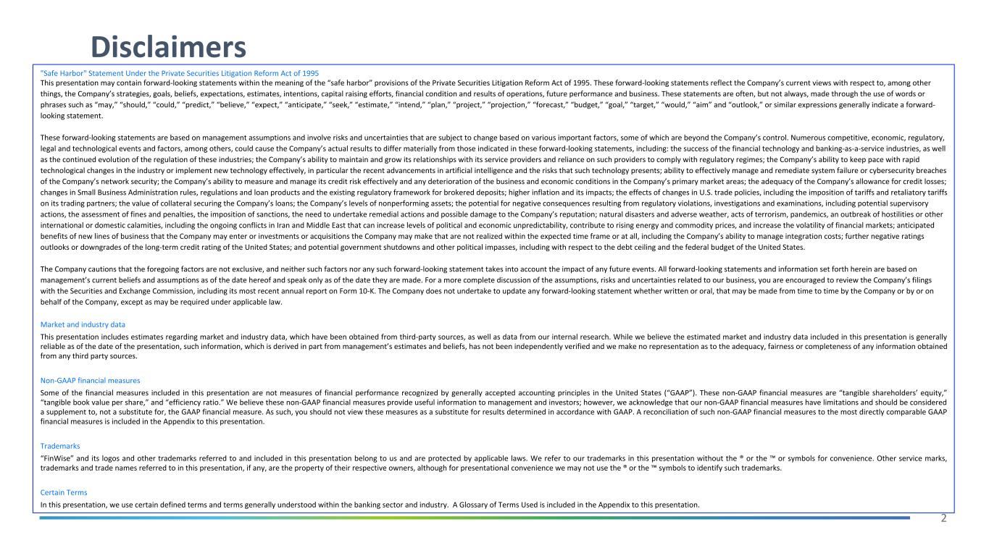
2 Disclaimers "Safe Harbor" Statement Under the Private Securities Litigation Reform Act of 1995 This presentation may contain forward-looking statements within the meaning of the “safe harbor” provisions of the Private Securities Litigation Reform Act of 1995. These forward-looking statements reflect the Company’s current views with respect to, among other things, the Company’s strategies, goals, beliefs, expectations, estimates, intentions, capital raising efforts, financial condition and results of operations, future performance and business. These statements are often, but not always, made through the use of words or phrases such as “may,” “should,” “could,” “predict,” “believe,” “expect,” “anticipate,” “seek,” “estimate,” “intend,” “plan,” “project,” “projection,” “forecast,” “budget,” “goal,” “target,” “would,” “aim” and “outlook,” or similar expressions generally indicate a forward- looking statement. These forward-looking statements are based on management assumptions and involve risks and uncertainties that are subject to change based on various important factors, some of which are beyond the Company’s control. Numerous competitive, economic, regulatory, legal and technological events and factors, among others, could cause the Company’s actual results to differ materially from those indicated in these forward-looking statements, including: the success of the financial technology and banking-as-a-service industries, as well as the continued evolution of the regulation of these industries; the Company’s ability to maintain and grow its relationships with its service providers and reliance on such providers to comply with regulatory regimes; the Company’s ability to keep pace with rapid technological changes in the industry or implement new technology effectively, in particular the recent advancements in artificial intelligence and the risks that such technology presents; ability to effectively manage and remediate system failure or cybersecurity breaches of the Company’s network security; the Company’s ability to measure and manage its credit risk effectively and any deterioration of the business and economic conditions in the Company’s primary market areas; the adequacy of the Company’s allowance for credit losses; changes in Small Business Administration rules, regulations and loan products and the existing regulatory framework for brokered deposits; higher inflation and its impacts; the effects of changes in U.S. trade policies, including the imposition of tariffs and retaliatory tariffs on its trading partners; the value of collateral securing the Company’s loans; the Company’s levels of nonperforming assets; the potential for negative consequences resulting from regulatory violations, investigations and examinations, including potential supervisory actions, the assessment of fines and penalties, the imposition of sanctions, the need to undertake remedial actions and possible damage to the Company’s reputation; natural disasters and adverse weather, acts of terrorism, pandemics, an outbreak of hostilities or other international or domestic calamities, including the ongoing conflicts in Iran and Middle East that can increase levels of political and economic unpredictability, contribute to rising energy and commodity prices, and increase the volatility of financial markets; anticipated benefits of new lines of business that the Company may enter or investments or acquisitions the Company may make that are not realized within the expected time frame or at all, including the Company’s ability to manage integration costs; further negative ratings outlooks or downgrades of the long-term credit rating of the United States; and potential government shutdowns and other political impasses, including with respect to the debt ceiling and the federal budget of the United States. The Company cautions that the foregoing factors are not exclusive, and neither such factors nor any such forward-looking statement takes into account the impact of any future events. All forward-looking statements and information set forth herein are based on management’s current beliefs and assumptions as of the date hereof and speak only as of the date they are made. For a more complete discussion of the assumptions, risks and uncertainties related to our business, you are encouraged to review the Company’s filings with the Securities and Exchange Commission, including its most recent annual report on Form 10-K. The Company does not undertake to update any forward-looking statement whether written or oral, that may be made from time to time by the Company or by or on behalf of the Company, except as may be required under applicable law. Market and industry data This presentation includes estimates regarding market and industry data, which have been obtained from third-party sources, as well as data from our internal research. While we believe the estimated market and industry data included in this presentation is generally reliable as of the date of the presentation, such information, which is derived in part from management’s estimates and beliefs, has not been independently verified and we make no representation as to the adequacy, fairness or completeness of any information obtained from any third party sources. Non-GAAP financial measures Some of the financial measures included in this presentation are not measures of financial performance recognized by generally accepted accounting principles in the United States (“GAAP”). These non-GAAP financial measures are “tangible shareholders’ equity,” “tangible book value per share,” and “efficiency ratio.” We believe these non-GAAP financial measures provide useful information to management and investors; however, we acknowledge that our non-GAAP financial measures have limitations and should be considered a supplement to, not a substitute for, the GAAP financial measure. As such, you should not view these measures as a substitute for results determined in accordance with GAAP. A reconciliation of such non-GAAP financial measures to the most directly comparable GAAP financial measures is included in the Appendix to this presentation. Trademarks “FinWise” and its logos and other trademarks referred to and included in this presentation belong to us and are protected by applicable laws. We refer to our trademarks in this presentation without the ® or the ™ or symbols for convenience. Other service marks, trademarks and trade names referred to in this presentation, if any, are the property of their respective owners, although for presentational convenience we may not use the ® or the ™ symbols to identify such trademarks. Certain Terms In this presentation, we use certain defined terms and terms generally understood within the banking sector and industry. A Glossary of Terms Used is included in the Appendix to this presentation.

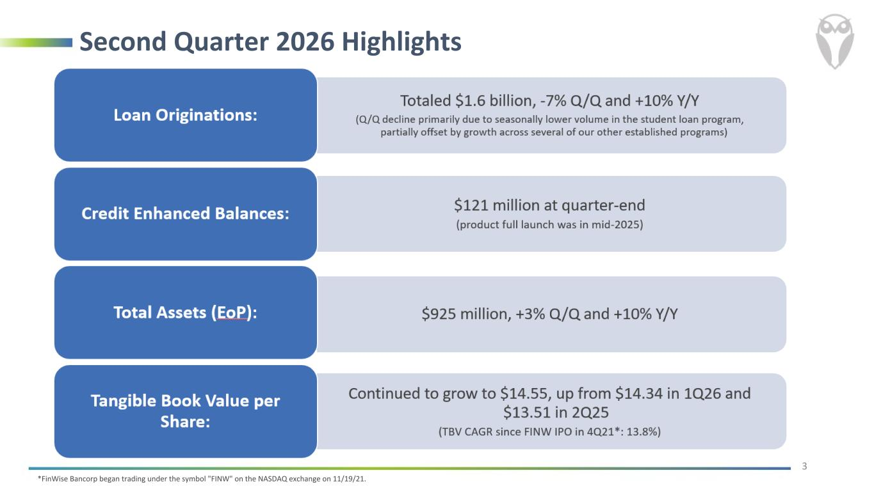
Second Quarter 2026 Highlights 3 *FinWise Bancorp began trading under the symbol "FINW" on the NASDAQ exchange on 11/19/21.

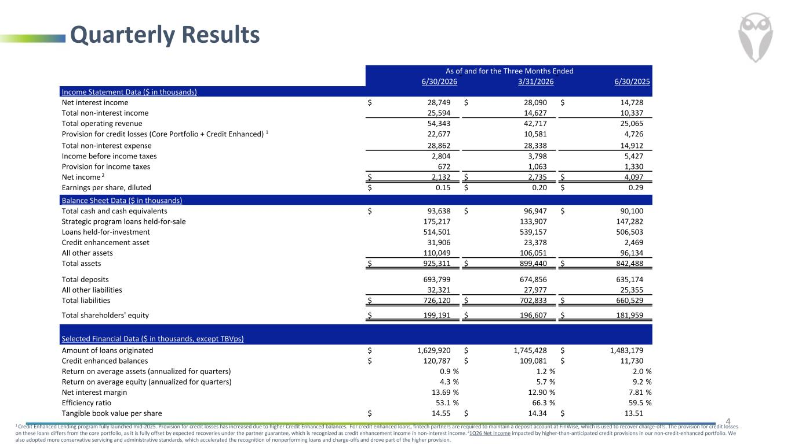
Quarterly Results 41 Credit Enhanced Lending program fully launched mid-2025. Provision for credit losses has increased due to higher Credit Enhanced balances. For credit enhanced loans, fintech partners are required to maintain a deposit account at FinWise, which is used to recover charge-offs. The provision for credit losses on these loans differs from the core portfolio, as it is fully offset by expected recoveries under the partner guarantee, which is recognized as credit enhancement income in non-interest income. 21Q26 Net Income impacted by higher-than-anticipated credit provisions in our non-credit-enhanced portfolio. We also adopted more conservative servicing and administrative standards, which accelerated the recognition of nonperforming loans and charge-offs and drove part of the higher provision. As of and for the Three Months Ended 6/30/2026 3/31/2026 6/30/2025 Income Statement Data ($ in thousands) Net interest income $ 28,749 $ 28,090 $ 14,728 Total non-interest income 25,594 14,627 10,337 Total operating revenue 54,343 42,717 25,065 Provision for credit losses (Core Portfolio + Credit Enhanced) 1 22,677 10,581 4,726 Total non-interest expense 28,862 28,338 14,912 Income before income taxes 2,804 3,798 5,427 Provision for income taxes 672 1,063 1,330 Net income 2 $ 2,132 $ 2,735 $ 4,097 Earnings per share, diluted $ 0.15 $ 0.20 $ 0.29 Balance Sheet Data ($ in thousands) Total cash and cash equivalents $ 93,638 $ 96,947 $ 90,100 Strategic program loans held-for-sale 175,217 133,907 147,282 Loans held-for-investment 514,501 539,157 506,503 Credit enhancement asset 31,906 23,378 2,469 All other assets 110,049 106,051 96,134 Total assets $ 925,311 $ 899,440 $ 842,488 Total deposits 693,799 674,856 635,174 All other liabilities 32,321 27,977 25,355 Total liabilities $ 726,120 $ 702,833 $ 660,529 Total shareholders' equity $ 199,191 $ 196,607 $ 181,959 Selected Financial Data ($ in thousands, except TBVps) Amount of loans originated $ 1,629,920 $ 1,745,428 $ 1,483,179 Credit enhanced balances $ 120,787 $ 109,081 $ 11,730 Return on average assets (annualized for quarters) 0.9 % 1.2 % 2.0 % Return on average equity (annualized for quarters) 4.3 % 5.7 % 9.2 % Net interest margin 13.69 % 12.90 % 7.81 % Efficiency ratio 53.1 % 66.3 % 59.5 % Tangible book value per share $ 14.55 $ 14.34 $ 13.51

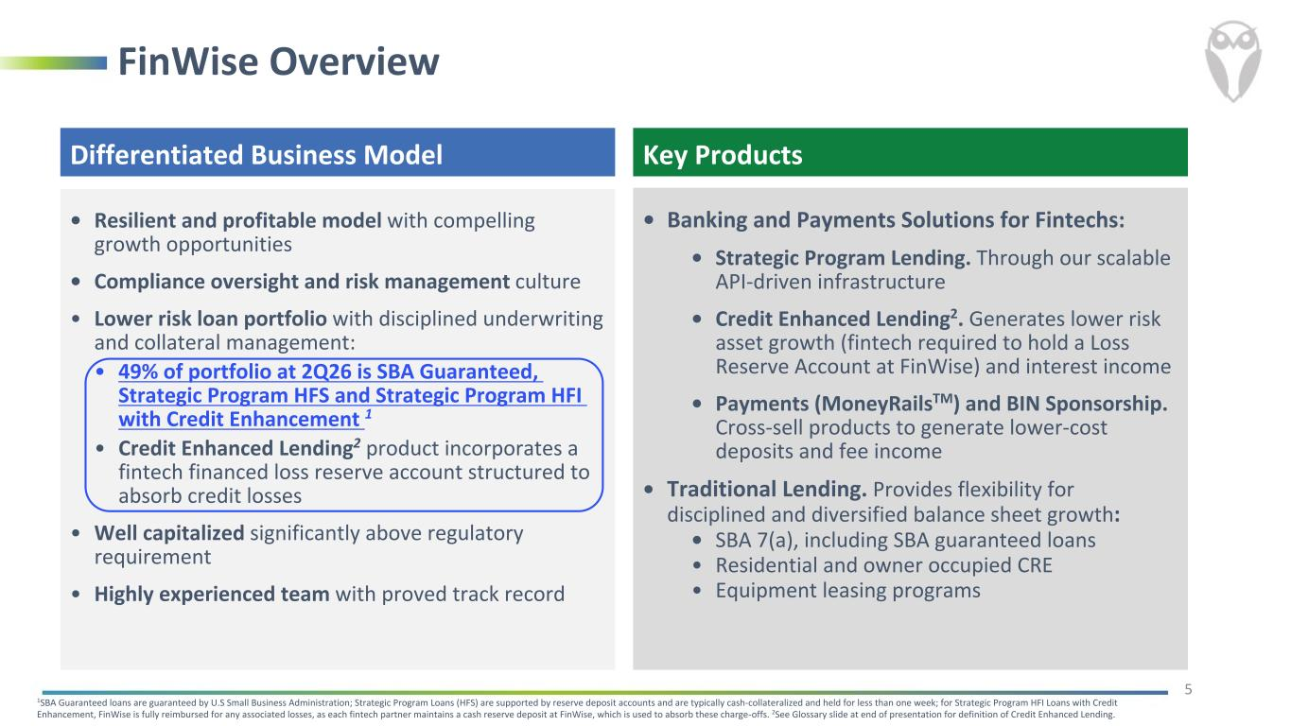
FinWise Overview Differentiated Business Model • Resilient and profitable model with compelling growth opportunities • Compliance oversight and risk management culture • Lower risk loan portfolio with disciplined underwriting and collateral management: • 49% of portfolio at 2Q26 is SBA Guaranteed, Strategic Program HFS and Strategic Program HFI with Credit Enhancement 1 • Credit Enhanced Lending2 product incorporates a fintech financed loss reserve account structured to absorb credit losses • Well capitalized significantly above regulatory requirement • Highly experienced team with proved track record 1SBA Guaranteed loans are guaranteed by U.S Small Business Administration; Strategic Program Loans (HFS) are supported by reserve deposit accounts and are typically cash-collateralized and held for less than one week; for Strategic Program HFI Loans with Credit Enhancement, FinWise is fully reimbursed for any associated losses, as each fintech partner maintains a cash reserve deposit at FinWise, which is used to absorb these charge-offs. 2See Glossary slide at end of presentation for definition of Credit Enhanced Lending. 5 • Banking and Payments Solutions for Fintechs: • Strategic Program Lending. Through our scalable API-driven infrastructure • Credit Enhanced Lending2. Generates lower risk asset growth (fintech required to hold a Loss Reserve Account at FinWise) and interest income • Payments (MoneyRailsTM) and BIN Sponsorship. Cross-sell products to generate lower-cost deposits and fee income • Traditional Lending. Provides flexibility for disciplined and diversified balance sheet growth: • SBA 7(a), including SBA guaranteed loans • Residential and owner occupied CRE • Equipment leasing programs Key Products

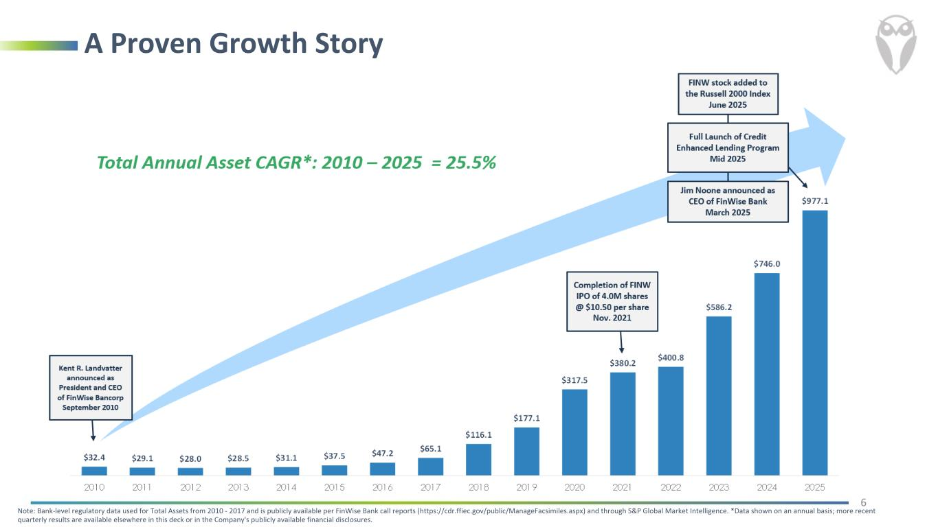
A Proven Growth Story 6 Note: Bank-level regulatory data used for Total Assets from 2010 - 2017 and is publicly available per FinWise Bank call reports (https://cdr.ffiec.gov/public/ManageFacsimiles.aspx) and through S&P Global Market Intelligence. *Data shown on an annual basis; more recent quarterly results are available elsewhere in this deck or in the Company's publicly available financial disclosures.

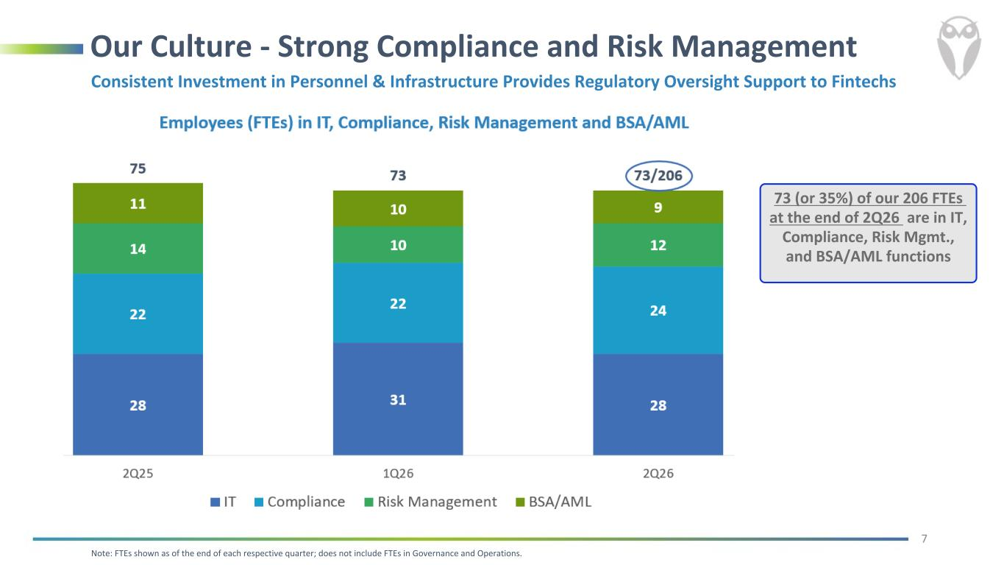
Our Culture - Strong Compliance and Risk Management 7 Consistent Investment in Personnel & Infrastructure Provides Regulatory Oversight Support to Fintechs Note: FTEs shown as of the end of each respective quarter; does not include FTEs in Governance and Operations. 73 (or 35%) of our 206 FTEs at the end of 2Q26 are in IT, Compliance, Risk Mgmt., and BSA/AML functions

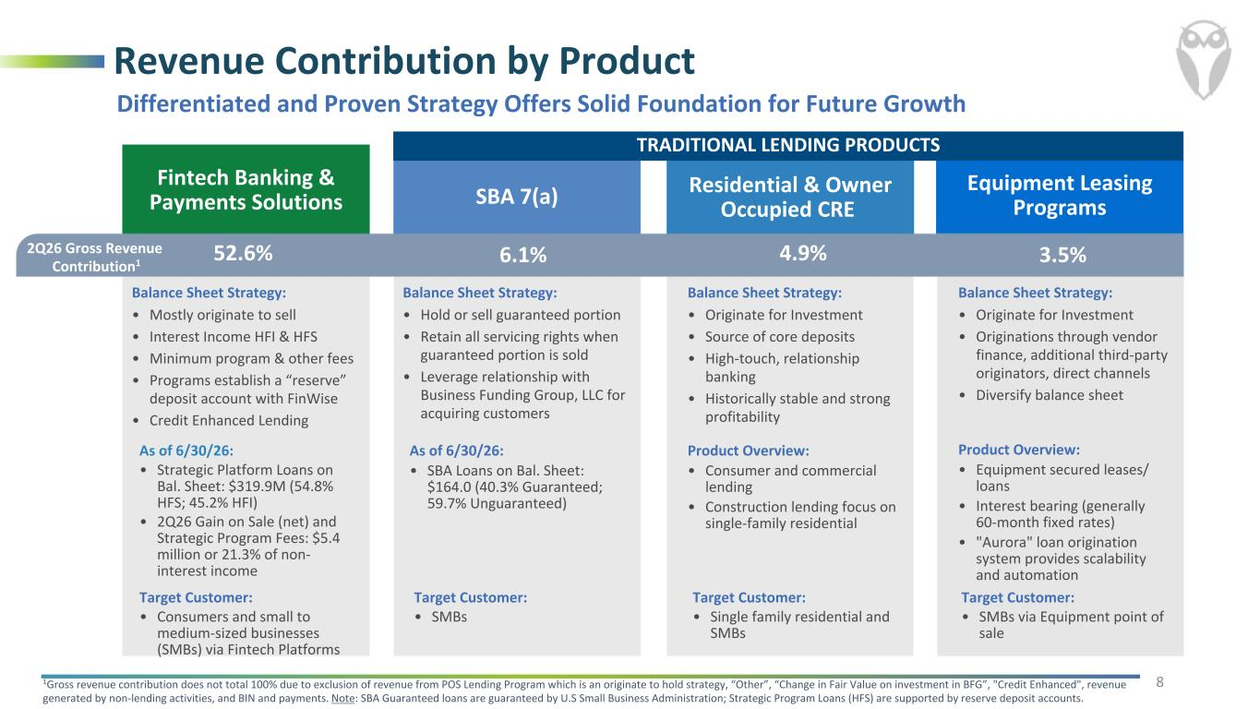
Equipment Leasing Programs Balance Sheet Strategy: • Originate for Investment • Originations through vendor finance, additional third-party originators, direct channels • Diversify balance sheet Fintech Banking & Payments Solutions Balance Sheet Strategy: • Mostly originate to sell • Interest Income HFI & HFS • Minimum program & other fees • Programs establish a “reserve” deposit account with FinWise • Credit Enhanced Lending SBA 7(a) Balance Sheet Strategy: • Hold or sell guaranteed portion • Retain all servicing rights when guaranteed portion is sold • Leverage relationship with Business Funding Group, LLC for acquiring customers Residential & Owner Occupied CRE Balance Sheet Strategy: • Originate for Investment • Source of core deposits • High-touch, relationship banking • Historically stable and strong profitability Revenue Contribution by Product 2Q26 Gross Revenue Contribution1 1Gross revenue contribution does not total 100% due to exclusion of revenue from POS Lending Program which is an originate to hold strategy, “Other”, “Change in Fair Value on investment in BFG”, "Credit Enhanced", revenue generated by non-lending activities, and BIN and payments. Note: SBA Guaranteed loans are guaranteed by U.S Small Business Administration; Strategic Program Loans (HFS) are supported by reserve deposit accounts. 52.6% 6.1% 4.9% 8 3.5% Differentiated and Proven Strategy Offers Solid Foundation for Future Growth As of 6/30/26: • Strategic Platform Loans on Bal. Sheet: $319.9M (54.8% HFS; 45.2% HFI) • 2Q26 Gain on Sale (net) and Strategic Program Fees: $5.4 million or 21.3% of non- interest income As of 6/30/26: • SBA Loans on Bal. Sheet: $164.0 (40.3% Guaranteed; 59.7% Unguaranteed) Product Overview: • Consumer and commercial lending • Construction lending focus on single-family residential Product Overview: • Equipment secured leases/ loans • Interest bearing (generally 60-month fixed rates) • "Aurora" loan origination system provides scalability and automation Target Customer: • Consumers and small to medium-sized businesses (SMBs) via Fintech Platforms Target Customer: • SMBs Target Customer: • Single family residential and SMBs Target Customer: • SMBs via Equipment point of sale TRADITIONAL LENDING PRODUCTS

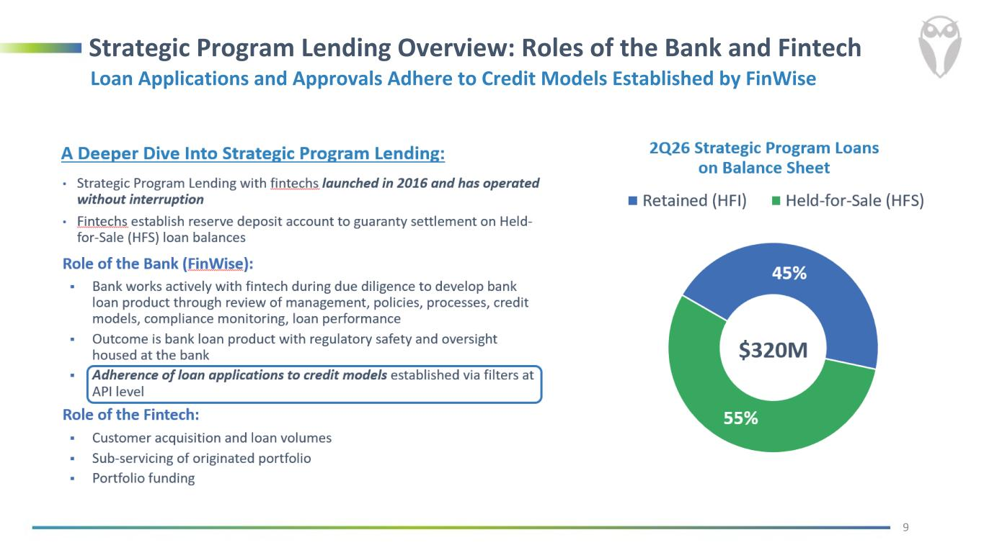
Strategic Program Lending Overview: Roles of the Bank and Fintech 9 Loan Applications and Approvals Adhere to Credit Models Established by FinWise

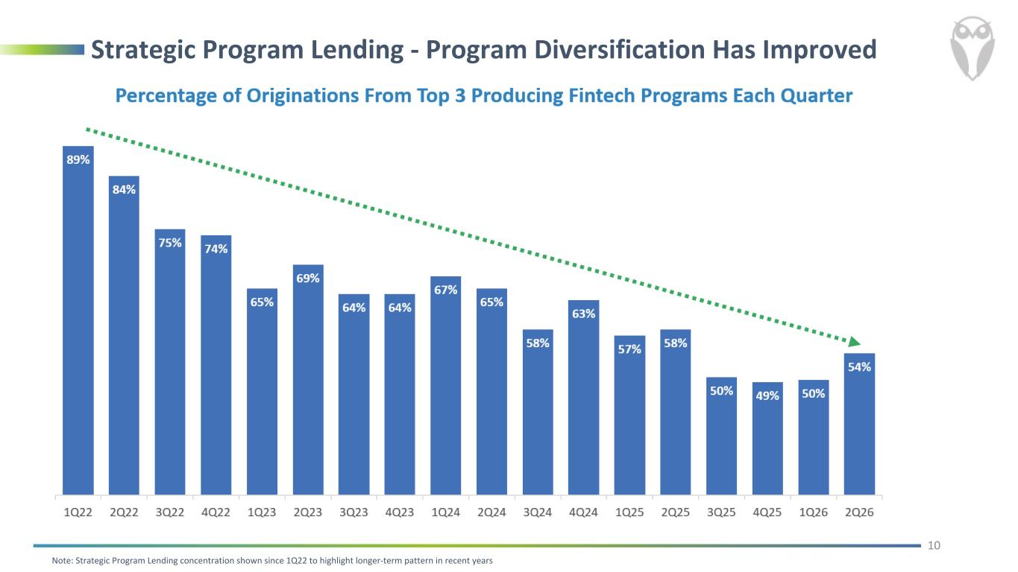
Strategic Program Lending - Program Diversification Has Improved Note: Strategic Program Lending concentration shown since 1Q22 to highlight longer-term pattern in recent years 10

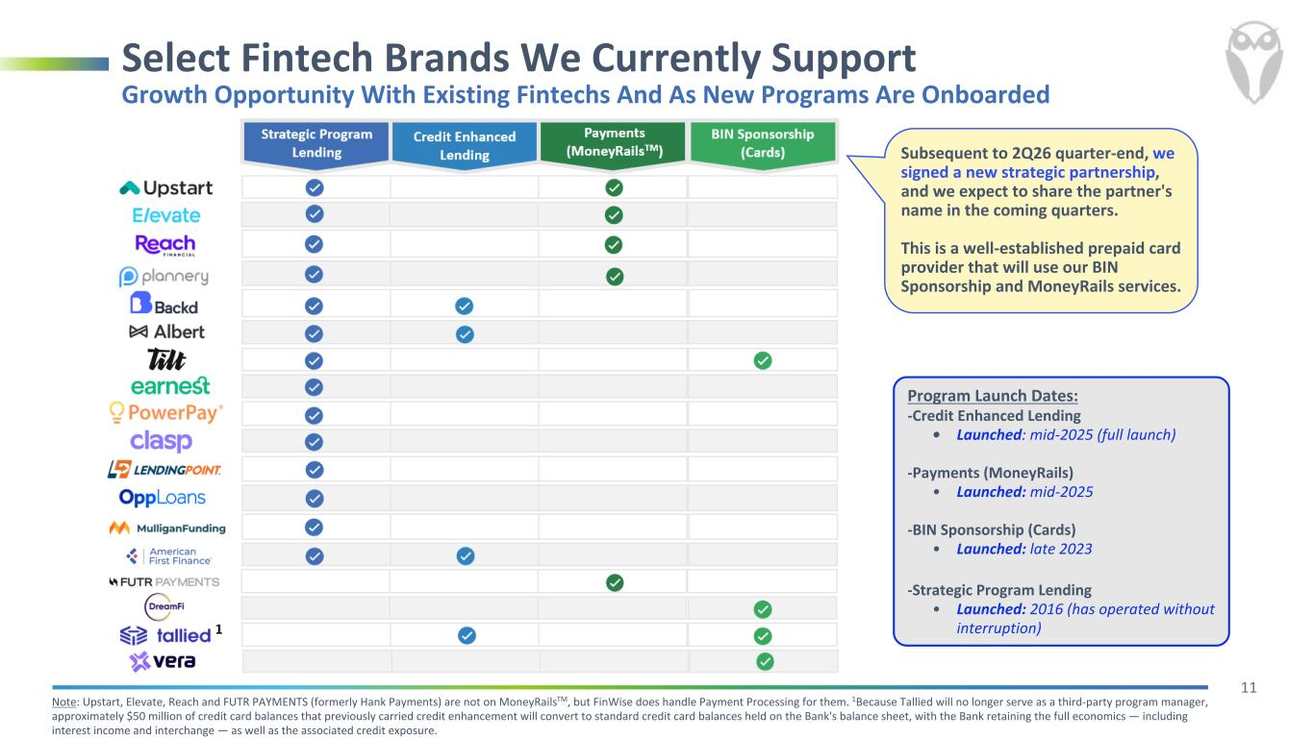
11 Select Fintech Brands We Currently Support Note: Upstart, Elevate, Reach and FUTR PAYMENTS (formerly Hank Payments) are not on MoneyRailsTM, but FinWise does handle Payment Processing for them. 1Because Tallied will no longer serve as a third-party program manager, approximately $50 million of credit card balances that previously carried credit enhancement will convert to standard credit card balances held on the Bank's balance sheet, with the Bank retaining the full economics — including interest income and interchange — as well as the associated credit exposure. Growth Opportunity With Existing Fintechs And As New Programs Are Onboarded Program Launch Dates: -Credit Enhanced Lending • Launched: mid-2025 (full launch) -Payments (MoneyRails) • Launched: mid-2025 -BIN Sponsorship (Cards) • Launched: late 2023 -Strategic Program Lending • Launched: 2016 (has operated without interruption) Subsequent to 2Q26 quarter-end, we signed a new strategic partnership, and we expect to share the partner's name in the coming quarters. This is a well-established prepaid card provider that will use our BIN Sponsorship and MoneyRails services.

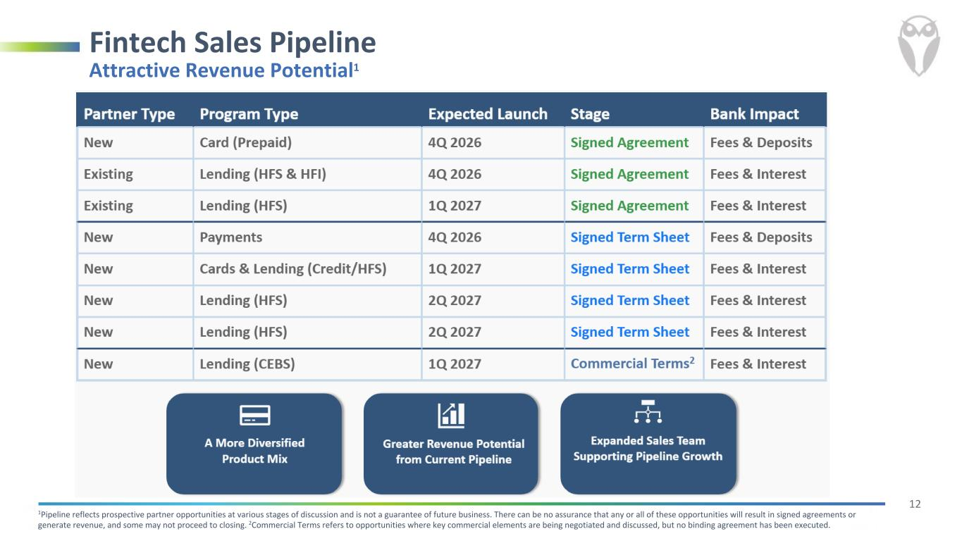
12 Fintech Sales Pipeline Attractive Revenue Potential1 1Pipeline reflects prospective partner opportunities at various stages of discussion and is not a guarantee of future business. There can be no assurance that any or all of these opportunities will result in signed agreements or generate revenue, and some may not proceed to closing. 2Commercial Terms refers to opportunities where key commercial elements are being negotiated and discussed, but no binding agreement has been executed.

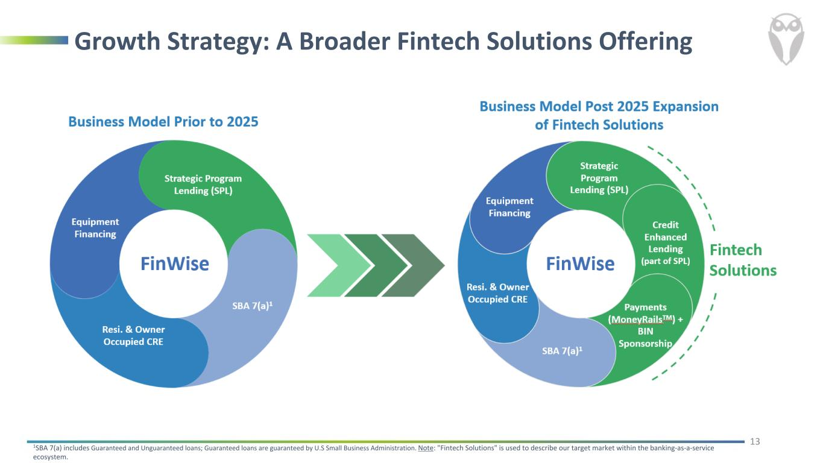
Growth Strategy: A Broader Fintech Solutions Offering 1SBA 7(a) includes Guaranteed and Unguaranteed loans; Guaranteed loans are guaranteed by U.S Small Business Administration. Note: "Fintech Solutions" is used to describe our target market within the banking-as-a-service ecosystem. 13 Strategic Program Lending (SPL) SBA 7(a)1 Equipment Financing BIN Sponsorship Strategic Program Lending (SPL) + Credit Enhancement SBA 7(a)1 Equipment Financing Payments (MoneyRails™)

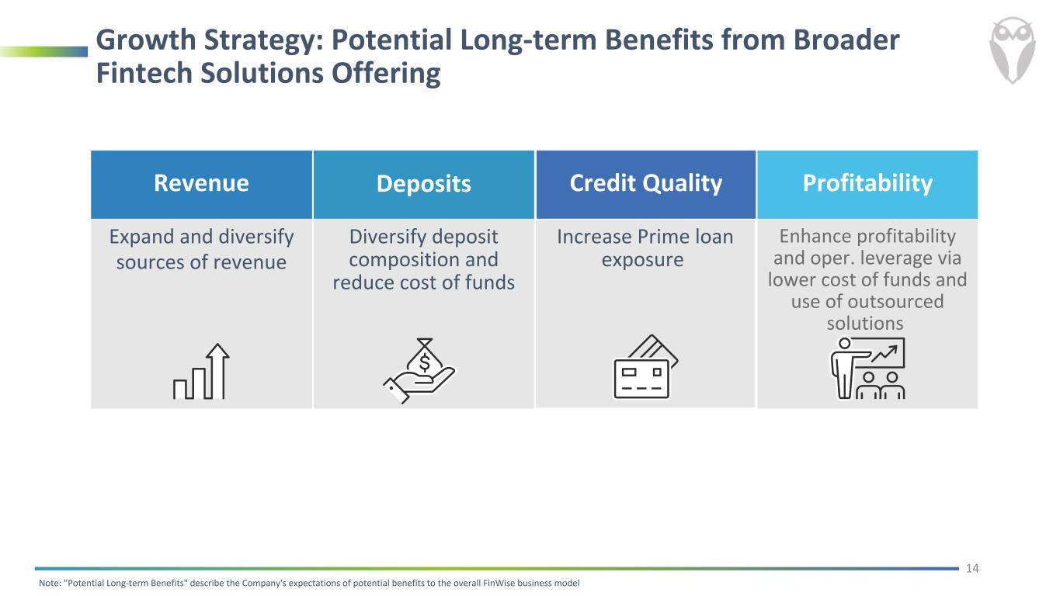
Growth Strategy: Potential Long-term Benefits from Broader Fintech Solutions Offering Revenue Expand and diversify sources of revenue Deposits Diversify deposit composition and reduce cost of funds Credit Quality Increase Prime loan exposure Profitability Enhance profitability and oper. leverage via lower cost of funds and use of outsourced solutions Note: "Potential Long-term Benefits" describe the Company's expectations of potential benefits to the overall FinWise business model 14

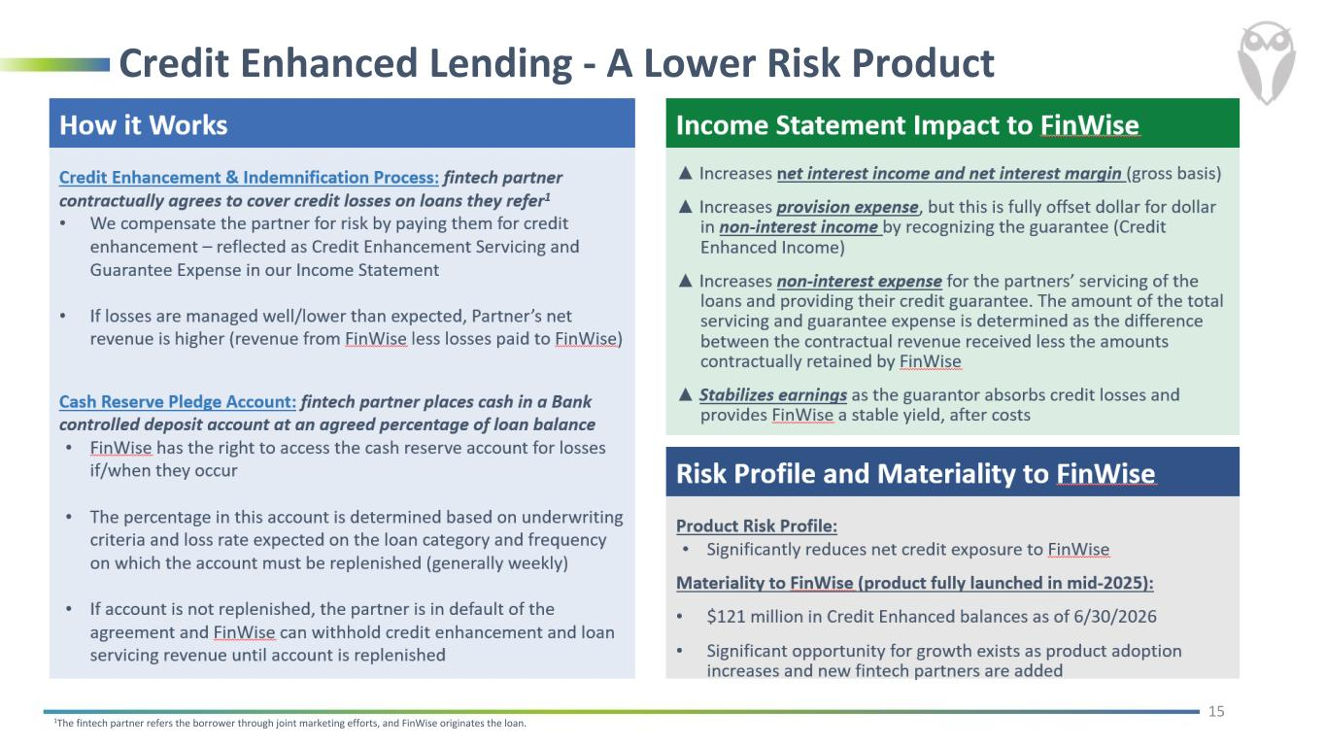
Credit Enhanced Lending - A Lower Risk Product 1The fintech partner refers the borrower through joint marketing efforts, and FinWise originates the loan. 15

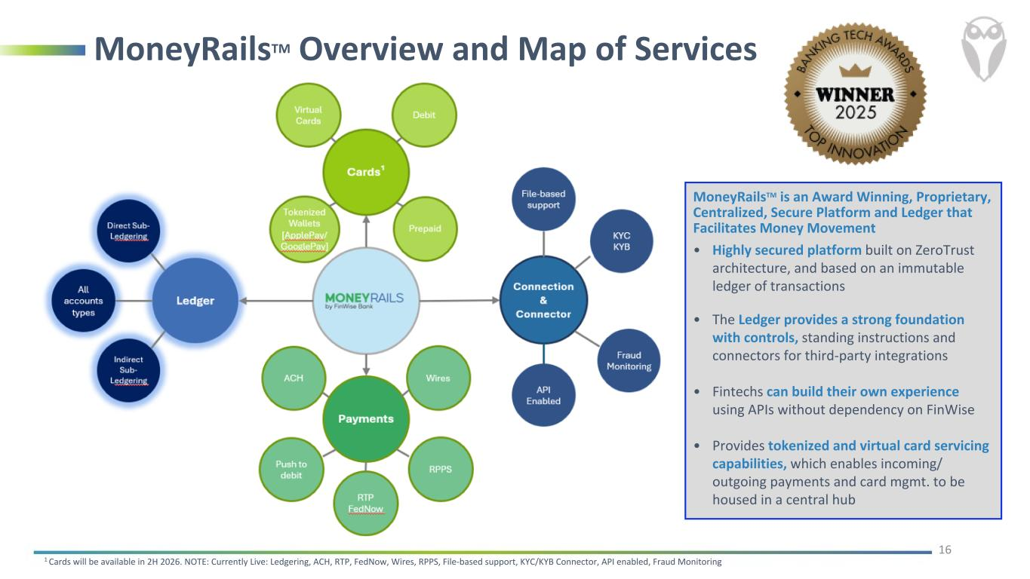
MoneyRailsTM Overview and Map of Services 16 MoneyRailsTM is an Award Winning, Proprietary, Centralized, Secure Platform and Ledger that Facilitates Money Movement • Highly secured platform built on ZeroTrust architecture, and based on an immutable ledger of transactions • The Ledger provides a strong foundation with controls, standing instructions and connectors for third-party integrations • Fintechs can build their own experience using APIs without dependency on FinWise • Provides tokenized and virtual card servicing capabilities, which enables incoming/ outgoing payments and card mgmt. to be housed in a central hub 1 Cards will be available in 2H 2026. NOTE: Currently Live: Ledgering, ACH, RTP, FedNow, Wires, RPPS, File-based support, KYC/KYB Connector, API enabled, Fraud Monitoring

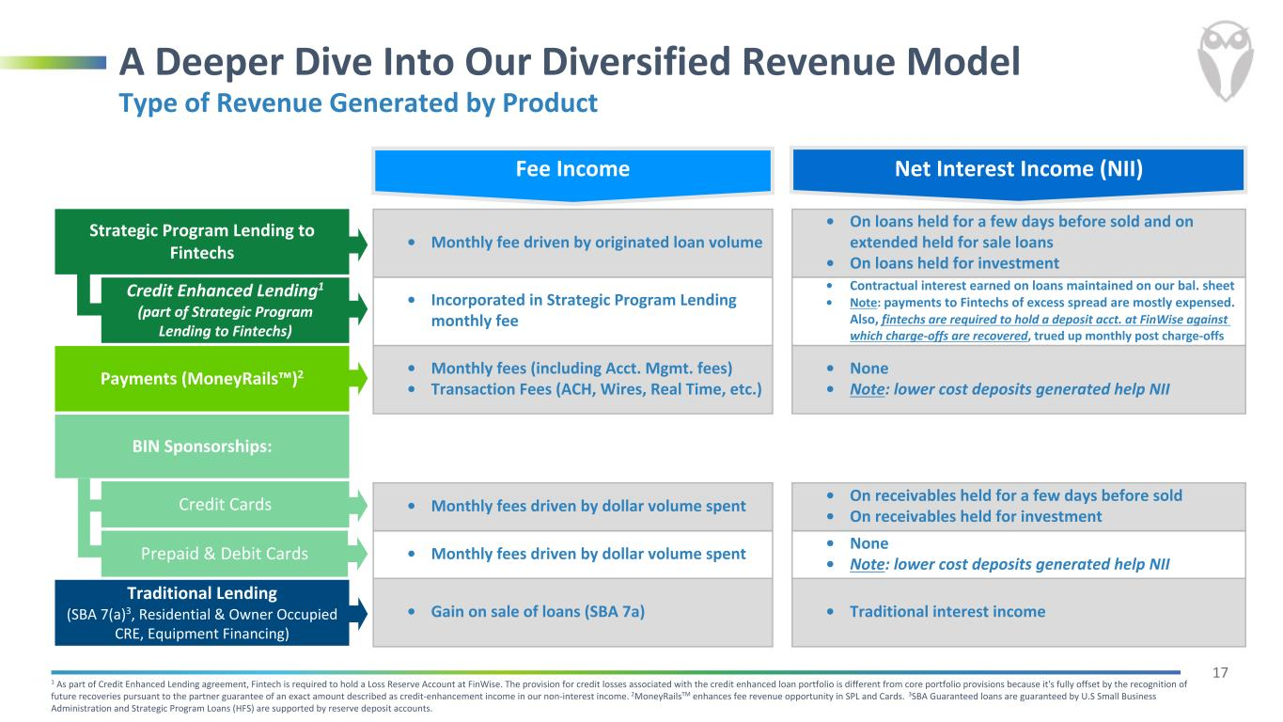
17 Interest Income • Monthly fee driven by originated loan volume • On loans held for a few days before sold and on extended held for sale loans • On loans held for investment • Incorporated in Strategic Program Lending monthly fee • Contractual interest earned on loans maintained on our bal. sheet • Note: payments to Fintechs of excess spread are mostly expensed. Also, fintechs are required to hold a deposit acct. at FinWise against which charge-offs are recovered, trued up monthly post charge-offs • Monthly fees (including Acct. Mgmt. fees) • Transaction Fees (ACH, Wires, Real Time, etc.) • None • Note: lower cost deposits generated help NII • Monthly fees driven by dollar volume spent • On receivables held for a few days before sold • On receivables held for investment • Monthly fees driven by dollar volume spent • None • Note: lower cost deposits generated help NII • Gain on sale of loans (SBA 7a) • Traditional interest income 1 As part of Credit Enhanced Lending agreement, Fintech is required to hold a Loss Reserve Account at FinWise. The provision for credit losses associated with the credit enhanced loan portfolio is different from core portfolio provisions because it's fully offset by the recognition of future recoveries pursuant to the partner guarantee of an exact amount described as credit-enhancement income in our non-interest income. 2MoneyRailsTM enhances fee revenue opportunity in SPL and Cards. 3SBA Guaranteed loans are guaranteed by U.S Small Business Administration and Strategic Program Loans (HFS) are supported by reserve deposit accounts. A Deeper Dive Into Our Diversified Revenue Model Strategic Program Lending to Fintechs Payments (MoneyRails™)2 Credit Cards Traditional Lending (SBA 7(a)3, Residential & Owner Occupied CRE, Equipment Financing) Credit Enhanced Lending1 (part of Strategic Program Lending to Fintechs) Prepaid & Debit Cards Type of Revenue Generated by Product BIN Sponsorships: Net Interest Income (NII)Fee Income

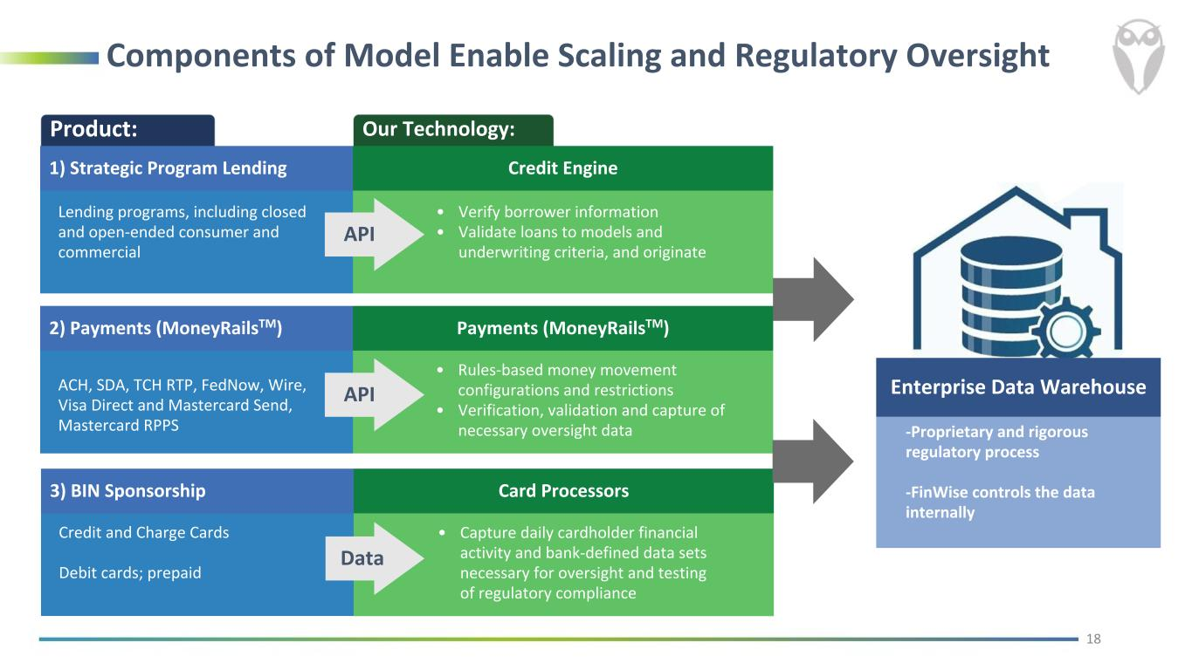
Components of Model Enable Scaling and Regulatory Oversight Our Technology:Product: Enterprise Data Warehouse -Proprietary and rigorous regulatory process -FinWise controls the data internally Lending programs, including closed and open-ended consumer and commercial • Verify borrower information • Validate loans to models and underwriting criteria, and originate API 2) Payments (MoneyRailsTM) Payments (MoneyRailsTM) ACH, SDA, TCH RTP, FedNow, Wire, Visa Direct and Mastercard Send, Mastercard RPPS • Rules-based money movement configurations and restrictions • Verification, validation and capture of necessary oversight data API 3) BIN Sponsorship Card Processors Credit and Charge Cards Debit cards; prepaid • Capture daily cardholder financial activity and bank-defined data sets necessary for oversight and testing of regulatory compliance Data 18 1) Strategic Program Lending Credit Engine

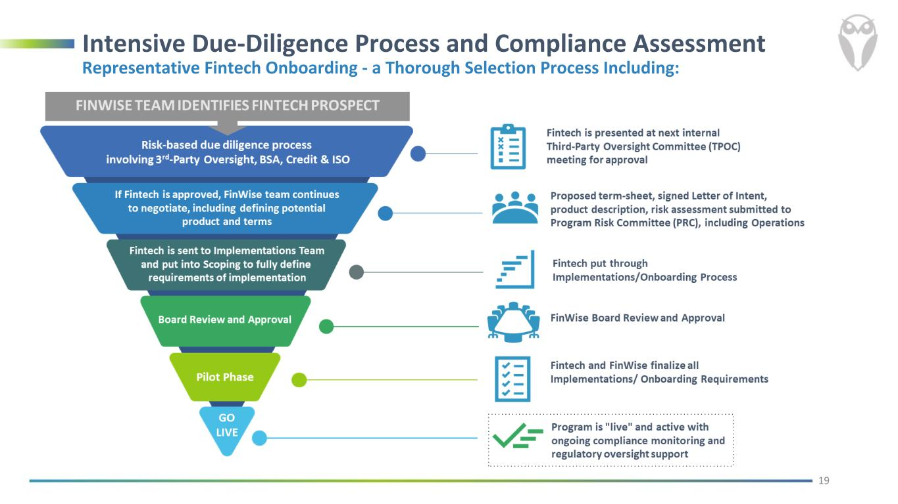
Intensive Due-Diligence Process and Compliance Assessment Representative Fintech Onboarding - a Thorough Selection Process Including: 19

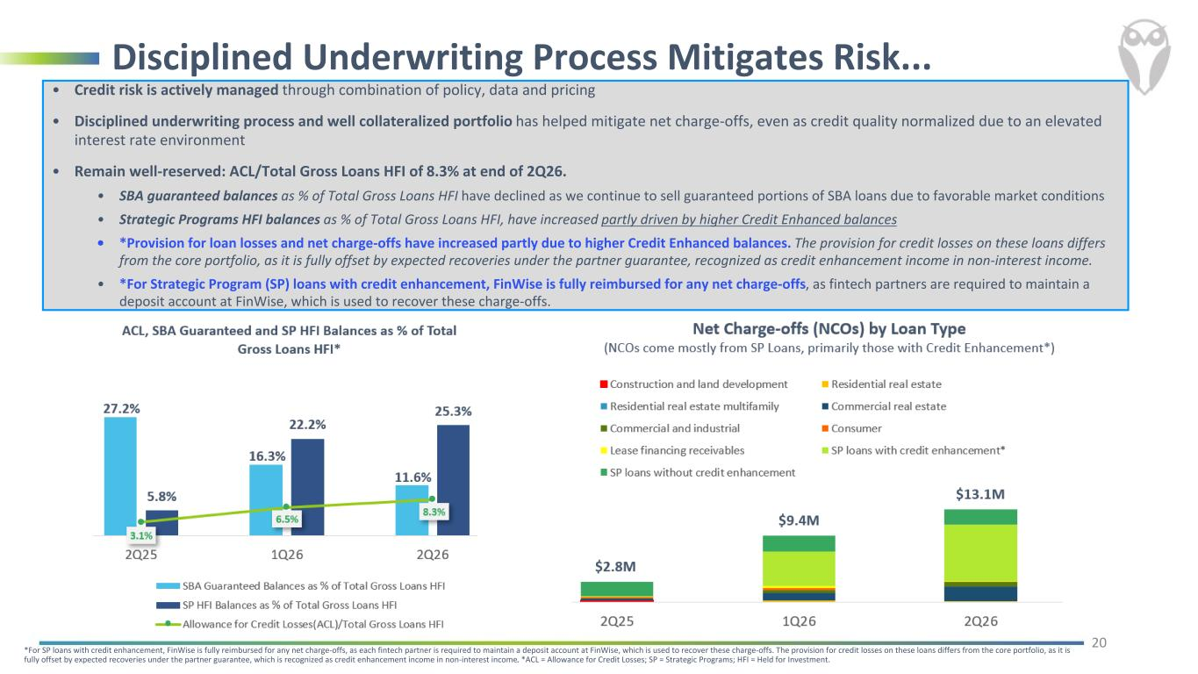
Disciplined Underwriting Process Mitigates Risk... • Credit risk is actively managed through combination of policy, data and pricing • Disciplined underwriting process and well collateralized portfolio has helped mitigate net charge-offs, even as credit quality normalized due to an elevated interest rate environment • Remain well-reserved: ACL/Total Gross Loans HFI of 8.3% at end of 2Q26. • SBA guaranteed balances as % of Total Gross Loans HFI have declined as we continue to sell guaranteed portions of SBA loans due to favorable market conditions • Strategic Programs HFI balances as % of Total Gross Loans HFI, have increased partly driven by higher Credit Enhanced balances • *Provision for loan losses and net charge-offs have increased partly due to higher Credit Enhanced balances. The provision for credit losses on these loans differs from the core portfolio, as it is fully offset by expected recoveries under the partner guarantee, recognized as credit enhancement income in non-interest income. • *For Strategic Program (SP) loans with credit enhancement, FinWise is fully reimbursed for any net charge-offs, as fintech partners are required to maintain a deposit account at FinWise, which is used to recover these charge-offs. 20 *For SP loans with credit enhancement, FinWise is fully reimbursed for any net charge-offs, as each fintech partner is required to maintain a deposit account at FinWise, which is used to recover these charge-offs. The provision for credit losses on these loans differs from the core portfolio, as it is fully offset by expected recoveries under the partner guarantee, which is recognized as credit enhancement income in non-interest income. *ACL = Allowance for Credit Losses; SP = Strategic Programs; HFI = Held for Investment.

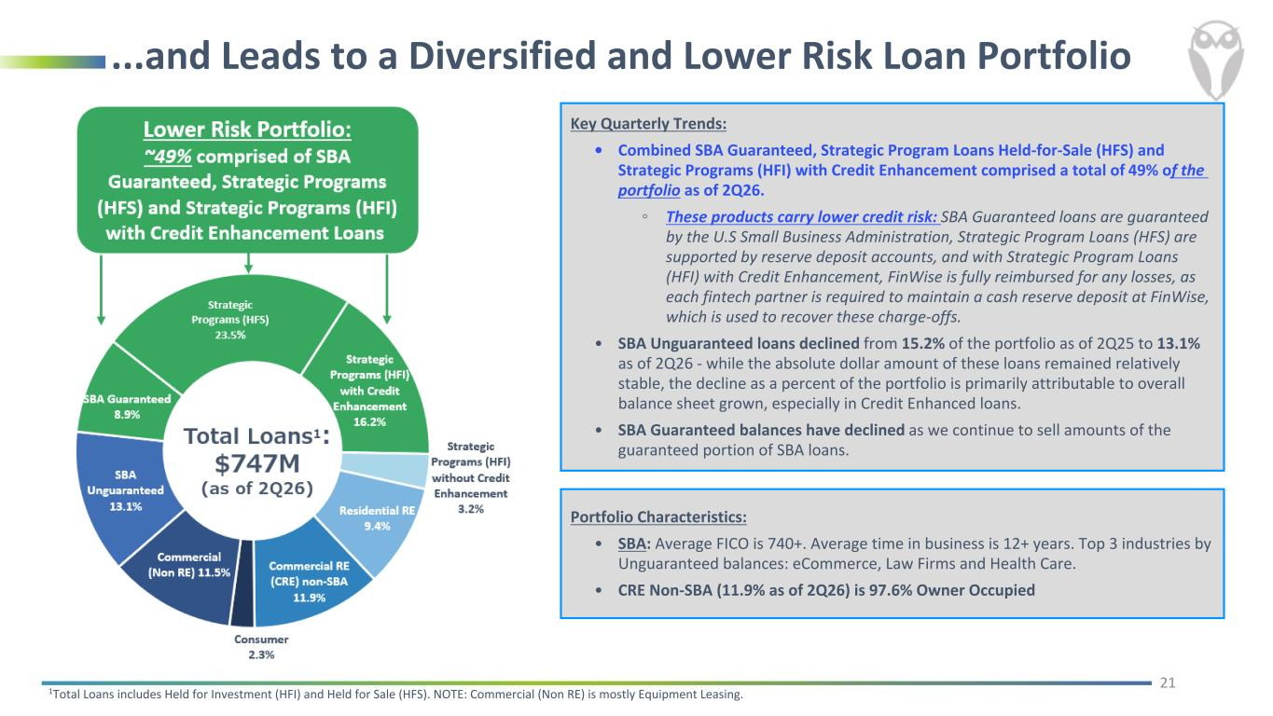
...and Leads to a Diversified and Lower Risk Loan Portfolio Key Quarterly Trends: • Combined SBA Guaranteed, Strategic Program Loans Held-for-Sale (HFS) and Strategic Programs (HFI) with Credit Enhancement comprised a total of 49% of the portfolio as of 2Q26. ◦ These products carry lower credit risk: SBA Guaranteed loans are guaranteed by the U.S Small Business Administration, Strategic Program Loans (HFS) are supported by reserve deposit accounts, and with Strategic Program Loans (HFI) with Credit Enhancement, FinWise is fully reimbursed for any losses, as each fintech partner is required to maintain a cash reserve deposit at FinWise, which is used to recover these charge-offs. • SBA Unguaranteed loans declined from 15.2% of the portfolio as of 2Q25 to 13.1% as of 2Q26 - while the absolute dollar amount of these loans remained relatively stable, the decline as a percent of the portfolio is primarily attributable to overall balance sheet grown, especially in Credit Enhanced loans. • SBA Guaranteed balances have declined as we continue to sell amounts of the guaranteed portion of SBA loans. 21 1Total Loans includes Held for Investment (HFI) and Held for Sale (HFS). NOTE: Commercial (Non RE) is mostly Equipment Leasing. Portfolio Characteristics: • SBA: Average FICO is 740+. Average time in business is 12+ years. Top 3 industries by Unguaranteed balances: eCommerce, Law Firms and Health Care. • CRE Non-SBA (11.9% as of 2Q26) is 97.6% Owner Occupied

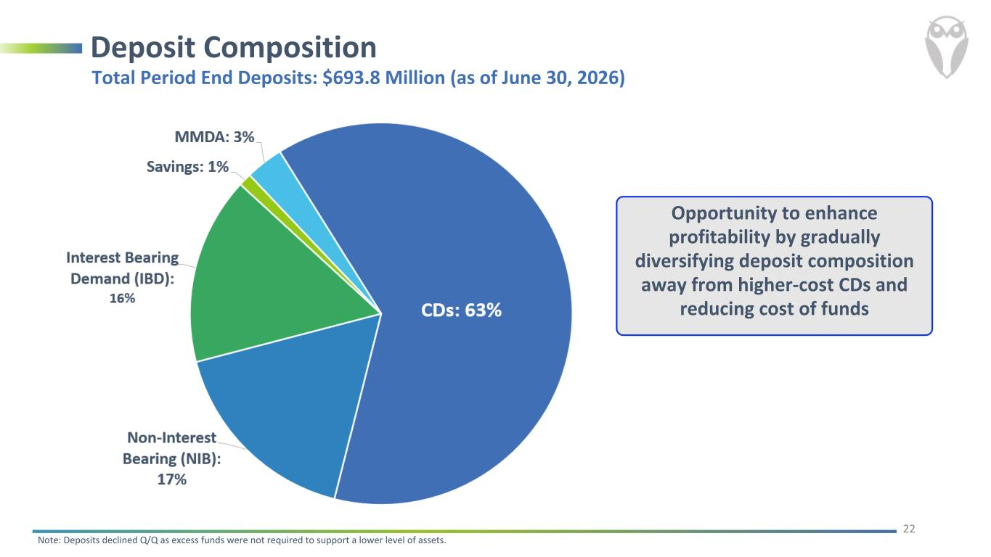
Deposit Composition 22 Total Period End Deposits: $693.8 Million (as of June 30, 2026) Opportunity to enhance profitability by gradually diversifying deposit composition away from higher-cost CDs and reducing cost of funds Note: Deposits declined Q/Q as excess funds were not required to support a lower level of assets.

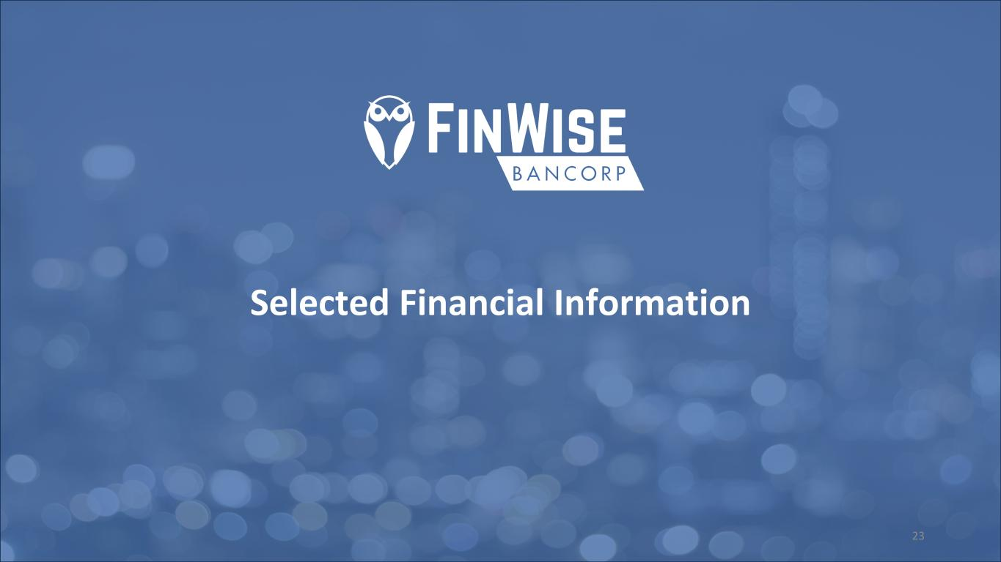
Selected Financial Information 23

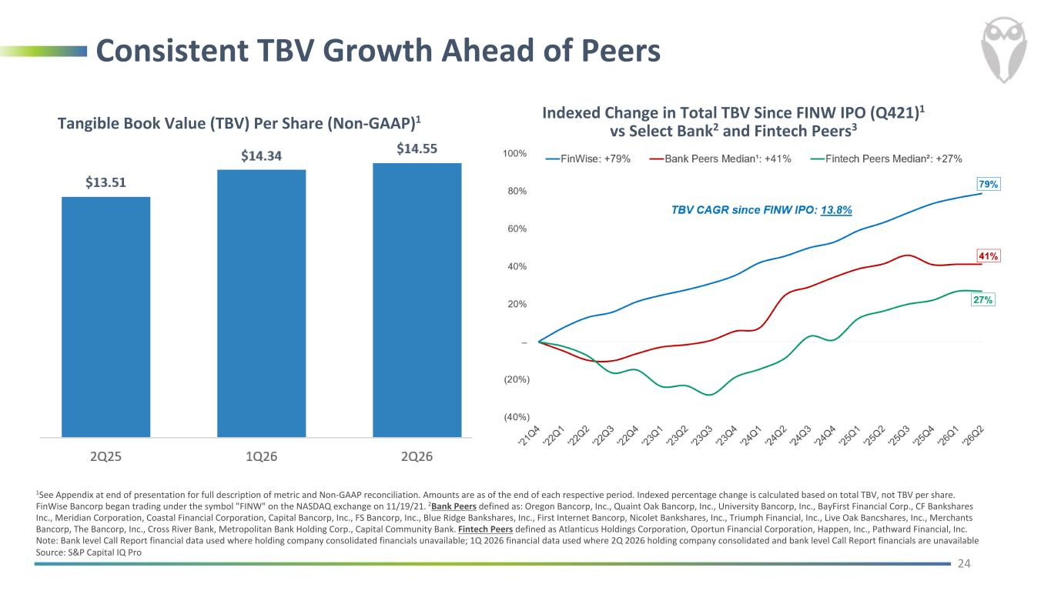
Consistent TBV Growth Ahead of Peers Tangible Book Value (TBV) Per Share (Non-GAAP)1 24 1See Appendix at end of presentation for full description of metric and Non-GAAP reconciliation. Amounts are as of the end of each respective period. Indexed percentage change is calculated based on total TBV, not TBV per share. FinWise Bancorp began trading under the symbol "FINW" on the NASDAQ exchange on 11/19/21. 2Bank Peers defined as: Oregon Bancorp, Inc., Quaint Oak Bancorp, Inc., University Bancorp, Inc., BayFirst Financial Corp., CF Bankshares Inc., Meridian Corporation, Coastal Financial Corporation, Capital Bancorp, Inc., FS Bancorp, Inc., Blue Ridge Bankshares, Inc., First Internet Bancorp, Nicolet Bankshares, Inc., Triumph Financial, Inc., Live Oak Bancshares, Inc., Merchants Bancorp, The Bancorp, Inc., Cross River Bank, Metropolitan Bank Holding Corp., Capital Community Bank. Fintech Peers defined as Atlanticus Holdings Corporation, Oportun Financial Corporation, Happen, Inc., Pathward Financial, Inc. Note: Bank level Call Report financial data used where holding company consolidated financials unavailable; 1Q 2026 financial data used where 2Q 2026 holding company consolidated and bank level Call Report financials are unavailable Source: S&P Capital IQ Pro Indexed Change in Total TBV Since FINW IPO (Q421)1 vs Select Bank2 and Fintech Peers3

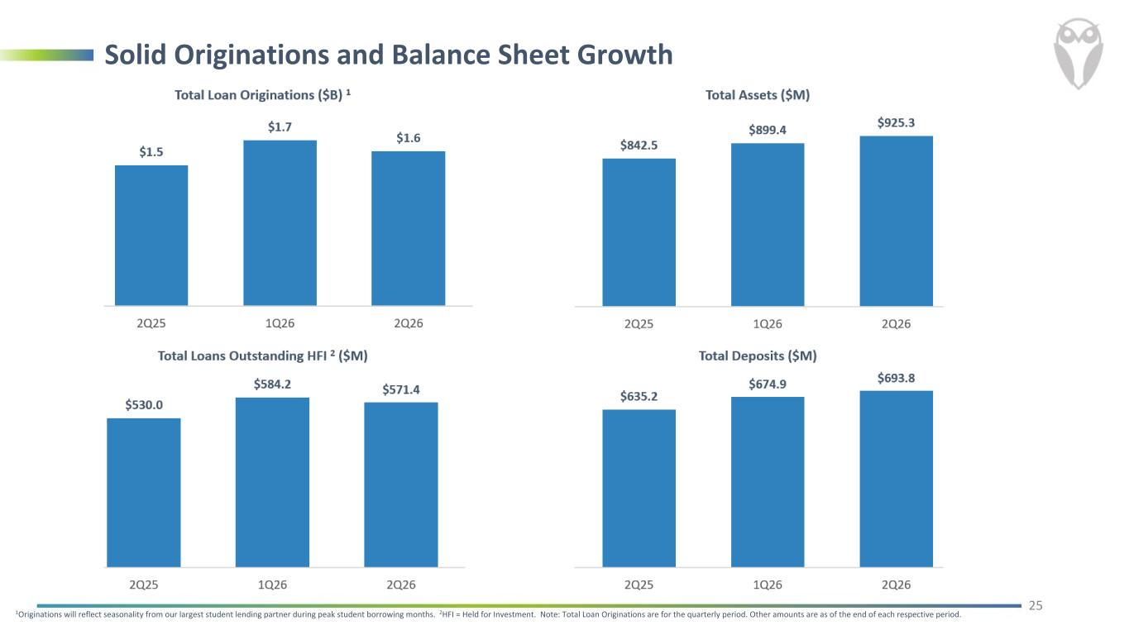
Solid Originations and Balance Sheet Growth 25 1Originations will reflect seasonality from our largest student lending partner during peak student borrowing months. 2HFI = Held for Investment. Note: Total Loan Originations are for the quarterly period. Other amounts are as of the end of each respective period.

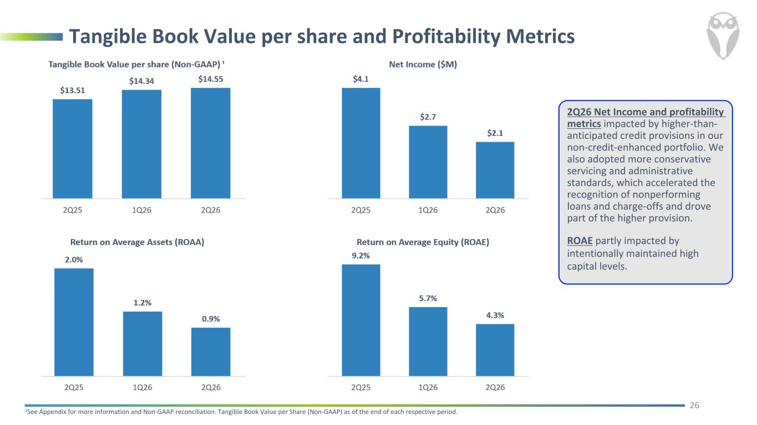
Tangible Book Value per share and Profitability Metrics 26 1See Appendix for more information and Non-GAAP reconciliation. Tangible Book Value per Share (Non-GAAP) as of the end of each respective period. 2Q26 Net Income and profitability metrics impacted by higher-than- anticipated credit provisions in our non-credit-enhanced portfolio. We also adopted more conservative servicing and administrative standards, which accelerated the recognition of nonperforming loans and charge-offs and drove part of the higher provision. ROAE partly impacted by intentionally maintained high capital levels.

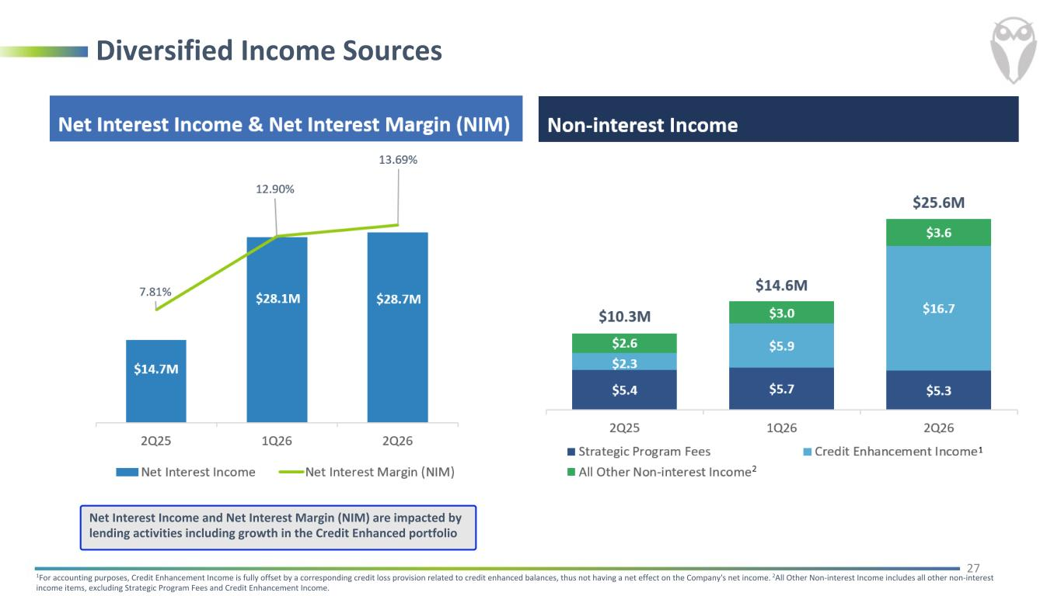
Diversified Income Sources 27 1For accounting purposes, Credit Enhancement Income is fully offset by a corresponding credit loss provision related to credit enhanced balances, thus not having a net effect on the Company's net income. 2All Other Non-interest Income includes all other non-interest income items, excluding Strategic Program Fees and Credit Enhancement Income. Net Interest Income and Net Interest Margin (NIM) are impacted by lending activities including growth in the Credit Enhanced portfolio

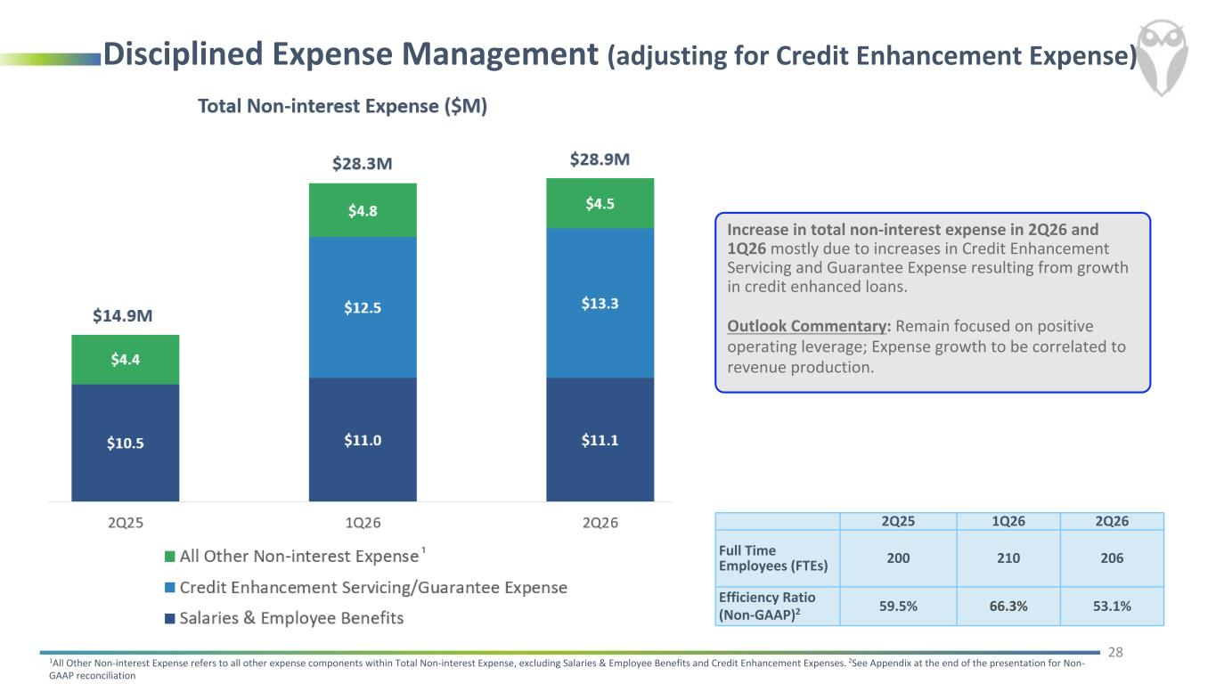
Disciplined Expense Management (adjusting for Credit Enhancement Expense) Increase in total non-interest expense in 2Q26 and 1Q26 mostly due to increases in Credit Enhancement Servicing and Guarantee Expense resulting from growth in credit enhanced loans. Outlook Commentary: Remain focused on positive operating leverage; Expense growth to be correlated to revenue production. 28 2Q25 1Q26 2Q26 Full Time Employees (FTEs) 200 210 206 Efficiency Ratio (Non-GAAP)2 59.5% 66.3% 53.1% 1All Other Non-interest Expense refers to all other expense components within Total Non-interest Expense, excluding Salaries & Employee Benefits and Credit Enhancement Expenses. 2See Appendix at the end of the presentation for Non- GAAP reconciliation

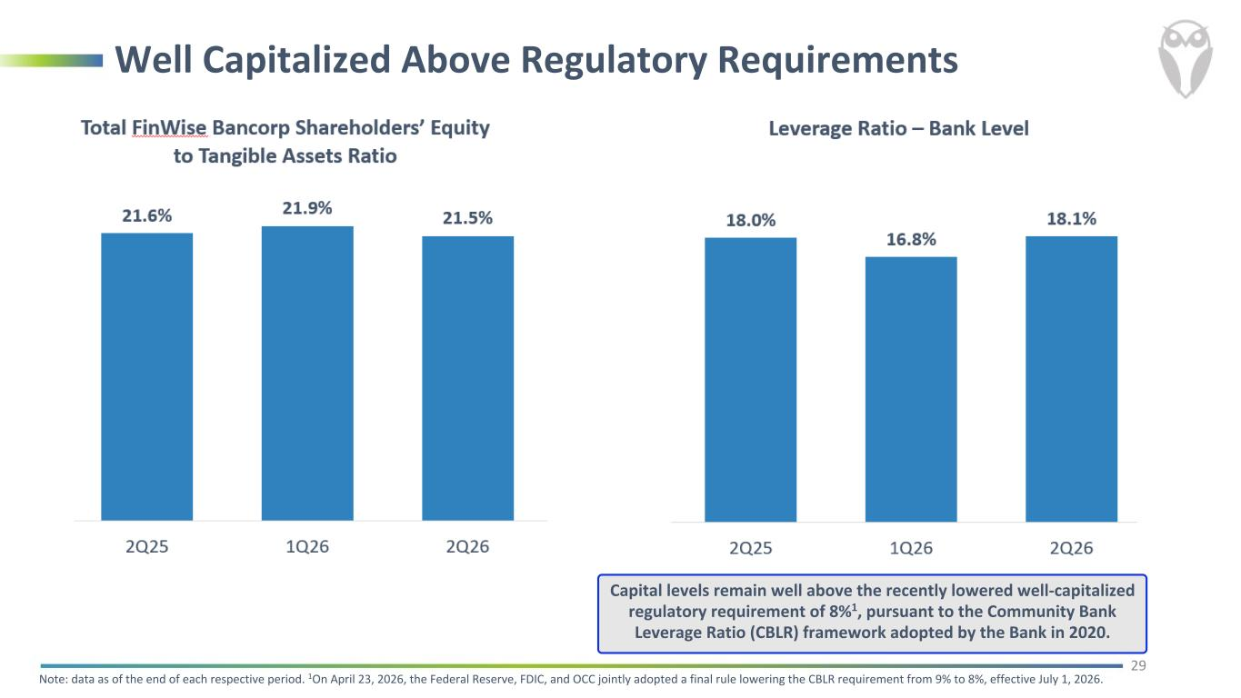
Well Capitalized Above Regulatory Requirements 29 Note: data as of the end of each respective period. 1On April 23, 2026, the Federal Reserve, FDIC, and OCC jointly adopted a final rule lowering the CBLR requirement from 9% to 8%, effective July 1, 2026. Capital levels remain well above the recently lowered well-capitalized regulatory requirement of 8%1, pursuant to the Community Bank Leverage Ratio (CBLR) framework adopted by the Bank in 2020.

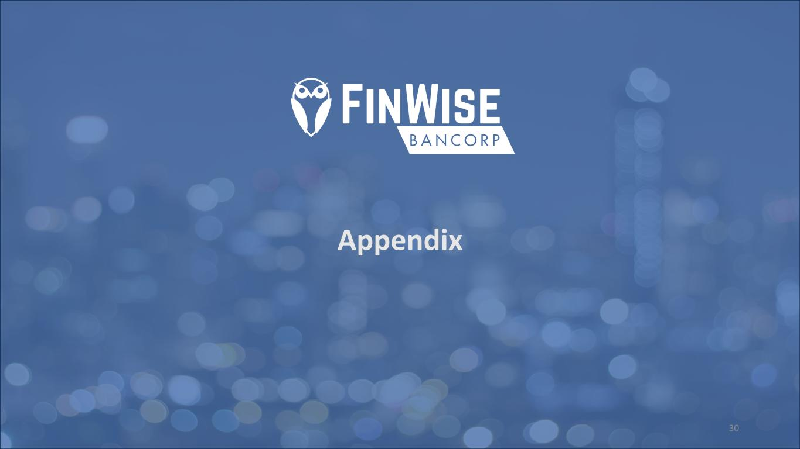
Appendix 30

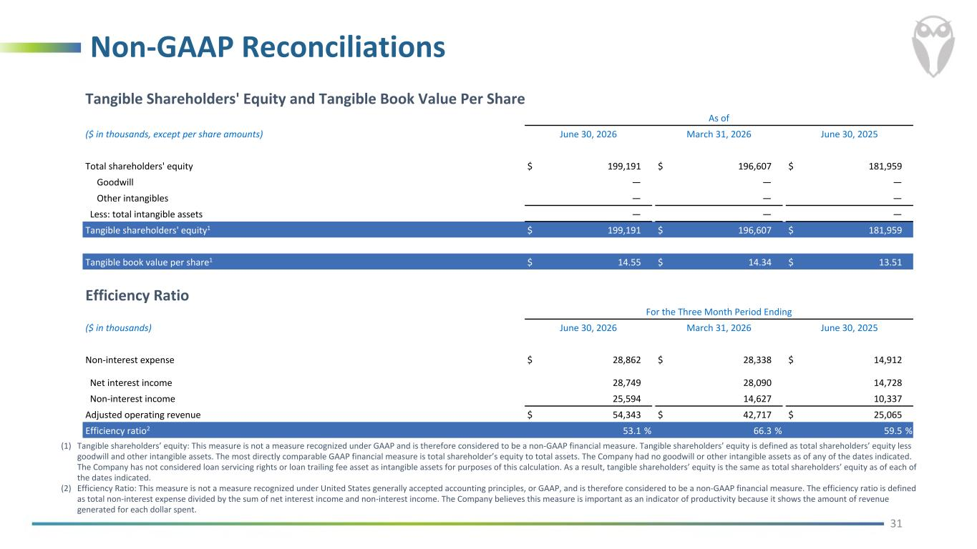
Non-GAAP Reconciliations 31 (1) Tangible shareholders’ equity: This measure is not a measure recognized under GAAP and is therefore considered to be a non-GAAP financial measure. Tangible shareholders’ equity is defined as total shareholders’ equity less goodwill and other intangible assets. The most directly comparable GAAP financial measure is total shareholder’s equity to total assets. The Company had no goodwill or other intangible assets as of any of the dates indicated. The Company has not considered loan servicing rights or loan trailing fee asset as intangible assets for purposes of this calculation. As a result, tangible shareholders’ equity is the same as total shareholders’ equity as of each of the dates indicated. (2) Efficiency Ratio: This measure is not a measure recognized under United States generally accepted accounting principles, or GAAP, and is therefore considered to be a non-GAAP financial measure. The efficiency ratio is defined as total non-interest expense divided by the sum of net interest income and non-interest income. The Company believes this measure is important as an indicator of productivity because it shows the amount of revenue generated for each dollar spent. Tangible Shareholders' Equity and Tangible Book Value Per Share As of ($ in thousands, except per share amounts) June 30, 2026 March 31, 2026 June 30, 2025 Total shareholders' equity $ 199,191 $ 196,607 $ 181,959 Goodwill — — — Other intangibles — — — Less: total intangible assets — — — Tangible shareholders' equity1 $ 199,191 $ 196,607 $ 181,959 Tangible book value per share1 $ 14.55 $ 14.34 $ 13.51 Efficiency Ratio For the Three Month Period Ending ($ in thousands) June 30, 2026 March 31, 2026 June 30, 2025 Non-interest expense $ 28,862 $ 28,338 $ 14,912 Net interest income 28,749 28,090 14,728 Non-interest income 25,594 14,627 10,337 Adjusted operating revenue $ 54,343 $ 42,717 $ 25,065 Efficiency ratio2 53.1 % 66.3 % 59.5 %

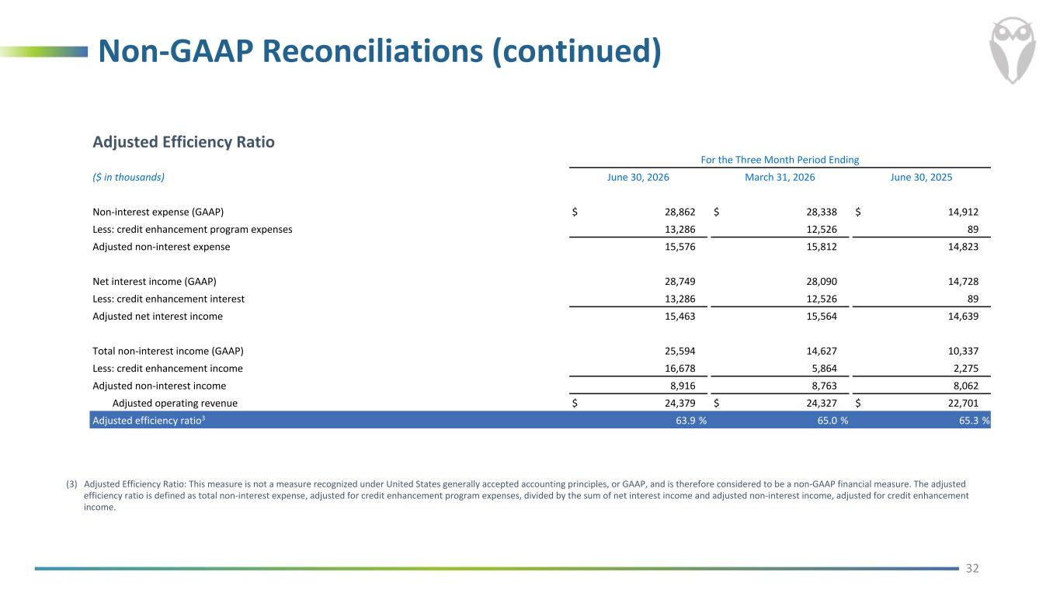
Non-GAAP Reconciliations (continued) 32 (3) Adjusted Efficiency Ratio: This measure is not a measure recognized under United States generally accepted accounting principles, or GAAP, and is therefore considered to be a non-GAAP financial measure. The adjusted efficiency ratio is defined as total non-interest expense, adjusted for credit enhancement program expenses, divided by the sum of net interest income and adjusted non-interest income, adjusted for credit enhancement income. Adjusted Efficiency Ratio For the Three Month Period Ending ($ in thousands) June 30, 2026 March 31, 2026 June 30, 2025 Non-interest expense (GAAP) $ 28,862 $ 28,338 $ 14,912 Less: credit enhancement program expenses 13,286 12,526 89 Adjusted non-interest expense 15,576 15,812 14,823 Net interest income (GAAP) 28,749 28,090 14,728 Less: credit enhancement interest 13,286 12,526 89 Adjusted net interest income 15,463 15,564 14,639 Total non-interest income (GAAP) 25,594 14,627 10,337 Less: credit enhancement income 16,678 5,864 2,275 Adjusted non-interest income 8,916 8,763 8,062 Adjusted operating revenue $ 24,379 $ 24,327 $ 22,701 Adjusted efficiency ratio3 63.9 % 65.0 % 65.3 %

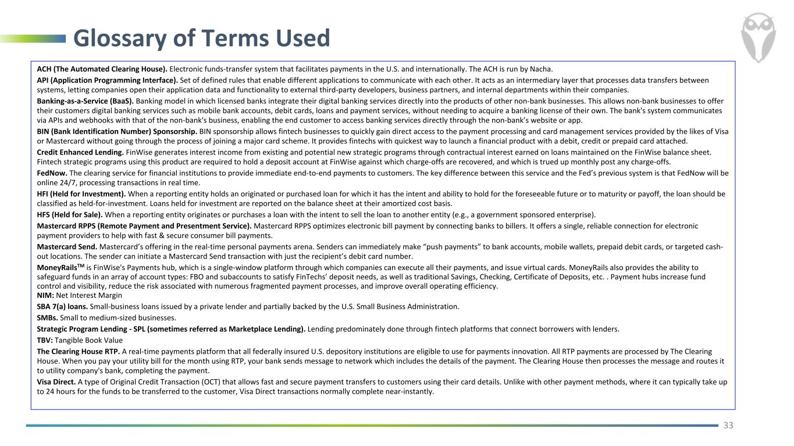
Glossary of Terms Used 33 ACH (The Automated Clearing House). Electronic funds-transfer system that facilitates payments in the U.S. and internationally. The ACH is run by Nacha. API (Application Programming Interface). Set of defined rules that enable different applications to communicate with each other. It acts as an intermediary layer that processes data transfers between systems, letting companies open their application data and functionality to external third-party developers, business partners, and internal departments within their companies. Banking-as-a-Service (BaaS). Banking model in which licensed banks integrate their digital banking services directly into the products of other non-bank businesses. This allows non-bank businesses to offer their customers digital banking services such as mobile bank accounts, debit cards, loans and payment services, without needing to acquire a banking license of their own. The bank's system communicates via APIs and webhooks with that of the non-bank's business, enabling the end customer to access banking services directly through the non-bank’s website or app. BIN (Bank Identification Number) Sponsorship. BIN sponsorship allows fintech businesses to quickly gain direct access to the payment processing and card management services provided by the likes of Visa or Mastercard without going through the process of joining a major card scheme. It provides fintechs with quickest way to launch a financial product with a debit, credit or prepaid card attached. Credit Enhanced Lending. FinWise generates interest income from existing and potential new strategic programs through contractual interest earned on loans maintained on the FinWise balance sheet. Fintech strategic programs using this product are required to hold a deposit account at FinWise against which charge-offs are recovered, and which is trued up monthly post any charge-offs. FedNow. The clearing service for financial institutions to provide immediate end-to-end payments to customers. The key difference between this service and the Fed’s previous system is that FedNow will be online 24/7, processing transactions in real time. HFI (Held for Investment). When a reporting entity holds an originated or purchased loan for which it has the intent and ability to hold for the foreseeable future or to maturity or payoff, the loan should be classified as held-for-investment. Loans held for investment are reported on the balance sheet at their amortized cost basis. HFS (Held for Sale). When a reporting entity originates or purchases a loan with the intent to sell the loan to another entity (e.g., a government sponsored enterprise). Mastercard RPPS (Remote Payment and Presentment Service). Mastercard RPPS optimizes electronic bill payment by connecting banks to billers. It offers a single, reliable connection for electronic payment providers to help with fast & secure consumer bill payments. Mastercard Send. Mastercard’s offering in the real-time personal payments arena. Senders can immediately make “push payments” to bank accounts, mobile wallets, prepaid debit cards, or targeted cash- out locations. The sender can initiate a Mastercard Send transaction with just the recipient’s debit card number. MoneyRailsTM is FinWise's Payments hub, which is a single-window platform through which companies can execute all their payments, and issue virtual cards. MoneyRails also provides the ability to safeguard funds in an array of account types: FBO and subaccounts to satisfy FinTechs’ deposit needs, as well as traditional Savings, Checking, Certificate of Deposits, etc. . Payment hubs increase fund control and visibility, reduce the risk associated with numerous fragmented payment processes, and improve overall operating efficiency. NIM: Net Interest Margin SBA 7(a) loans. Small-business loans issued by a private lender and partially backed by the U.S. Small Business Administration. SMBs. Small to medium-sized businesses. Strategic Program Lending - SPL (sometimes referred as Marketplace Lending). Lending predominately done through fintech platforms that connect borrowers with lenders. TBV: Tangible Book Value The Clearing House RTP. A real-time payments platform that all federally insured U.S. depository institutions are eligible to use for payments innovation. All RTP payments are processed by The Clearing House. When you pay your utility bill for the month using RTP, your bank sends message to network which includes the details of the payment. The Clearing House then processes the message and routes it to utility company's bank, completing the payment. Visa Direct. A type of Original Credit Transaction (OCT) that allows fast and secure payment transfers to customers using their card details. Unlike with other payment methods, where it can typically take up to 24 hours for the funds to be transferred to the customer, Visa Direct transactions normally complete near-instantly.

